SMSC through our chosen writing text drivers:
F2
Text | SMSC/FBV focus | Synopsis
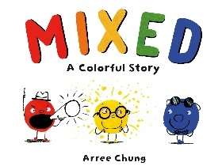 | - Spiritual  - Moral  - Social  - Cultural  - Mutual respect and tolerance | A thought-provoking picture book with characterful illustrations and humour. Follow the colours as they overcome their differences in this sweet tale of acceptance and celebrating difference.
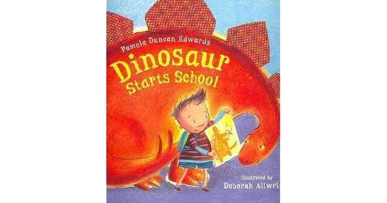 | - Social  - Spiritual | A little boy helps his dinosaur friend overcome his fears of the first day of school by addressing all sorts of questions that children might typically ask about starting school and offering answers that should help calm them as they prepare for the big day.
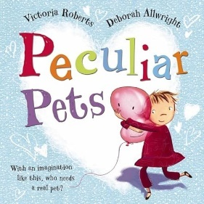 | - Spiritual  - Social | A little girl wants a pet very badly. Her mother doesn't feel that she is ready. With a big imagination she creates pets out of various things she finds lying around in her world. Her first pet is a rock she named fluffy, then there was a red glove and a candy wrapper and a balloon named Bruce. Funny things happen with these pets which is why she has so many.
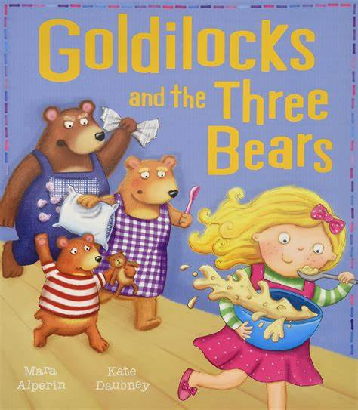 | - Spiritual  - Moral  - Social | Goldilocks and the Three Bears is a fairy tale about a little, mischievous girl who broke into the three bears' house, ate their porridge, sat in their chairs, and slept in their beds.
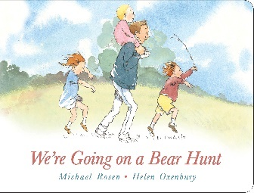 | - Spiritual  - Social | Follow the family’s excitement as they wade through the grass, splash through the river and squelch through the mud in search of the bear. What a surprise awaits in the cave on the other side of the dark forest.
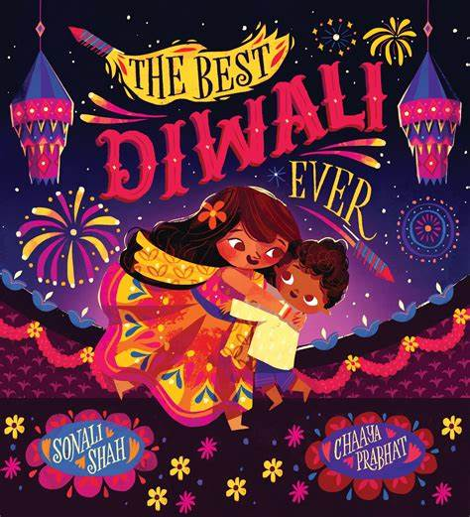 | - Spiritual  - Social  - Cultural  - Mutual respect and tolerance | Peek into the magic of Diwali in this heart-warming picture book about Diwali, siblings and how very special this celebration can be. This year, Ariana has plans to make Diwali an extra special celebration, with yummy sweets, divas around the house, pretty clothes, fireworks and... the rangoli competition, of course.
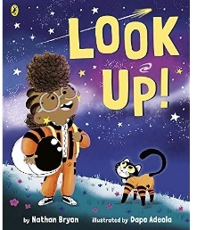 | - Spiritual  - Social  - Cultural | Look Up! is an entertaining and vibrant story book about a space-loving girl called Rocket. Rocket is excited about the chance to view an upcoming meteor shower, and she wants everyone she meets to be ready to look up and see it. Frustratingly, her much older brother would rather look down at his phone. With a little sibling compromise and a never-giving-in approach from Rocket, the pair have a wonderful time together and Rocket helps everyone to see how amazing the sky can be when you just look up.
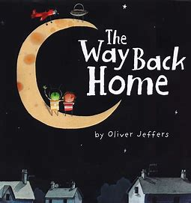 | - Spiritual  - Social | The boy discovers an aeroplane in his cupboard. He flies it to the moon but runs out of petrol and ends up there, alone and afraid. Little does the boy know that a Martian’s spaceship has also fallen into trouble nearby; soon he has a small green companion stranded alongside him to share his fear. The pair work together to escape from the moon and, despite a few mishaps, both eventually head back to their own homes, wondering if they will ever meet again.
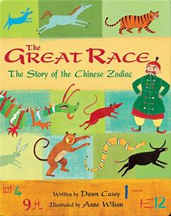 | - Spiritual  - Social  - Cultural  - Moral | Relates how the Jade Emperor chose twelve animals to represent the years in his calendar. Also discusses the Chinese calendar, zodiac, the qualities associated with each animal, and what animal rules the year in which the reader was born.
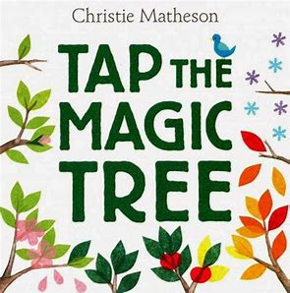 | - Spiritual | Tap the Magic Tree asks you to help one lonely tree change with the seasons. Now that's interactive-and magical! It begins with a bare brown tree. But tap that tree, turn the page, and one bright green leaf has sprouted! Tap again-one, two, three, four-and four more leaves have grown on the next page.
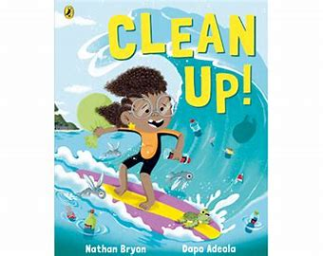 | - Spiritual  - Social  - Cultural  - Moral | When Rocket goes for a holiday to visit her grandparents in Jamaica she's shocked by the pollution that is spoiling their island home and putting the local sea life at risk. Can she think of a way to save the day?  This is a heartwarming, timely and empowering picture book, showing how we ALL can make a difference.
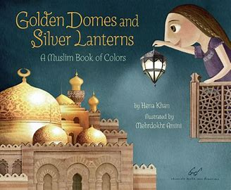 | - Spiritual  - Social  - Cultural  - Mutual respect and tolerance | Magnificently capturing the colourful world of Islam for the youngest readers, this breathtaking and informative picture book celebrates Islam's beauty and traditions. From a red prayer rug to a blue hijab, everyday colours are given special meaning as young readers learn about clothing, food, and other important elements of Islamic culture, with a young Muslim girl as a guide. Sure to inspire questions and observations about world religions and cultures
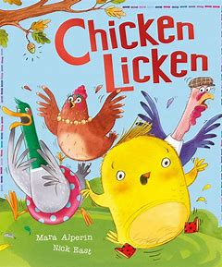 | - Social  - Moral | When an acorn drops on Chicken Licken’s head, he thinks the sky is falling and dashes off to tell the King. But instead he finds Foxy Loxy . . . Is Chicken Licken about to become Chicken Lunch?  It teaches children to approach situations calmly and thoughtfully rather than reacting impulsively to what they hear or see.
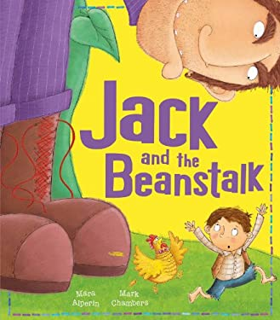 | - Moral  - Spiritual | This story follows young Jack as he trades his cow for magic beans that grow into a Giant beanstalk. Jack encounters a fierce giant and a magical hen that lays golden eggs. Teaching children to be brave and take advantage of opportunities.
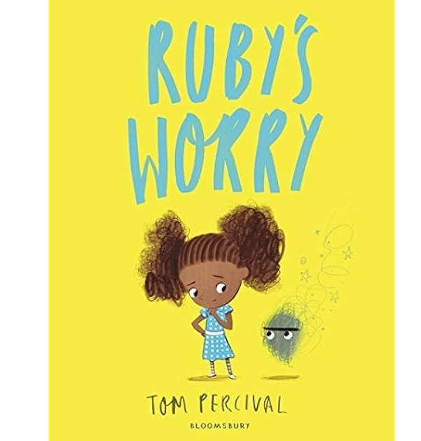 | - Spiritual  - Social | Percival depicts a ‘worry’ with a yellow orb that appears next to Ruby one day and continues to grow when she ignores the shadow-like entity, simply hoping that the worry will disappear of its own accord. When she meets another child with their own ‘worry’ and asks them about their feelings, she realises how to rid herself of worries – she needs to talk about them. This book has sparked meaningful class discussions, supporting pupils to understand that ‘it’s okay to not be okay’.
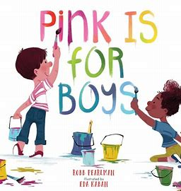 | - Spiritual  - Social  - Cultural  - Moral  - Individual liberty | Pink is for boys... and girls... and everyone! This timely and beautiful picture book rethinks and reframes the stereotypical blue/pink gender binary and empowers kids – and their grown-ups – to express themselves in every colour of the rainbow. Featuring a diverse group of relatable characters, Pink Is for Boys invites and encourages girls and boys to enjoy what they love to do, whether it's racing cars and playing baseball, or loving unicorns and dressing up
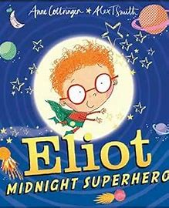 | - Spiritual | By day, Eliot is a quiet boy who likes to read and play with his toys. But when the clock strikes midnight, Eliot is transformed into a superhero! When he’s not showing off his incredible swimming skills or wowing the crowds with his expert lion-taming, you can find him assisting the Queen.  One day Eliot receives an urgent message from the world’s Most Important Scientists: a giant meteor is hurtling towards Earth! Will Eliot be able to rise to the challenge and save the world from destruction in the nick of time.

Year 1
Text | SMSC/ FBV focus | Synopsis
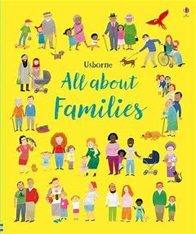 | - Spiritual  - Social  - Cultural  - Mutual respect and tolerance | Families come in all shapes and sizes and from all sorts of backgrounds. They speak various languages, eat different sorts of food, live in different kinds of homes and celebrate special occasions in a variety of ways.  A celebration of family differences, this is a busy book full of all-embracing illustrations of every kind of family imaginable that are fun to look at time and time again. Beyond just giving pleasure, All About Family is also designed to ensure every child feels that their kind of family is just one of many and not anything unusual.
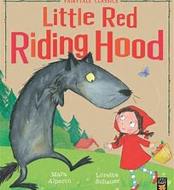 | - Moral  - Spiritual  - Social | When Little Red arrives at Granny's cottage, there's someone BIG, HAIRY and very, very SCARY waiting in Granny's bed...  Will Little Red be breakfast for that big, bad wolf?  The book teaches the moral lesson of the dangers of talking to strangers and the importance of heeding parental advice.
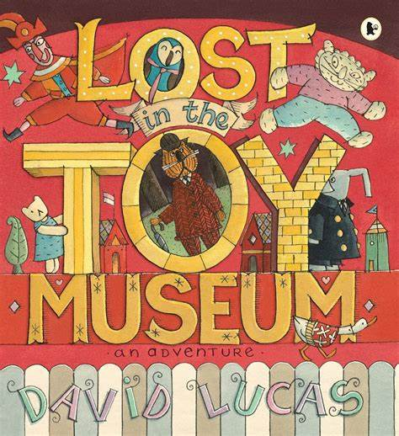 | - Social  - Spiritual | One night, when the lights go out at the toy museum, everyone runs off and hides. Left all on his own, Bunting, the sensible old toy cat, sets out to look for them. As he follows the trail of clues through the museum, the normally reserved Bunting learns how to have fun.
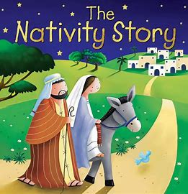 | - Cultural  - Spiritual  - Mutual respect and tolerance | The story follows Mary and Joseph from being told they will have a baby by the angel Gabriel, through to the birth of Jesus and the visits from the shepherds and wise men.
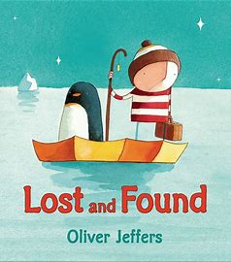 | - Social | A book with themes of loneliness and friendship.  What is a boy to do when a lost penguin shows up at his door? Find out where it comes from, of course, and return it. But the journey to the South Pole is long and difficult in the boy’s rowboat. There are storms to brave and deep, dark nights. To pass the time, the boy tells the penguin stories. Finally, they arrive. Yet instead of being happy, both are sad. That’s when the boy The penguin hadn’t been lost, it had merely been lonely.
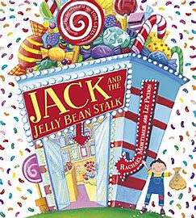 | - Moral  - Spiritual | Fee-Fi-Fo-Fum, I smell ... jelly beans! When Jack sells his cow for jelly beans, his mum is furious. But (of course) these are magic beans and soon Jack is on a big adventure up in the clouds.  Starring a hangry giant, a little white goose and a lifetime's supply of jelly beans!
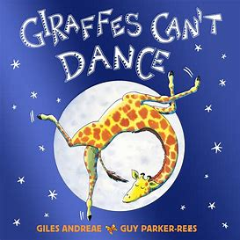 | - Spiritual  - Social  - Moral  - Cultural | Gerald the tall giraffe would love to join in with the other animals at the Jungle Dance, but everyone knows that giraffes can't dance . . . or can they?  A funny, touching and triumphant picture book story about a giraffe who finds his own tune and confidence too.  With themes of friendship and self-belief.
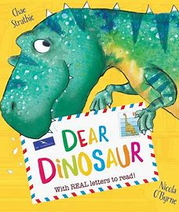 | - Social  - Spiritual | When Max visits the Big Museum, he's disappointed that he has to leave before he can ask all his questions about dinosaurs. However, Dinosaur Dora, the helpful museum curator, suggests that he writes the T-Rex a letter. Who knows, the T-Rex might just write back! So begins a new (and rather unlikely) friendship where Max learns all about dinosaurs, and T-Rex learns quite a lot about being friends with a little boy, too.

Year 2
Text | SMSC/ FBV focus | Synopsis
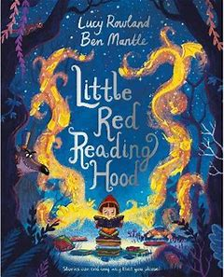 | - Spiritual  - Moral | Little Red Reading Hood LOVES reading books and making up stories of her own. When she meets a cunning wolf while on her way to the library, he convinces her to stray from the path and read for a little while. But hasn’t she read this in a story before? Perhaps it’s time she came up with a new ending . . .  A contemporary and fun take on the classic fairy tale, Little Red Riding Hood. Inspiring the love of books and reading.
 | - Cultural  - Individual liberty  - Mutual respect and tolerance | When Mae Jemison was a little girl, she dreamed of blasting off into space on a rocket ship. She was so excited as she watched the Apollo Moon landings, but she wondered why none of the astronauts were women. This book follows her remarkable achievements.
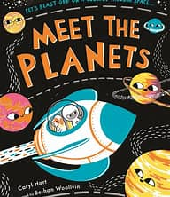 | - Spiritual | Zoooooooom! We're off on an exciting space adventure in our rocket to meet all the planets of the solar system.
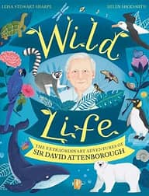 | - Cultural  - Spiritual | Journey through the jungle and coral reefs, across the African plains and icy poles, and even to the Galapagos Islands, as you discover all there is to know about the world's best-known and best-loved naturalist, Sir David Attenborough, in this beautifully illustrated non-fiction picture book. From a childhood spent searching for fossils to his awe-inspiring work as a broadcaster and conservationist, learn about Sir David Attenborough's WILD life, as you experience iconic moments from his documentaries and are inspired by his untiring efforts to protect our planet.
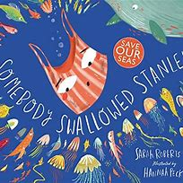 | - Moral  - Spiritual | A powerful story about plastic pollution. Mistaken for a jellyfish, Stanley who has stripes and two handles (and is actually a carrier bag) is the taste of the sea! A humorous but thought-provoking tale about environmental issues.
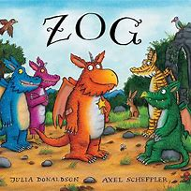 | - Social  - Spiritual | Zog is a keen dragon at Dragon School who aims to be the best in his class and win a golden star. The story follows his attempts at learning to fly, roar and breathe fire, leading to a series of minor injuries for which a mysterious girl provides assorted bandages and plasters. Themes of friendship and ambition.
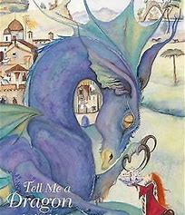 | - Spiritual  - Cultural | Lyrical descriptions imagine each child’s relationship with their own dragon, and the reader is invited to imagine their dragon, too, at the end of the book. Richly and vividly illustrated and with a wealth of detail, this is an imaginative resource for art and language work.
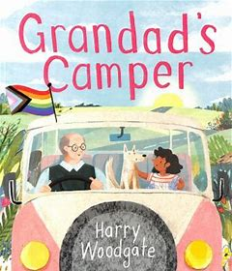 | - Spiritual  - Social  - Cultural  - Mutual respect and tolerance  - Individual liberty | Delightfully colourful and carrying a warm, positive message of inclusion and love, Woodgate's uplifting picture book depicts a grandad recapturing the adventures of his youth courtesy of his granddaughter.
Year 3
Text | SMSC/ FBV focus | Synopsis
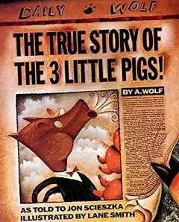 | - Spiritual  - Moral  - Social | A tale of morality and misunderstanding. You may think you know the story of the Three Little Pigs and the Big Bad Wolf - but only one person knows the real story. And that person is A. Wolf. His tale starts with a birthday cake for his dear old granny, a bad head cold and a bad reputation.
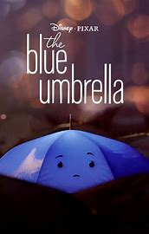 | - Social | It is just another evening commute until the rain starts to fall, and the city comes alive to the sound of dripping rain pipes, whistling awnings and gurgling gutters. And in the midst, two umbrellas — one blue, one not — fall eternally in love
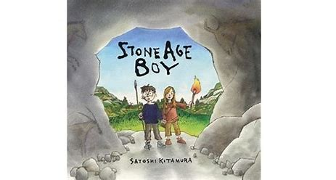 | - Social  - Spiritual  - Cultural | One day a little boy is walking along when he trips, stumbles and falls … into the Stone Age! He meets a girl his own age and her tribe, and learns all about their way of life. He watches them make tools, clothes and weapons. He sees how they hunt, fish, cook, celebrate – and even how they paint on the walls of caves.
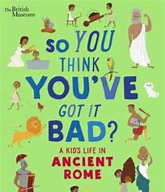 | - Culture | The book compares modern-day life for children to different aspects of daily life for the Ancient Romans, including clothes and hairstyles, education, family life, pets, food and hobbies.
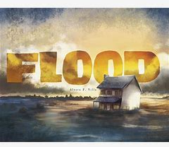 | - Social | Children to learn and explore the emotions surrounding a catastrophic event like a hurricane or flood.
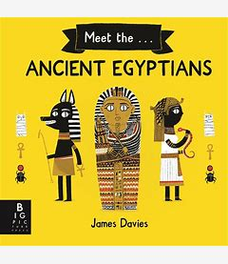 | - Cultural  - Spiritual | Get to know the basics on Ancient Egypt from gods and worship to mummification, with easy-to-digest, humorous text that is reminiscent of the best-selling Horrible Histories series.
 | - Spiritual | A lovely story allowing readers to consider imaginative journeys and also the many landscapes that form our world.

Year 4
Text | SMSC/ FBV focus | Synopsis
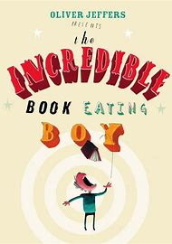 | - Spiritual | Henry discovers his unusual taste by mistake one day, and is soon swept up in his new-found passion. And better still, he realises that the more books he eats, the smarter he gets. But a book-eating diet isn't the healthiest of habits as he finds out
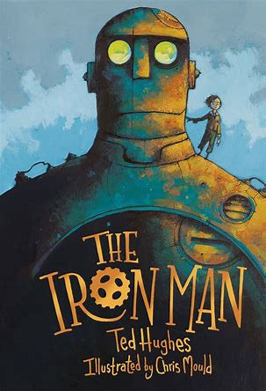 | - Spiritual  - Moral  - Social  - Mutual respect and tolerance | A mysterious and destructive creature called The Iron Man appears on the cliff's edge, leaving humanity frightened and confused. Mankind must stop him, but even their traps can't contain him. When a monstrous threat from outer space looms, it is up to The Iron Man to save the planet.
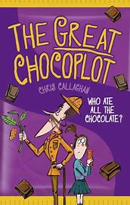 | - Social  - Spiritual | It’s the end of chocolate – forever! At least, until Jelly can solve the mystery of the great chocoplot…Jelly and her family live in Chompton-on-de-Lyte, where everyone loves a Chocablocka bar or two – so when the end of chocolate is announced, she can’t believe it. Determined to investigate, Jelly and her gran follow a trail of clues to a posh chocolate shop and its owner, the pompous Garibaldi Chocolati. Gari’s suspiciously smug, despite his failing business and yucky chocolate.Is it really the chocopocalypse, or is there a chocoplot afoot?
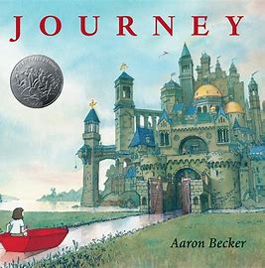 | - Social  - Spiritual  - Individual liberty | A lonely girl draws a magic door on her bedroom wall and through it escapes into a world where wonder, adventure, and danger abound. Red marker in hand, she creates a boat, a balloon, and a flying carpet that carry her on a spectacular journey toward an uncertain destiny. When she is captured by a sinister emperor, only an act of tremendous courage and kindness can set her free. Can it also lead her home and to her heart’s desire?
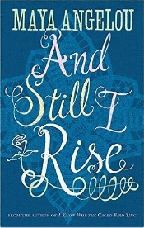 | - Social  - Moral  - Individual liberty | ‘Still I Rise’ is about the power of the human spirit to overcome discrimination and hardship.

Year 5
Text | SMSC/ FBV focus | Synopsis
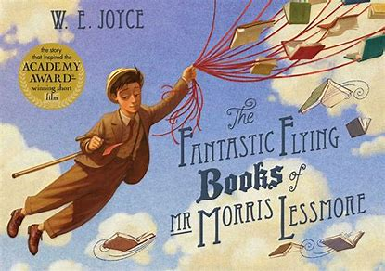 | - Spiritual  - Social | The Fantastic Flying Books of Mr. Morris Lessmore is a poignant, humorous allegory about the curative powers of story. The story follows Morris Lessmore, a man who is blown away by a hurricane and finds himself in a fantasy land along with his books.
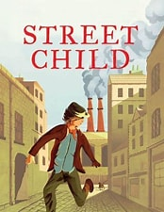 | - Social  - Moral | Street Child is the inspirational tale of a poor Victorian boy fighting for survival on the grim streets of Victorian London.
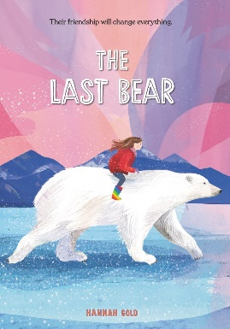 | - Social  - Moral | There are no polar bears left on Bear Island. At least, that’s what April’s father tells her when his scientific research takes them to a faraway Arctic outpost.  But one night, April catches a glimpse of something distinctly bear shaped loping across the horizon. A polar bear who shouldn’t be there—who is hungry, lonely and a long way from home.
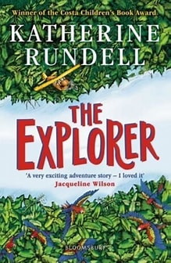 | - Social | Four children stranded in the Amazon jungle must rely on their wits and teamwork to survive and find their way home.
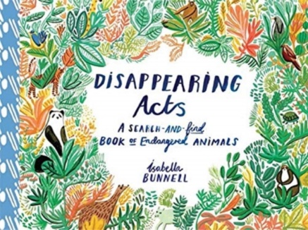 | - Moral | Densely detailed landscapes of a rainforest, coral reef, mountains and skies are harbouring within them numbats, and snow leopards and mountain gorillas. Exploring habitats of endangered animals and engaging children in environmental issues.
Year 6
Text | SMSC/ FBV focus | Synopsis
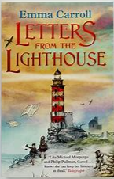 | - Social  - Mutual tolerance and respect | Letters from the Lighthouse is an incredibly empathetic story that not only portrays the hardships of life during the war but also poignantly explores the anguishing encounters of refugees looking for safety in new places while carrying with them the heartbreak of leaving a war-torn home behind.
 | - Individual liberty  - Spiritual  - Social | A young girl called Lila wants to become a firework-maker, like her father Lalchand. Despite her talents, Lalchand believes this is an unsuitable job for girls. Lila disagrees, and journeys to get Royal Sulphur from Razvani the Fire-Fiend at Mount Merapi, as all aspirant firework-makers must do.
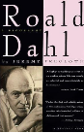 | - Individual liberty  - Mutual tolerance and respect  - Social | Misogynist, anti-Semite, misanthrope--Roald Dahl was reputed to be these as well as war hero, devoted father, and philanthropist. To millions however, he was the Evelyn Waugh of children's books, author of such beloved classics as Charlie and the Chocolate Factory and James and the Giant Peach. Here Treglown crafts a "scrupulously fair-minded portrait" (New York Times Book Review) of a complex man.
 | - Social  - Moral  - Mutual tolerance and respect | s a book by climate activist Greta Thunberg.It consists of a collection of eleven speeches which she has written and presented about global warming and the climate crisis
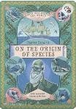 | - Spiritual | Part of the non-fiction series Words that Changed the World, this book is an accessible guide to the theory of evolution, presented in an attractive format with beautiful illustrations throughout.
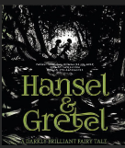 | - Spiritual  - Social | Neil Gaiman has created a chilling and dark retelling of the story of Hansel and Gretel. New details are added to the story, a war has brought hard times on the family, the parents feel that the only choice is to lose the children in the forest. Some things remain the same, the children still find a gingerbread house in the woods and the witch still has plans to eat Hansel.  Lorenzo Mattotti has created dark and mysterious black and white illustrations which perfectly compliment Neil Gaiman's text. The pages of text and picture alternate working together to tell the story.
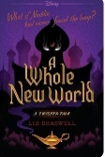 | - Spiritual | When Jafar steals the Genie's lamp, he uses his first two wishes to become sultan and the most powerful sorcerer in the world. Agrabah lives in fear, waiting for his third and final wish. To stop the power-mad ruler, Aladdin and the deposed princess Jasmine must unite the people of Agrabah in rebellion. But soon their fight for freedom threatens to tear the kingdom apart in a costly civil war.  What happens next? A Street Rat becomes a leader. A princess becomes a revolutionary. And readers will never look at the story of Aladdin in the same way again

