Art at Nottingham Academy
Intent statement: | Intent:  At Nottingham Academy we believe that art is a vital part of children’s education, with children having the opportunity to develop a range of skills and knowledge throughout their art journey in school, allowing children to discover a lifelong interest and talent in this area. The art curriculum will develop children’s artistic abilities, as well as an understanding of their own and others’ cultural heritages through the study of a diverse range of artists.  Children will develop their understanding of the visual language of art with effective teaching and considered sequences of lessons and experiences. Understanding of the visual elements of art and design (line, space, texture, colour, value, shape, form) will be developed by providing a curriculum which will enable children to reach their full potential. Strong cross curricular links have been made to ensure children have the opportunity to apply knowledge and deepen understanding through the context of art.
Substantive knowledge in Art: | Substantive Knowledge is the development of the formal elements (line, space, texture, shape, colour, form, value) by introducing and experiencing a wide range of media, using associated key vocabulary and knowing the work and techniques of a wide range of artists, craftspeople and designers. The children will work through a range of disciplines: drawing, painting, printing, texture, collage, 3D work and digital art in order to explore the 7 elements. Substantive knowledge is also the knowledge of known artists, their style and period of art.
Disciplinary knowledge in Art: | Disciplinary knowledge is creatively thinking of possibilities, making comparisons, questioning and critiquing, reaching judgements, addressing challenges and reflecting on the impact of works of Art and Design produced independently, collectively and by others. Presenting outcomes verbally and in written form.
Vocabulary: | The teaching of vocabulary is crucial to academic success for our children. Tier 2 and 3 vocabulary is mapped out throughout our curriculum in order to ensure vocabulary is both progressive and ambitious.

Sequence of Knowledge
EYFS- Nursery
Substantive Knowledge
Throughout Early Years children develop their artistic flare through; working on their own and collaboratively with others, working in 2D and 3D as well as different scales and investigating different kinds of art, craft and design. Art plays a huge part in everyday life and provision in Nursery and Reception and links are made throughout the others areas of development.
Painting:  - Use pre-made paints  - Can name primary colours.  - Mix primary colours  - Explore mixing primary colours to make secondary colours  - Hold paint brush in palm of hand to make marks  - Start to use thinner paint brush to add detail to painting | Drawing:  - Make marks  - Draw circles and lines  - Draw faces with features and give meaning to marks  - Draw ‘potato people’  - Draw things that they observe  - Draw simple things from memory | Collage:  - Use glue sticks to join  - Use glue and spatulas to join items with support  - Explore different materials freely  - Create a model with one texture
Sculpture:  - Builds towers by stacking objects  - Builds walls to create enclosing spaces.  - Build simple models using a variety of resources  - Explores clay/ playdoh using fingers  - Makes marks in clay/ playdoh  - Manipulates clay/playdoh- roll, cut, squah, pinch, twist | Role-play:  - Play with familiar small world equipment like animals, dolls etc  - Use own experiences to develop storyline | Printing:  - Print with large blocks and sponges  - Print using a range of materials
Vocabulary:
Colour names, mix, paint brush, sponge, print, paint, draw, stick, join, roll, squash, twist, shapes, build, stack

Sequence of Knowledge
EYFS- Reception
Substantive Knowledge
Throughout Early Years children develop their artistic flare through; working on their own and collaboratively with others, working in 2D and 3D as well as different scales and investigating different kinds of art, craft and design. Art plays a huge part in everyday life and provision in Nursery and Reception and links are made throughout the others areas of development.
Painting:  - Mix primary colours to make secondary  - Add white or black paint to alter tint or shade  - Colour matching to a specific colour and shade  - Use a thin paint brush to add detail  - Hold a paint brush with a tripod grip | Drawing:  - Draw people with increasing detail e.g limbs and features  - Draw from memory in more detail  - Begin to draw self-portraits landscapes and buildings | Collage:  - Use glue sticks and glue spatula’s independently  - Join items with masking tape  - Join is a variety of ways independently
Sculpture:  - Build simple models in a variety of ways  - Builds models to replicate those in real life  - Make a model using clay/playdoh | Role-play:  - Use experiences and learnt stories to develop storylines in their pretend play  - Invent, adapt and recount narratives and stories with their peers and teachers | Printing:  - Can select from a range of tools to improve painting e.g stampers, rollers  - Create patterns or meaningful pictures when printing
Disciplinary knowledge
Design:
- Draw designs before making models
- Begin to add labels to designs
- Share their creations, explaining the process they have used

Vocabulary:
Colour names, mix, paint brush, thick, thin, sponge, print, paint, draw, stick, join, roll, squash, twist, shapes, build, stack design, model, tools, pattern

Sequence of Knowledge
KS1- Year 1
Substantive Knowledge
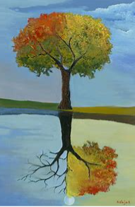  Painting/ drawing/printing linked to seasons  Artist study:  David Najar- focus on 4 seasons  - Learn about the work of different artists | Collage pictures linked to Giraffes can’t dance  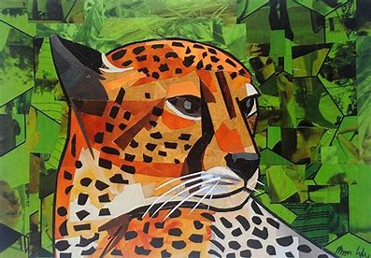  Artist study:  Megan Coyle  - Learn about the work of different artists | 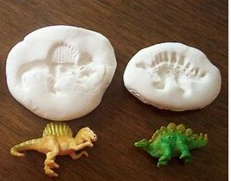  3D Form- create clay fossils  - Linked to history dinosaur topic- how were fossils made?
Formal elements:  Line  Space  texture  Shapes  Colour | Formal elements:  Shapes  Colour  texture | Formal elements:  Form  Shapes
Drawing  - Experiment and use a variety of media: pencils, crayons, pastels, felt tips, chalk, charcoal  - Through observation and imagination, begin to explore the use of line and shape, using different surfaces  Painting  - Use a variety of tools and techniques e.g brush sizes and techniques  - Mix and match colours to artefacts and colours  - Name and mix primary colours, shades and tones  - Create different textures e.g. add sand, soap and use combs, sticks, fingers  Printing:  - Design patterns of increasing complexity and repetition  - Take simple prints e.g. mono printing  - Create simple printing blocks for press print  - Experiment with overprinting | Textiles/ collage  - Create images from imagination, experience and observation  - Choose and use a wide range of media: fabric, tissue.  - Apply decoration: beads, buttons & feathers | 3D form  - Use clay in a variety of ways: rolling, joining, kneading  - Construct and join recycled, natural and man-made materials  - Explore shape and form in sculpture with a range of malleable media
Disciplinary knowledge: A year 1 Artist will….
Exploring and developing ideas
- Record and explore ideas from first hand observations, experience and imagination.
- Ask and answer questions about the starting points for their work, and develop their ideas.
- Explore the differences and similarities within the work of artists, craftspeople and designers in different times and cultures.
Evaluating and developing work
- Review what they and others have done and say what they think and feel about it (e.g. annotate sketchbook).
- Identify what they might change in their current work or develop in their future work.

Vocabulary:
Colour mixing applying collection evaluate observe, proportion landscape, portrait pattern, smudging, colour names, primary colour, secondary colour, seasons, autumnal, line, space, texture, shape, colour, form, shiny, smooth, rough, bumpy, print, indentation, collage,
Prior learning:
EYFS- Malleable materials and use of tools in CP
F2- Collages linked to ‘Clean up text’
F2- Painting and collage of trees in different seasons (linked to text Tap the magic tree)
Cross curricular links and enhancements:
Maths- Shape, pattern
Science- links to seasons
History- how fossils were formed- 3D form using clay

Sequence of Knowledge
KS1- Year 2
Substantive Knowledge
Collage linked to animals habitats  Artist study:  Andy Goldworthy (linked to habitats in science) 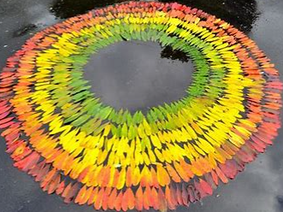 | Painting of sunflowers  Artist study:  Vincent Van Gogh (Sunflowers linked to plants in science)  - Learn about the work of different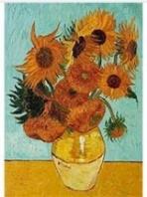 artists | 3D clay sculpture- Dragons eye  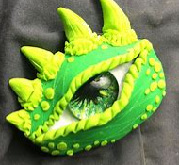  Links to English texts
Formal elements:  Shapes  Colour  Space  Line  Form | Formal elements:  Colour  Texture  Line | Formal elements:  Form  Shapes  Texture
Collage:  - Arrange and/ or glue materials to different backgrounds  - Create images from imagination, experience and observation  - Fold, crumple, tear and overlap materials | Drawing:  - Experiment with the visual elements: line, shape, pattern and colour through observation and the imagination  - Layer different media e.g. crayons, felt-tips, pencils  - Investigate tone by drawing light/dark lines, patterns and shapes  Painting:  - Experiment using a variety of tools and techniques e.g. layering, mixing media  - Work on different scales e.g. large brushes on large paper  - Mix a range of secondary colours, shades and tones | 3D form:  - Use clay in a variety of ways: rolling, joining, kneading  - Construct and join recycled, natural and man-made materials  - Explore shape and form in sculpture with a range of malleable media  Painting:  - Experiment using a variety of tools and techniques e.g. layering, mixing media  - Work on different scales e.g. large brushes on large paper  - Mix a range of secondary colours, shades and tones
Disciplinary knowledge: A year 2 Artist will….
Exploring and developing ideas
- Record and explore ideas from first hand observations, experience and imagination.
- Ask and answer questions about the starting points for their work and the processes they have used. Develop their ideas.
- Explore the differences and similarities within the work of artists, craftspeople and designers in different times and cultures.
Evaluating and developing work
- Review what they and others have done and say what they think and feel about it (e.g. annotate sketchbook).
- Identify what they might change in their current work or develop in their future work.
- Annotate work in sketchbook.
Vocabulary:
Tertiary printing weaving collage materials visual sketching techniques textiles overlapping overlaying charcoal smudging/sketching oil pastels, line, space, texture, shape, colour, form, value, pattern, colour, shape, artist, Van Gogh, sunflower, parts of plant, Olga Gamynina, Andy Goldworthy, mould, knead, join,
Prior learning:
Year 1- Collage pictures relating to Giraffes can’t dance
Year 1- David Najar- focus on 4 seasons (drawing and painting)
Year 1- Use of clay to make dinosaur fossils
Cross curricular links and enhancements:
Maths- Shape properties, pattern
Science- links to animal habitats and part of a plant

Sequence of Knowledge
KS2- Year 3
Substantive Knowledge
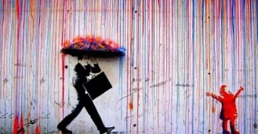  Printing and Painting of rain  Artist: Banksy- Singing in the rain (linked to English the Blue umbrella)  - Learn about the work of different artists | Drawing and Painting of plants  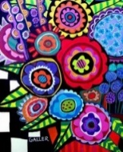  Artist: Heather Galler (vibrant paints of plants linked to science topic)  - Learn about the work of different artists | 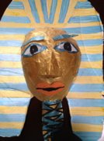  3D form/ painting - creating Egyptian mask  Links to history topic- explore pattern and design
Formal elements:  Colour  Line  Texture  value | Formal elements:  Colour  Shape  Line  Value | Formal elements:  Form  Shape  colour
Printing:  - Create printing blocks using relief or impressed method  - Create repeating patterns Develop print techniques e.g. mono printing, block printing  Painting:  - Develop a painting from a drawing using a variety of sources e.g. poetry, music  - Work in a range of scales e.g. thin brush on small paper Identify primary colours.  - Make secondary colours and understand contrasting colours  - Mix and match colours to create atmosphere and light effects | Drawing:  - Explore the relationship between line and tone, pattern and shape, line and texture  - Select appropriate materials.  Painting:  - Develop a painting from a drawing using a variety of sources e.g. poetry, music  - Work in a range of scales e.g. thin brush on small paper Identify primary colours.  - Make secondary colours and understand contrasting colours  - Mix and match colours to create atmosphere and light effects | 3D form:  - Construct and join recycled, natural and man-made materials  - Use papier-mâché to create simple 3D effects  Painting:  - Develop a painting from a drawing using a variety of sources e.g. poetry, music  - Work in a range of scales e.g. thin brush on small paper Identify primary colours.  - Make secondary colours and understand contrasting colours  Mix and match colours to create atmosphere and light effects
Disciplinary knowledge: A year 3 Artist will….
Exploring and developing ideas
- Select and record from first hand observations, experience and imagination, and explore ideas for different purposes.
- Question and make thoughtful observations about starting points and select ideas to use in their work.
- Explore the roles and purposes of artists, craftspeople and designers working in different times and cultures.
Evaluating and developing work
- Compare ideas, methods and approaches in their own and others’ work and say what they think and feel about them
- Adapt their work according to their views ad describe how they might develop it further
- Annotate in sketch books
Vocabulary:
Observation, imagination, experience, awareness, craftspeople, annotate, dotting, scratching, splashing, sculpture-controlled , print, technique, colour, drip, impression, bold, bright, vibrant, colour names, primary, secondary, contrasting, paper mache, 3D effect,
Prior learning:
Year 2- paintings of sunflowers- Vincent Van Gogh – contrasting to Heather Galler vibrant art
Year 3- Knowledge of the Egyptians to create masks

Cross curricular links and enhancements:
Maths- Shape properties, pattern
Science- links to plants
History- Links to Egyptians- masks English- Links to the Blue Umbrella text

Sequence of Knowledge
KS2- Year 4
Substantive Knowledge
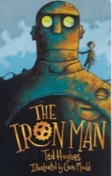  Drawing of an ironman  Artist/ illustrator: Chris Mould  (See tutorials on youtube)  - Learn about the work of different artists | 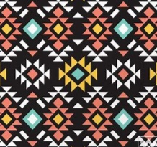  Printing- create a resist print of Aztec pattern | 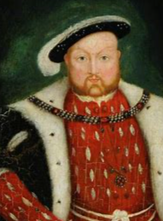  Drawing and Painting- portraits of Britain’s past Monarchs  Artist- Hans Holbein and Nicholas Hilliard Portraits of Henry VIII and Elizabeth I-  - Learn about the work of different artists
Formal elements:  Line  Shape  value | Formal elements:  Line  Shape  Colour  Texture  Form | Formal elements:  Line  Shape  Colour  Texture  Value
Drawing:  - Begin to use simple perspective (single focal point) and begin to develop an awareness of scale e.g. foreground, background  - Explore the relationship between line and tone, pattern and shape, line and texture  - Explore colour mixing and blending techniques with coloured pencils (shading, hatching).  - Select appropriate material | Printing:  - Use techniques including relief, mono, resist, poly-block, rubbings  - Build up layers and overlays using colours and textures.  - Experience marbling and resist printing  - Organise work in terms of pattern | Drawing:  - Explore the relationship between line and tone, pattern and shape, line and texture  - Explore colour mixing and blending techniques with coloured pencils (shading, hatching).  Painting:  - Demonstrate a secure knowledge of primary, secondary, warm and cold, complementary and contrasting colours  - Create imaginative work from a variety of sources  - Develop a painting from drawing by testing media and materials  - Create different effects by using tools and techniques e.g. dots, scratches and dashes
Disciplinary knowledge: A year 4 Artist will….
Exploring and developing ideas
- Select and record from first hand observation, experience and imagination, and explore ideas for different purposes.
- Question and make thoughtful observation about starting points and select ideas to use in their work.
- Explore the roles and purposes of artists, craftspeople and designers working in different times and cultures.
Evaluating and developing work
- Compare ideas, methods and approaches in their own and others’ work and say what they think and feel about them
- Adapt their work according to their views and describe how they might develop it further
- Annotate in sketch books
Vocabulary: Hue stumping commercial equipment reflecting affect surface placement light/dark shadows scale explore unusual line/tone/tint, artist, sketch, shade, line, space, texture, shape, colour, form, value, facial features, paint, skin tones, illustrator, shape properties, layers, rubbings,
Prior learning:
Year 3- Knowledge of printing- Banksy singing in the rain
EYFS/ Year 1 - Self portraits- facial features
Cross curricular links and enhancements:
Maths- Shape properties, pattern, angles
History – Links to British Monarchs, Aztecs English- Illustrator of Ironman book Science – facial features

Sequence of Knowledge
KS2- Year 5
Substantive Knowledge
Painting and Collage- Layered Viking longboat Art  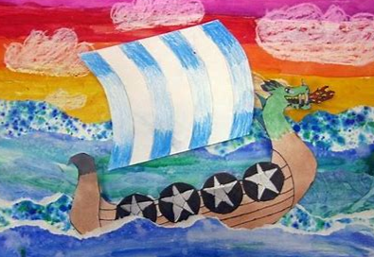 | Drawing/ Painting :  Artist: Henri Rousseu- watercolours  - Learn about the work of different artists  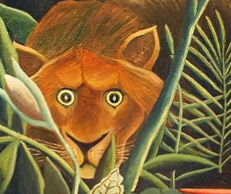 | Drawing/ Printing: British Empire art  Artist: William Morris  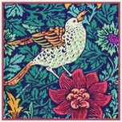
Formal elements:  Line  Shape  Texture  Value | Formal elements:  Line  Shape  Colour  Texture  Form | Formal elements:  Space  Shape  Colour
Painting:  - Experient using shades and tints using black and white.  - Choose appropriate paint, paper and implements to adapt and extend their work.  - Carry out preliminary studies, test media and materials and mix appropriate colours.  - Work from a variety of sources, inc. those researched independently.  Printing:  - Use techniques including: mono, relief, resist, poly-block, rubbings  - Organise work in terms of pattern, repetition, symmetry or random style  - Experiment with overprinting colour  Collage:  - Extend their work within a specific technique.  - Use a range of media to create collage.  - Use fabric/ materials to create 3D structures  - Join materials in different ways  - Experiment overlapping and layering fabric/ materials to create texture  - Add collage to a printed or painted background | Drawing:  - Using dry and wet media, explore the potential of the visual elements: line, shape, pattern, colour and texture  - Through sustained and independent work, develop detailed drawings  - Explore colour mixing and blending techniques with coloured pencils e.g. shading and hatching  Painting:  - Experient using shades and tints using black and white.  - Choose appropriate paint, paper and implements to adapt and extend their work.  - Carry out preliminary studies, test media and materials and mix appropriate colours.  - Work from a variety of sources, inc. those researched independently. | Drawing:  - Using dry and wet media, explore the potential of the visual elements: line, shape, pattern, colour and texture  - Through sustained and independent work, develop detailed drawings  Printing:  - Use techniques including: mono, relief, resist, poly-block, rubbings  - Organise work in terms of pattern, repetition, symmetry or random style  - Experiment with overprinting colour
Disciplinary knowledge: A year 5 Artist will….
Exploring and developing ideas
- Select and record from first hand observation, experience and imagination, and explore ideas for different purposes.
- Question and make thoughtful observations about starting points and select ideas and processes to use in their work.
- Explore the roles and purposes of artists, craftspeople and designers working in different times and cultures.
Evaluating and developing work
- Compare ideas, methods and approaches in their own and others’ work and say what they think and feel about them.
- Adapt their work according to their views and describe how they might develop it further.

Vocabulary:
medium acrylic lighten graphite statues sustained potential complimentary & contrasting colours preliminary poly blocks/relief/mono printing , line, space, texture, shape, colour, form, value, layers, artist, colours, contrasting, blending, pastels, shading, hatching, overlapping, background, foreground, texture vocab
Prior learning:
- Knowledge of artists- Banksy (year 3) Heather Galler (Year 3) Van Gogh( YEAR 2) Chris Mould (illustrator)
- Year 4 – Drawing/ painting of monarchs
Cross curricular links and enhancements:
Maths- Shape properties, pattern, angles
History – The Great British Empire, Vikings

Sequence of Knowledge
KS2- Year 6
Substantive Knowledge
Sculpture/ 3D form - creating wire poppies (links to WW2)  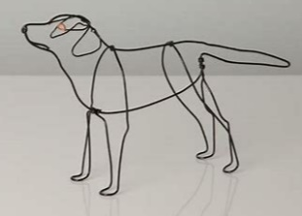  Artist: Bridge Baker  Alexander Calder  Elizabeth Berrien  - Learn about the work of different artists | Drawing and painting- linked to evolution (Links to Science)  Draw and paint animals linked to evolution topic in Science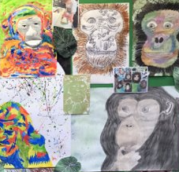 | Painting- Optical illusion art  Artist: Bridget Riley  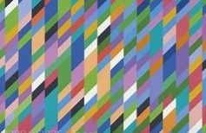  - Learn about the work of different artists
Formal elements:  Line  Shape  space  Form | Formal elements:  Line  Colour  Texture  Shape | Formal elements:  Line  Texture  Shape  Colour  Value
3D form:  - Create and construct sculpture with increasing independence. ​  - Produce patterns within a sculpture​  - Use recycled, natural and manmade materials within sculpture | Drawing:  - Demonstrate a wide variety of ways to make different marks with wet and dry media  - Develop ideas using mixed media Manipulate and experiment with the elements of art: line, shape  - Create shades and tints using black and white  - Develop ideas using different or mixed media, using a sketchbook.  - Identify artists that have worked in a similar way  Painting:  - Create shades and tints using black and white.  - Choose appropriate paint, paper and implements to adapt and extend their work.  - Carry out preliminary studies, test media and materials and mix appropriate colours.  - Work from a variety of sources, inc. those researched independently.  - Show an awareness of how paintings are created  - Develop a painting from a drawing | Drawing:  - Demonstrate a wide variety of ways to make different marks with wet and dry media  - Develop ideas using mixed media Manipulate and experiment with the elements of art: line, shape and value  - Create shades and tints using black and white  - Develop ideas using different or mixed media, using a sketchbook.  - Identify artists that have worked in a similar way  Painting:  - Create shades and tints using black and white.  - Choose appropriate paint, paper and implements to adapt and extend their work.  - Carry out preliminary studies, test media and materials and mix appropriate colours.  - Work from a variety of sources, inc. those researched independently.  - Show an awareness of how paintings are created  - Develop a painting from a drawing
Disciplinary knowledge: A year 6 Artist will….
Exploring and developing ideas
- Select and record from first hand observation, experience and imagination, and explore ideas for different purposes.
- Question and make thoughtful observations about starting points and select ideas and processes to use in their work.
- Explore the roles and purposes of art

Evaluating and developing work
- Compare ideas, methods and approaches in their own and others’ work and say what they think and feel about them.
- Adapt their work according to their views and describe how they might develop it further.
Vocabulary:
Mood/feeling expressive modifying analytical dimensions layering/intersecting manipulate pictorial Parrell one point/perspective definition strategy collaborative , line, space, texture, shape, colour, form, value, shade tint, sketch, shade, hatching, artist, bend, twist, shape, pattern, tessellation of shape
Prior learning:
Year 6- Knowledge of WW2 and significance of poppies
Year 5- drawing and painting linked to rise and fall of British Empire
Cross curricular links and enhancements:
Maths- Shape properties, pattern, angles
History – WW2
Science- application of knowledge of evolution and inheritance

