Nottingham Academy coverage of Art periods and artists
Period of Art |  | Artists studies | Year group | Examples
Prehistoric art |  | Dinosaur fossils  Cave paintings (Drawing) | Year 1  Year 3 | 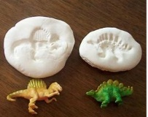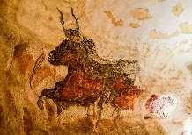
Ancient art |  | Egyptians masks  Aztec (Printing) | Year 3  Year 4 | 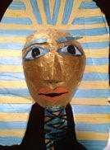
Medieval art |  | The Vikings | Year 5 | 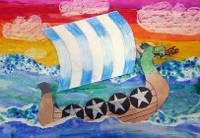
Renaissance art |  | Hans Holbein | Year 4 | 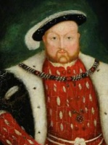
Arts and Craft movement |  | William Morris | Year 5 | 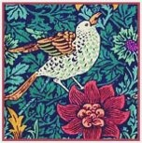
Impressionism/ Post impressionism |  | Vincent Van Gogh  Henri Rousseau | Year 2  Year 5 | 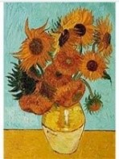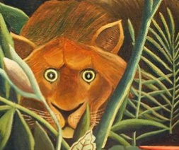
Contemporary Art | Contemporary Expressionism | David Najar | Year 1 | 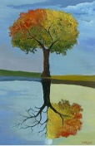
Contemporary Art | Collage art | Megan Coyle | Year 1 | 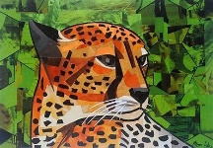
Contemporary Art | Sculpture and photography | Andy Goldsworthy  Bridget Baker  Alexander Calder | Year 2  Year 6 | 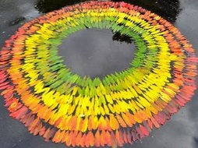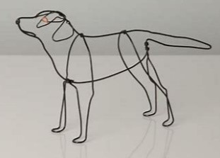
Contemporary Art | Pop art/ Graffiti | Banksy | Year 3 | 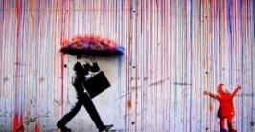
Contemporary Art | Folk art | Heather Galler | Year 3 | 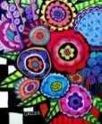
Contemporary Art | Op art | Bridget Riley | Year 6 | 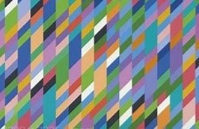
Contemporary Art | Illustrator | Chris Mould | Year 4 | 

