Reading overview 2024-2025 | Autumn |  |  | Spring |  | Summer
Year 1 | Little Wandle validated phonics scheme.  Children are taught to read a range of books within a small group which are closely matched to their phonics ability. The children are exposed to a range of texts, including fiction, non-fiction and poetry which support the development of their early reading skills. The Little Wandle guided reading sessions focus on the skills of decoding, prosody and comprehension. Children re-read the same book throughout the week in order to build up these skills and with repetition of the same text develop fluency in reading.  Class stories are shared at different points of the day.
Year 2    Guided Reading /  Phonics | Little Wandle is our validated phonics scheme which is continued into year 2 for those children who need to revisit phase 2-5. Keep up sessions take place for those children that did not pass their phonics screening.
 | Gorilla- Antony Brown  The storm whale-Benji Davis  Grandma Bird- Benji Davis |  The darkest dark- Chris Hadfield  Lights on cotton rock- David Litchfield  Non- fiction-astronauts- One giant leap |  | Tidy- Emily Gravett  There’s an orangutan in my bedroom- James Sellick  Wild Free- non-fiction | The Baker’s boy- Tom and Tony Bradman  Great Fire of London- Poem by Paul Perro  The Koala who could- Rachel Bright | The dragon machine- Helen Ward  Martha maps it out- Leigh Hodgkinson | Izzi Gizmo- Pip Jones  Bessie Coleman- flying free- Karen Paryn      The Magical yet- Angela DiTerlizzi
Year 2  Class texts   | The boy who grew a dragon- Andy Shephard  Plus, texts reflecting children’s interest, cultural context, and a wide range of authors. |  |  | Charlie changes into a chicken-  Sam Copeland  Plus, texts reflecting children’s interest, cultural context, and a wide range of authors. |  | Joan Proctor-Dragon Doctor  Plus, texts reflecting children’s interest, cultural context, and a wide range of authors.
Year 3  Guided Reading /  Phonics | Little Wandle is our validated phonics scheme which is continued into year 3 for those children who need to revisit phase 2-5.
 | Roald Dahl Revolting rhymes  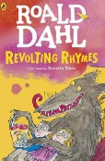 | The First Drawing- Mordicai Gertein  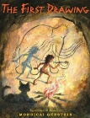 |  | Roman Diary- The Journey of Ilona  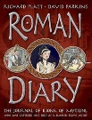 | 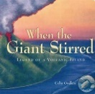  When the giants stirred- Celia Godkin | Egypt Magnified  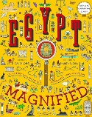  - | 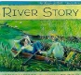  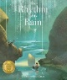  River Story -Meredith Hooper  The Rhythm of the rain- Graheme Baker-Smith
Year 3 | Roald Dahl Revolting rhymes | Terry Deary – Stone Age tales |  | Roman Diary- The Journey of Iliona |  | The day the screens went blank- Danny Wallace | The Wild Robot- Peter Brown
Year 4  Guided Reading /  Phonics | Little Wandle is our validated phonics scheme which is continued into year 4 for those children who need to revisit phase 2-5.
 |   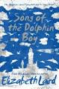  Song of the dolphin boy- Elizabeth Laird | Monster Slayer- Brian Pattern (version of Beowulf)  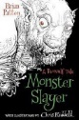 |  | 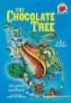  The chocolate tree- traditional  tale | Varjak Paw- S F Said    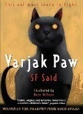 | Twitch M G Leonard      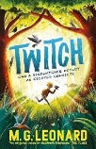 | The legend of Podkin one ear- Kieran Larwood  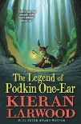
Year 4  Class texts | Planet Omar- Accidental Trouble Magnet  Zanib Main | Operation Gadgetman-  Malorie Blackman |  | The boy at the back of the class-  Onjali.K. Rauf |  | Varjack Paw-  S F Said | The legend of Podkin one ear- Kieran Larwood
Year 5  Guided Reading / Class text | Viking Boy-Tony Bradman  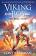  Malamander  Thomas Taylor | The Bright Storm-Vashtii Hardy 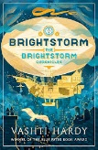 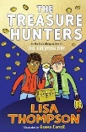  The Treasure hunters- Lisa Thompson |  | Orphans of the tide -Struan Murray  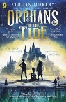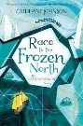  Race to the frozen north  Mathew Henson story Catherine Johnson | The last bear- Hannah Gold  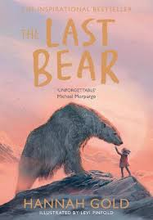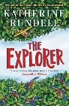  The Explorer  Katherine Rundell | Journey to the river sea- Eva Ibbotson  Can you see me?  Libby Scott  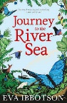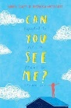 | The 1,000-year-old boy-Ross Welford  Danny Chung does not do maths-  Maisie Chan  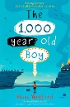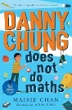
Year 6  Guided Reading / Class text | When the sky falls- Phil Earle  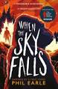 |  |  | The Lion above the door- Onjali.K.Rauf  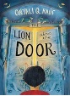 | Granny- Antony Horowitz  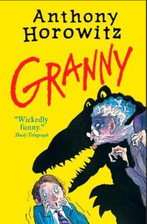 | SATS prep  Nightfall in New York- Katherine Woodfine    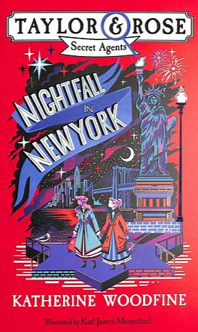 | Wonder – R. J. Palacio  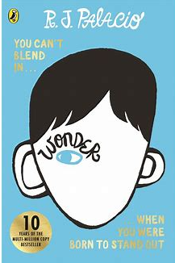
Year 7 | Treasure Island/Faster Reading An exciting coming-ofage adventure novel by Scottish author Robert Louis Stevenson, telling a story of "buccaneers and buried gold". |  | Welcome to Nowhere/Faster Reading A powerful and beautifully written story about the life of one family in wartime by the award-winning author Elizabeth Laird. | Dystopian Fiction Dystopian fiction exploring perspectives on problematic social and political practices. | Poetry from Other Cultures A range of thought provoking poetry from around the world | Modern Media An interesting look at the impact of modern media in the world today. | Our Day Out A play about school trips and education in 1970s England.

