This half term our topic is – Dragons.
English
Writing:
In English we will be writing a narrative based on Zog by Julia Donaldson. We will also be writing descriptive poems about our own dragons.
Reading / phonics:
We will be reading:
The Dragon Machine – Helen Ward.
The Boy Who Grew Dragons – Andy Shepherd.
The Moonshine Dragon - Cornelia Funke.
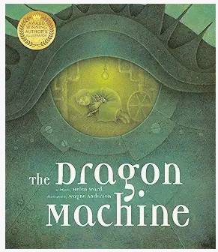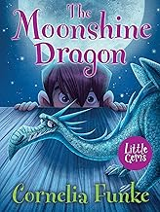
Year 2- Summer 1
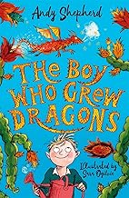
Foundation Subjects:
In Geography we will be learning about our local environment and we will be creating our own map of the school. In Art we will be sculpting a dragon eye using clay. In computing we will be exploring questioning and E-safety. In RE we will be exploring different religious stories and why they are considered important (Christianity and Judaism focus).

Things you could do to support your child’s learning:
Read with your child at least 3 times per week and sign their reading diary.

Encourage them to practice times tables regularly on TTRS and complete the weekly homework.

Talk to them about their learning.
Science
We will be learning about Humans - How to keep our bodies fit and healthy.
We will be learning about the basic needs of all living things (water, food and air).
We will also be describing the importance of exercise, eating the right types of food and what good hygiene means.
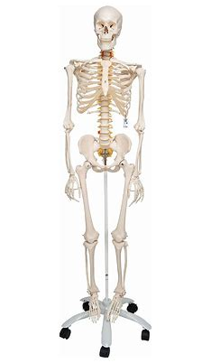

Maths
We will be practicing the 4 operations: + - x ÷.

We will also be learning about fractions (of a length, shape, set of objects and quantity).

We will be learning about statistics (pictograms, tally charts, block diagrams and simple tables).

We will also be continuing to practice the 2, 5 and 10 times tables.

