YEAR 2  2025-26 |  |  | Autumn Term |  |  |  |  |  |  | Spring Term |  |  |  |  |  |  |  | Summer Term
Termly breakdown |  |  | 7 weeks |  | 7 weeks |  |  |  |  | 6 weeks |  |  |  | 5 weeks |  |  |  | 6 weeks |  |  |  | 8 weeks
Theme and text driver |  |  | 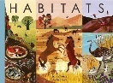  Amazing animals    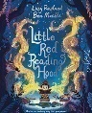 |  |     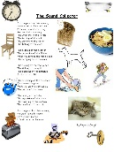    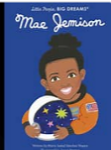  Outer Space |  |  |  |  |   Wonderful World  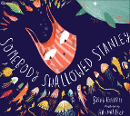 |  |  |  | Fire, Fire  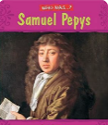  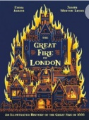 |  |  |  | Dragons    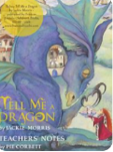  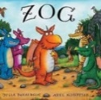 |  |  |  |   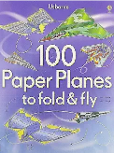  Transport
 |  | Writing genres  GPS  Spelling   | Narrative- Little red Reading Hood | Non Chronological report on whales | Poetry- The sound collector | Biography- Mae Jemison |  | Narrative- Christmas Star |  | Instructions- how to plant a seed | Explanation- How a seed grows | Narrative- Someone swallowed Stanley |  | Report- Great Fire of London |  | Diary - Great Fire of London |  | Narrative- Zog | Description Tell me a dragon |  |  | Narrative- Grandad’s camper |  | Recount- trip to Crich |  | Instructions- How to make a paper plane
 |  | Guided Reading /  Phonics   | Little Wandle is our validated phonics scheme which is continued into year 2 for those children who need to revisit phase 2-5. Keep up sessions take place for those children that did not pass their phonics screening.
 |  |  |   Gorilla- Antony Brown  The storm whale-Benji Davis  Grandma Bird- Benji Davis  Habitats |  | The darkest dark- Chris Hadfield  Lights on cotton rock- David Litchfield  Non- fiction-astronauts- One giant leap |  |  |  |  | Tidy- Emily Gravett  There’s an orangutan in my bedroom- James Sellick  The Koala who could- Rachel Bright  Where on Earth- Australia- non fiction |  |  |  | The Bakers boy- Tom and Tony Bradman  Great Fire of London- Poem by Paul Perro |  |  |  | The dragon machine- Helen Ward  The boy who grew dragons  Zog and the flying doctors |  |  |  | Izzi Gizmo- Pip Jones  Bessie Coleman- flying free- Karen Paryn  The Magical yet- Angela DiTerlizzi
 |  | Class texts   | The boy who grew a dragon- Andy Shephard |  |  |  |  |  |  | Charlie changes into a chicken-  Sam Copeland |  |  |  |  |  |  |  | Joan Proctor-Dragon Doctor
 | Mathematics  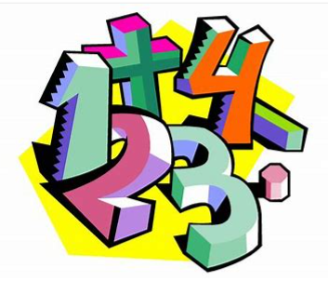  NB- Teachers will adapt to reflect needs of the children |  | Number and place value- 4 weeks | Addition and subtraction- 3 weeks | Addition and subtraction – 3 wks | Money including addition and subtraction – 2wks | Shape- 1 wk |  | Shape/addition/ subtraction- 1wk | Revisit addition and subtraction -1wk | Multiplication and division – 4wks |  | Revisit addition and subtraction -1wk | Revisit 4 operations – 1wk |  | Length and height- 2 weeks | Mass, capacity and temp-2 wks | Revisit 4 operations 1wk | Fractions- 3 wks | Statistics incl 4 op- 2 wks | Fractions- 1wk | Revisit 4 operations-1 wk | Position and direction – 2 wks |  | Time -2 wks |  | Revisit 4 op- 1wk | Fractions- 1wk | Consolidation 1 wk
 | Science   |  | Living things and their habitats  An introduction to types of habitats and animals that live there.  Animals  Lifecycles and offspring of animals, how they grown and change. |  |  |  |  |  |  | Plants  An in depth look at the parts of the plant, what plants need to grow and stages of growth. |  |  |  | Materials  An in depth look at common materials and their properties |  |  |  | Animals  Recap of animals group and classification  Humans  How to keep our bodies fit and healthy.
Non- core subjects | History  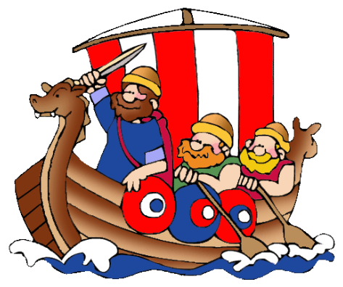 |  |  |  | Neil Armstrong and the first moon landing  (Significant person and event) |  |  |  |  |  |  |  |  | Great Fire of London  (Significant Event) |  |  |  |  |  |  |  | Aviation history- The Wright brothers/ Bessie Coleman  (Significant individual and event)  
Non- core subjects | Geography   |  | Human vs Physical  Exploring and comparing human and physical features in the local area |  |  |  |  |  |  | Comparing Capitals  Comparing Capitals- London VS Sydney |  |  |  |  |  |  |  | Mega Maps  A deeper look at maps and creating maps of the school environment
Non- core subjects | Art   |  | Collage  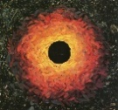  Artist Study: Andy Goldsworthy  (linked to science habitats) |  |  |  |  |  |  | Drawing/ Painting  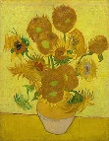  Artist Study: Vincent Van Gogh (Sunflowers) |  |  |  |  |  |  |  | 3D Form-  Clay Dragons Eyes  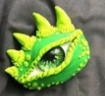
Non- core subjects |  |  | BLACK HISTORY- WHOLE SCHOOL ART WEEK
Non- core subjects | D & T   |  |  |  | Textiles-  Design and make a Christmas decoration |  |  |  |  |  |  |  |  | Construction:  Design and make a Tudor house |  |  |  |  |  |  |  | Mechanisms  Wheels and axles-  Design and make a moving vehicle
Non- core subjects |   Computing (Purple Mash)  Digital literacy  Computer Science  Information technology |  | Unit 2.2 Online safety- lesson 1 |  | Unit 1.8 Spreadsheets  Unit2.3 Spreadsheets |  |  |  |  | Unit 2.2 Online safety- lesson 2 |  |  |  | Unit 2.8 Presenting ideas |  |  |  | Unit 2.2 Online safety- lesson 3 |  |  |  | Unit 2.1 Coding
Non- core subjects |  |  | Unit 1.7 Coding |  |  |  |  |  |  | Unit 2.5 Effective searching |  |  |  |  |  |  |  | Unit 2.4 Questioning
Non- core subjects | Music   |  | KS1 Singing assembly |  | Charanga Unit: Hands, Feet, Heart  Genre: Afro-pop  KS1 Singing assembly |  |  |  |  | KS1 Singing assembly |  |  |  | Charanga Unit: I wanna play in a band  Genre: Rock  KS1 Singing assembly |  |  |  | KS1 Singing assembly |  |  |  | Charanga Unit: Friendship song  Genre: Vocal music  KS1 Singing assembly
Non- core subjects | PE   |  | FMS- Activities to develop throwing & catching  (Primary PE Unit- Ball skills) |  | Team Games  (Primary PE Unit- ball games) |  |  |  |  | Health related exercise  (Primary PE Unit- Fitness) |  |  |  | Multi-skills  (Primary PE Unit-Multi-skills) |  |  |  | Whole school Fitness week  Striking and Fielding skills  (Primary PE Unit-Kwik Cricket) |  |  |  | Athletics  (Primary PE Unit-Athletics)
Non- core subjects |  |  | Team games  (Primary PE Unit- Football Fundamentals) |  | Multi-skills  (Primary PE Unit- Multi-skills) |  |  |  |  | Gym  (Primary PE Unit- Gymnastics) |  |  |  | Dance  (Primary PE Unit- Great Fire of London Dance) |  |  |  | Dance  (Primary PE Unit-Dance) |  |  |  | Net and wall- tennis  (Primary PE Unit-Tennis
Non- core subjects | RE  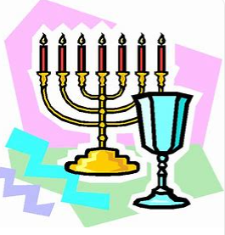 |  | Leaders  What makes some  people inspiring to others? Moses and Saint Peter  (Christians and Jewish people. Non-religious) |  | Believing  What do Jewish people believe about God, creation, humanity, and the natural world? What are some ways Jewish people show how they belong?  (Jewish people) |  |  |  |  | Belonging  What does it mean to belong? What is it like to belong to the Christian religion in Nottingham City and Nottinghamshire today?  (Christians) |  |  |  |  |  |  |  | Story  How and why are some stories important in religions? What can we learn from these stories and from the Torah and the Bible?  (Jewish and Christian)
Non- core subjects | PSHE  & British Values   |  | BM (Being Me In My World)  ‘Who am I and how do I fit?  Rights and Responsibilities |  | CD (Celebrating Difference)  Respect for similarity and difference. Anti-bullying and being unique  Celebrating diversity.   |  |  |  |  | DG (Dreams and Goals)  Aspirations, how to achieve goals and understanding the emotions that go with this |  |  |  |  | HM (Healthy Me)  Being and keeping safe and healthy |  |  | RL (Relationships)  Building positive, healthy relationships |  |  |  | CM (Changing Me)  Coping positively with change
Non- core subjects | Curriculum Enrichment opportunities   |  | Animals visit  Library visit  Kate Fear – Trinity Church |  |  |  |  |  |  | Colwick Woods  Library visit |  |  |  | Fire Station visit  Kate Fear- Trinity Church    Stephen Lawrence day  Eid day |  |  |  | Visit to Synagogue/  Visit from Rabbi  Mental Health awareness day |  |  |  |   Charity Day  Culture day  Crich tramway village
 | Parental involvement   |  | Little Wandle parent workshops  Parents evening  Black history month- whole school art |  | Black history art showcase  Christmas performance |  |  |  |  |  |  |  |  | Parents evening  Curriculum showcase event |  |  |  | Whole school fitness week |  |  |  | TTRS day  Culture day

