YEAR 4  2025-26 |  |  | Autumn Term |  |  |  | Spring Term |  |  |  |  |  |  | Summer Term
Termly breakdown |  |  | 7 weeks |  | 7 weeks |  | 6 weeks |  |  |  |  | 5 weeks |  | 6 weeks |  |  |  |  | 8 weeks
Topic Driver and theme title |  |  | Brilliant books |  | Marvellous Metal |  | Mayan and Aztecs |  |  |  |  | Animals and us |  | Creative concoctions |  |  |  |  | The power of me
 | English | Theme and text driver |   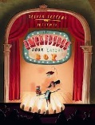 |  |       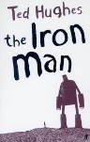 |  | 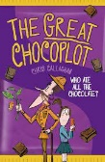 |  |  |  |  |   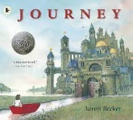 |  | 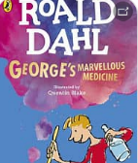 |  |  |  |  | 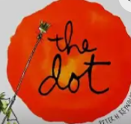
 | English | Writing genres  GPS  Spelling   | Narrative – the incredible book eating boy | Letter-  From perspective of doctor | Narrative- The Iron man | Diary- related to Ironman | Letter-The great chocoplot | Chronological report- from bean to bar |  |  |  | Narrative-The journey | Review of Wollaton | Poetry | Georges Marvellous medicine-  Recipe and report | Recipe- instructions on how to make a healthy food (smoothie?) |  | Persuasion advert  smoothie | Fact file- The digestive system |  |  | Narrative/poetry  The Dot
 | English | Guided Reading /  Phonics   | 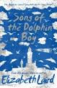  Song of the dolphin boy- Elizabeth Laird |  | Monster Slayer- Brian Pattern (version of Beowulf)  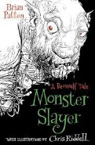 |  | 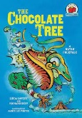  The chocolate tree- traditional    tale |  |  |  |  | 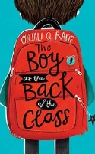  The Boy at the back of the class |  |  |  |  |  |  | The legend of Podkin one ear- Kieran Larwood  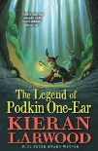
 | English | Class texts   | Planet Omar- Accidental Trouble Magnet  - Zanib Main |  | Song of the dolphin boy-  Elizabeth Laird |  | The boy at the back of the class-Onjali.K. Rauf |  |  |  |  |  |  |  |  |  |  |  | Podkin- 1 ear
 | Mathematics  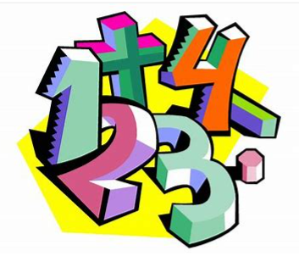 |  | Place value- 4 weeks | Addition and subtraction – 3 weeks | Revisit addition and subtraction – 1 week | Multiplication and division – 6 weeks | Revisit addition and subtraction- 1wk | Revisit multiplication and division – 1 week | + & - with length and perimeter -2 weeks | Area including multiplication – 1 wk | Revisit 4 operations – 1 wk | Fractions- 4 weeks | Decimals- 1 week | Revisit 4 operations – 1 week | Decimals 3wks | 4 operations- involving money – 1 week | Time- 1 week |  |  | Revisit 4 operations – 1 week | Statistics with 4 ops- 1 |  | Shape/ position/ direction – 3 wks | Revisit fractions- 1 wk | 4 operations and consolidation 2wk
 | Science   |  | State of matter  Exploring the 3 states, their properties and how they can change. |  | Electricity  Electrical appliances around us, insulators and conductors. How to make a simple circuit. |  | Sound  How sound and made and how it travels |  |  |  |  | Living things and their habitats  How habitats can change or be destroyed- the impact on animals.  Classifying animals according to their characteristics. |  | Living things and their habitats  A continuation from last term  Animals, including humans  The digestive system, a close look at our mouth and teeth. Carnivores, herbivores and the food chain.
Non- core subjects | History  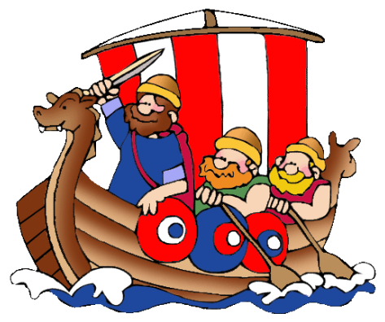 |  |  |  | Britain’s settlement by Anglo-Saxons |  | Civilization: Mayan and Aztecs |  |  |  |  |  |  |  |  |  |  |  |   The changing power of monarchs using case studies
Non- core subjects | Geography   |  | Whacky Weather  Exploring water cycle and thunderstorms |  |  |  |  |  |  |  |  | UK vs Spain  Cities of the UK, Countries, continents  Comparing and contrasting Nottingham and region of Spain |  | UK vs South America  Comparing and contrasting types of settlements
Non- core subjects | Art   |  | Black History month- whole school art week |  | Drawing:  Artist: illustrator Chris Mould  Chalk and charcoal sketch of the ironman  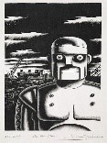 |  |  |  |  |  |  | Printing:  Create a resist print of an Aztec pattern.  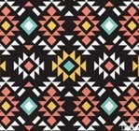 |  |  |  |  |  |  | Drawing/ Paintings  Artist study: Hans Holbein  British Monarchs from the past.  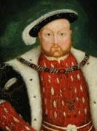
Non- core subjects | D & T   |  |  |  | Construction/ electrical systems:  Design and make a replica of the Iron man |  | Food and Nutrition:  Design and make Mayan corn tortillas |  |  |  |  |  |  | Construction:  Design and make an interactive model to show how the digestive system works.
Non- core subjects | Computing   |  | Unit 4.2 lesson 1 |  | Unit 4.2 lesson 2 |  | Unit 4.2 lesson 3 |  |  |  |  | Unit 4.6 Animation  Unit 4.7 Effective searching |  | Unit 4.2 lesson 4 |  |  |  |  | Unit 4.11  Micro-bit
Non- core subjects |  |  | Unit 4.1 Coding  Use Y4 Coding Crash Course |  | Unit 4.3 Spreadsheets  Use Unit 4.3 Spreadsheets Crash Course |  | Unit 4.5 Logo |  |  |  |  |  |  | Unit 4.9 Making Music |  |  |  |  | Unit 4.4 Writing for different audiences
Non- core subjects | Music   |  |  |  | Charanga Unit: Mamma Mia  Genre: Pop |  |  |  |  |  |  | Charanga Unit: Glockenspiel Performance- unit 2  Genre: Percussion |  |  |  |  |  |  | Charanga Unit: Stop!  Genre: Grime  Charanga Unit: Lean on me  Genre: Soul/Gospel
Non- core subjects | PE   |  | Dodgeball  (Primary PE Unit-Dodgeball) |  | Invasion games – handball  (Primary PE Unit-Handball) |  | Net and wall- Badminton  (Power of PE) |  |  |  |  | Net and wall- Netball  (Primary PE- netball) |  | Whole School Fitness week  Striking and fielding- rounders  (Primary PE Unit- rounders) |  |  |  |  | Outdoor adventure  (Primary PE Unit-Outdoor adventure)
Non- core subjects |  |  | Yoga  (Primary PE Unit-Yoga) |  | Dance  (Primary PE Unit-Dance) |  | Dance  (Primary PE Unit-Eco Warrior Dance) |  |  |  |  | Gym  (Primary PE Unit-Gymnastics) |  | Athletics  (Primary PE unit- Indoor athletics |  |  |  |  | Tennis  (Primary PE Unit-Tennis)
 |  |  |  |  |  |  |  |  |  |  |  | Swimming
Non- core subjects | RE  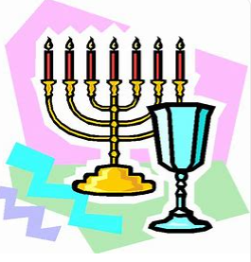 |  | Religion, family,  community,  worship,  celebration,  ways of living  How do Hindu  families practise faith? What are the deeper meanings of some Hindu festivals?  (Hinduism) |  | Spiritual expression  Christianity, music and worship: what can we learn?  (Christianity and also the idea of being ‘spiritual but non-religious) |  | Symbols and religious expression  How do people express their religious and spiritual ideas on pilgrimages?  (Islam, Hinduism, Christianity, non-religious worldviews) |  |  |  |  |  |  | The journey of life and death  Why do some people think life is like a journey? Where do we go? What do different people think about life after death?  (Christianity, Hinduism, Islam, Non-religious worldviews such as Humanism can also be considered)
Non- core subjects | MFL  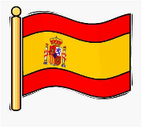 |  | Revisit:  Me presento: about me |  | Incidental recap |  | Revisit:  Las Estaciones – The seasons(EL) |  |  |  |  | Incidental recap |  | Revisit:  Animals |  |  |  |  | Incidental recap
Non- core subjects |  |  | New learning:  Animals (EL) |  |  |  | New learning:  Fruit and veg (EL) |  |  |  |  |  |  | New learning: Weather and date (IN)
Non- core subjects | PSHE  & British Values  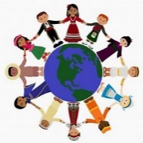 |  | BM (Being Me in My World)  'Who am I and how do I fit?'  Democracy   |  | CD (Celebrating Difference)  Respect for similarity and difference. Anti-bullying and being unique  Accepting self and others. |  | DG (Dreams and Goals)  Aspirations, how to achieve goals and understanding the emotions that go with this  Hopes and dreams |  |  |  |  | HM (Healthy Me)  Being and keeping safe and healthy  Inner strength |  | RL (Relationships)  Building positive, healthy relationships  Changes – grief and memories. |  |  |  |  | CM (Changing Me)  Coping positively with change  Changing Me
Non- core subjects | Curriculum Enrichment opportunities   |  | Visit to Hindu temple  Black history- whole school art week |  | Visit from UON lecturer for robot workshop morning |  | Maya experience day  Food tech lab  Year 4 whole school virtual concert with the music service  Y4- Great Orchestra Experiment live concert |  |  |  |  | Performance-Linked to Mayans & Aztecs  Visit –Wollaton Hall (Science focused)  Eid day |  | Fitness week- whole school |  |  |  |  | Big band concert    Charity day  Culture day
 | Parental involvement   |  | Parents evening |  | Whole school black history art showcase  Ironman showcase event |  |  |  |  |  |  | Mayan AND Aztecs performance  Parents evening |  |  |  |  |  |  | Culture day  Summer Fayre

