YEAR 5  2025-26 |  |  | Autumn Term |  |  |  |  |  | Spring Term |  |  |  |  |  |  | Summer Term
Termly breakdown |  |  | 7 weeks |  |  |  | 7 weeks |  | 6 weeks |  |  | 5 weeks |  |  |  | 6 weeks |  |  |  |  | 8 weeks
Topic Driver and text stimulus |  |  |   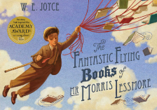  Changing form |  |  |  |   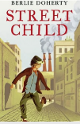  Victorians   |  | Calling Earth  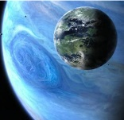 |  |  |   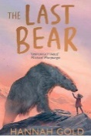  Pole to Pole |  |  |  | Under the canopy  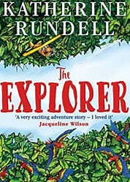 |  |  |  |  | Disappearing animals  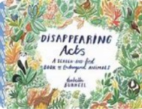
 | English | Writing genres  GPS  Spelling   | Narrative- Fantastic Flying books of Mr Morris Lessmore | Poetry – The Malfeasance |  |  | Narrative- Street Child | Diary of a street child | Narrative- Pandora | Persuasive advert – Visit Pandora |  | Non Chronological Report- The Emperor Penguin | Persuasive letter- global warming |  |  | Narrative-Explorer | Instructions – mini write  Letter |  | Message in a bottle letter- mini write |  | Review of Twycross Zoo- linked to trip |  | Fact file- endangered animals
 | English |   Guided Reading/ Class text | Viking Boy-Tony Bradman  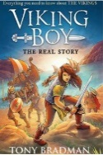 |  |  |  | Street Child – Berlie Doherty |  | Race to the frozen North  -Mathew Henson story    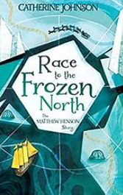 |  |  | The last bear- Hannah Gold |  |  |  | The Explorer  Katherine Rundell |  |  |  |  | Orphans of the tide- Struan Murray  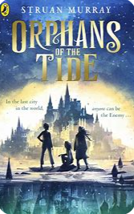
 | Mathematics  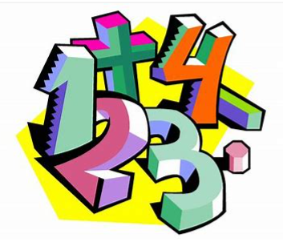 |  | Number and place value- with neg numbers- 2 wks | Addition and subtraction – 2 wks | Multiplication and division – 2 wks | Review – 1 week | Revisit 4 operations- 1 week | Fractions- 6 weeks | Revisit 4 operations – 1 week | Fractions, decimals and percentages- 4 weeks | Revisit 4 operations | Perimeter and area- with 4 operations – 1 week | Perimeter, Area and volume- with 4 operations – 1 week | Statistics with 4 op- 2 weeks | Revisit 4 operations 1wk | Revisit 4 operations- 1 wk | Properties of shape- 2 wks | Position and direction- 2 wks |  | Revisit fractions, decimals and percentages- 1 week | Revisiting 4 operations- 1 wk | Revisit fractions, decimals and percentages – 1 wk |  | Decimals – 2 wks | Converting units- 2 weeks | Revisit 4 operations – 1 wk | Revisit fractions, dec, perc- 1wk
 | Science   |  | Properties and changing materials Properties of magnets and how they are used around us. Exploring thermal insulation. Filtration and evaporation experiments. |  |  |  | Forces  In depth look at friction and gravity. What happens when forces are balanced or unbalanced. |  | Earth and Space  Planets in our solar system. How the Earth rotates and orbits. The phases of the moon. |  |  |  |  |  |  | Living things and their habitats  Reproduction in plants and animals |  |  |  |  | Animals including humans  Puberty, gestation periods, the human lifecycle, animal life cycles.
Living things and their habitats
Reproduction in plants and animals
Non- core subjects | History  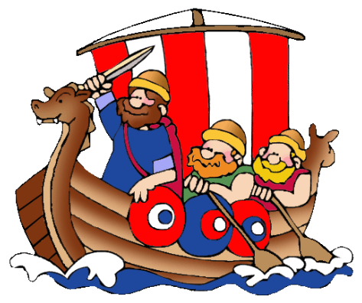 |  |   The Vikings |  |  |  |     The Victorians |  |  |  |  |  |  |  |  |  |  |  |  |  | The Rise and fall of the British Empire
Non- core subjects | Geography   |  |  |  |  |  |  |  | Location, location, location  Explore the importance and location of rivers, as well as land use. |  |  | Brilliant Biomes  Biomes and the impact humans have on the environment |  |  |  | UK vs South America  Similarities and differences between region in UK and region in South America
Non- core subjects | Art   |  | Collage  Layered Viking longboat art  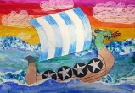 |  |  |  |  |  |  |  |  | Drawing/ Painting - watercolours  Artist study: Henri Rousseu  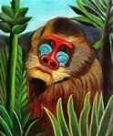 |  |  |  |  |  |  |  |  | Drawing and printing:  Artist Study: William Morris  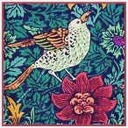
Non- core subjects |  |  | BLACK HISTORY- WHOLE SCHOOL ART WEEK
Non- core subjects | D & T   |  |  |  |  |  | Textiles:  Design and make Christmas stockings- focus on sewing |  | Construction/ Mechanisms:  Design and make a  Mars Rover including a working pulley to collect rock samples |  |  |  |  |  |  | Construction/ Mechanisms:  Design and make a model rainforest with a CAM mechanism
Non- core subjects |   Computing (Purple Mash)  Digital literacy  Computer Science  Information technology |  | Unit 5.2 Online Safety lesson 1 |  |  |  | Unit 5.2 Online Safety lesson 2 |  | Unit 5.2 Online Safety lesson 3 |  |  | Unit 5.5 Game creator |  |  |  | Unit 5.2 Online Safety lesson 4 |  |  |  |  | Unit 5.9 External devices
Non- core subjects |  |  | Unit 5.1 Coding  Use Y5 Coding Crash Course |  |  |  | Unit 5.8 Word Processing |  | Unit 5.3 Spreadsheet  Use Unit 5.3 Spreadsheets Crash Course |  |  |  |  |  |  | Unit 5.4 Databases
Non- core subjects | Music   |  |  |  |  |  | Charanga Unit: Livin’ on a prayer  Genre: Rock  Charanga Unit: Classroom Jazz – unit 1  Genre: Jazz |  |  |  |  | Charanga Unit: Make you feel my love  Genre: Pop ballad |  |  |  |  |  |  |  |  | Charanga Unit: The Fresh Prince of Bel-Air  Genre: Hip-Hop/Rap
Non- core subjects | PE   |  | Dance  (Primary PE Unit-Dance) |  |  |  | Invasion game- Football  (Primary PE Unit-Football) |  | Invasion game- basketball  (Primary PE Unit-Basketball |  |  | Net and wall- badminton  (Power of PE) |  |  |  | Swimming  (Primary PE Unit-Swimming) |  |  |  |  | Swimming
Striking and fielding
Cricket
(Primary PE Unit-Cricket)
Non- core subjects |  |  | Developing less traditional activities: Leadership and Team building  (Primary PE Unit-Leadership) |  |  |  | Yoga  (Primary PE Unit-Yoga time) |  | Outdoor Adventure  (Primary PE Unit-Outdoor Adventure) |  |  | Gym  (Primary PE Unit-Gymnastics |  |  |  | Whole school fitness week  Netball  (Primary PE Unit-Netball) |  |  |  |  | Athletics  (Primary PE unit- indoor athletics)
Non- core subjects | RE  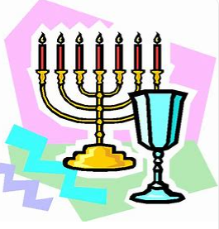 |  | Inspirational people in today’s world  What can we learn from great leaders and inspiring examples in today’s world?  Aut 1- Local focus- William Booth of Sneinton (Founder of the Salvation army)  Aut 2- Pandurang Shastri Athavale or Swami Vivekananda (Hindu leaders) |  |  |  |  |  | Religion and the individual: What matters to Christians?  What is expected of a person in following a religion or belief? What matters most to Christians I their religion?  (Christianity) |  |  |  |  |  |  | Beliefs and questions  How do people’s beliefs about God, the world and others have impact on their lives? |  |  |  |  | Beliefs in action in the world  How are religious and spiritual thoughts and beliefs expressed in arts and architecture and in charity and generosity?
Non- core subjects | MFL   |  | Revisit: Seasons (KS2 IN) |  |  |  | Incidental  recapping |  | Revisit:  I am learning Spanish (KS2- EL) |  |  | Incidental recapping |  |  |  | Revisit: My family (KS2- IN) |  |  |  |  | Incidental recapping
Non- core subjects |  |  | New learning:  Phonics and Pronunciation (KS2 EL & IN)  Classroom instructions (KS2 Extras- core vocab)  Days of the week (KS2 Extras- core vocab)
 |  |  |  |  |  |  |  |  |  |  |  |  |  |  |  | New learning: In the cafe (KS2 IN)
 |  |  |  |  |  |  |  |  | New learning: Traditions and celebrations (KS2 IN)
Non- core subjects | PSHE  & British Values  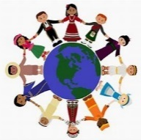 |  | BM (Being Me in My World)  'Who am I and how do I fit?'  Using my voice for good.   |  |  |  | CD (Celebrating Difference)  Respect for similarity and difference. Anti-bullying and being unique  Other cultures – what can I learn? |  | DG (Dreams and Goals)  Aspirations, how to achieve goals and understanding the emotions that go with this  Future dreams, what is out there for me?   |  |  | HM (Healthy Me)  Being and keeping safe and healthy  Looking after my body and mind. |  |  |  | RL (Relationships)  Building positive, healthy relationships  Different types of friendships.   |  |  |  |  | CM (Changing Me)  Coping positively with change  Coping with change, including puberty.
Non- core subjects | Curriculum Enrichment opportunities   |  | Visit to William Booth Birthplace museum  2 day music camp  Whole school Black History Art week |  |  |  | Christmas concert with music service |  | Kate Fear- Trinity Church |  |  | Trip to the Space centre  Spring concert with music service for Y5 and Y6 musicians  Eid day  Stephen Lawrence day |  |  |  | INTU University PP- What is a University? (workshop)  INTU university PP-  Animals including humans workshop  Trip to Twycross zoo |  |  |  |  | End of year production  Trip to Cambridge University- aspirations and music  Big band concert  Charity day  Whole school culture day
 | Parental involvement   |  | Parents evening |  |  |  | Black history art showcase  Christmas music concert |  | Curriculum showcase event |  |  | Spring Music concert-  Parents evening |  |  |  |  |  |  |  |  | Big band concert

