Nottingham Academy Primary
Safeguarding Team
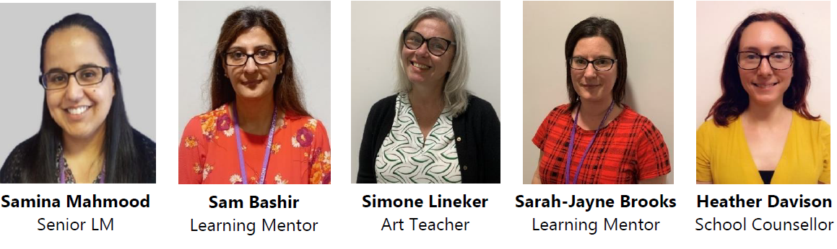
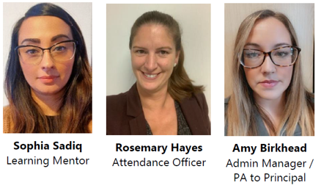

Designated Safeguarding Leads
Nicola Atherley
Safeguarding Lead
07795812770

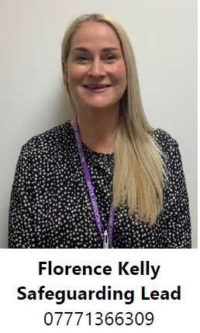

Florence Kelly
DSSL
Andrew Staszkiewicz
Principal / DSL

