We are looking forward to welcoming the children back and are excited to start our “Poles to Poles” topic.
English
Writing:
We will be writing about fireworks. We will then move on to the story “Lost in the Toy Museum.” Finally to finish off we will be writing about the Nativity story.
When writing we are always working towards using capital letters, finger spaces and full stops in our sentences.
Reading / phonics:
We will be reading:

Phase 5 Phonics sounds we will be learning – ai, ee, igh, oa, oo, oo, ar, or, ur, er, ow, oi, ear, air
Tricky words- was, they, some, come, were, there, sure, pure.
Spring One - Year 1
Foundation Subjects:
In History we are looking at old and new toys and talking about their differences. In Art we will be looking at David Najar the artist and his style of painting nature through his imagination. In RE we will look at Christianity and how they pass on messages through stories.

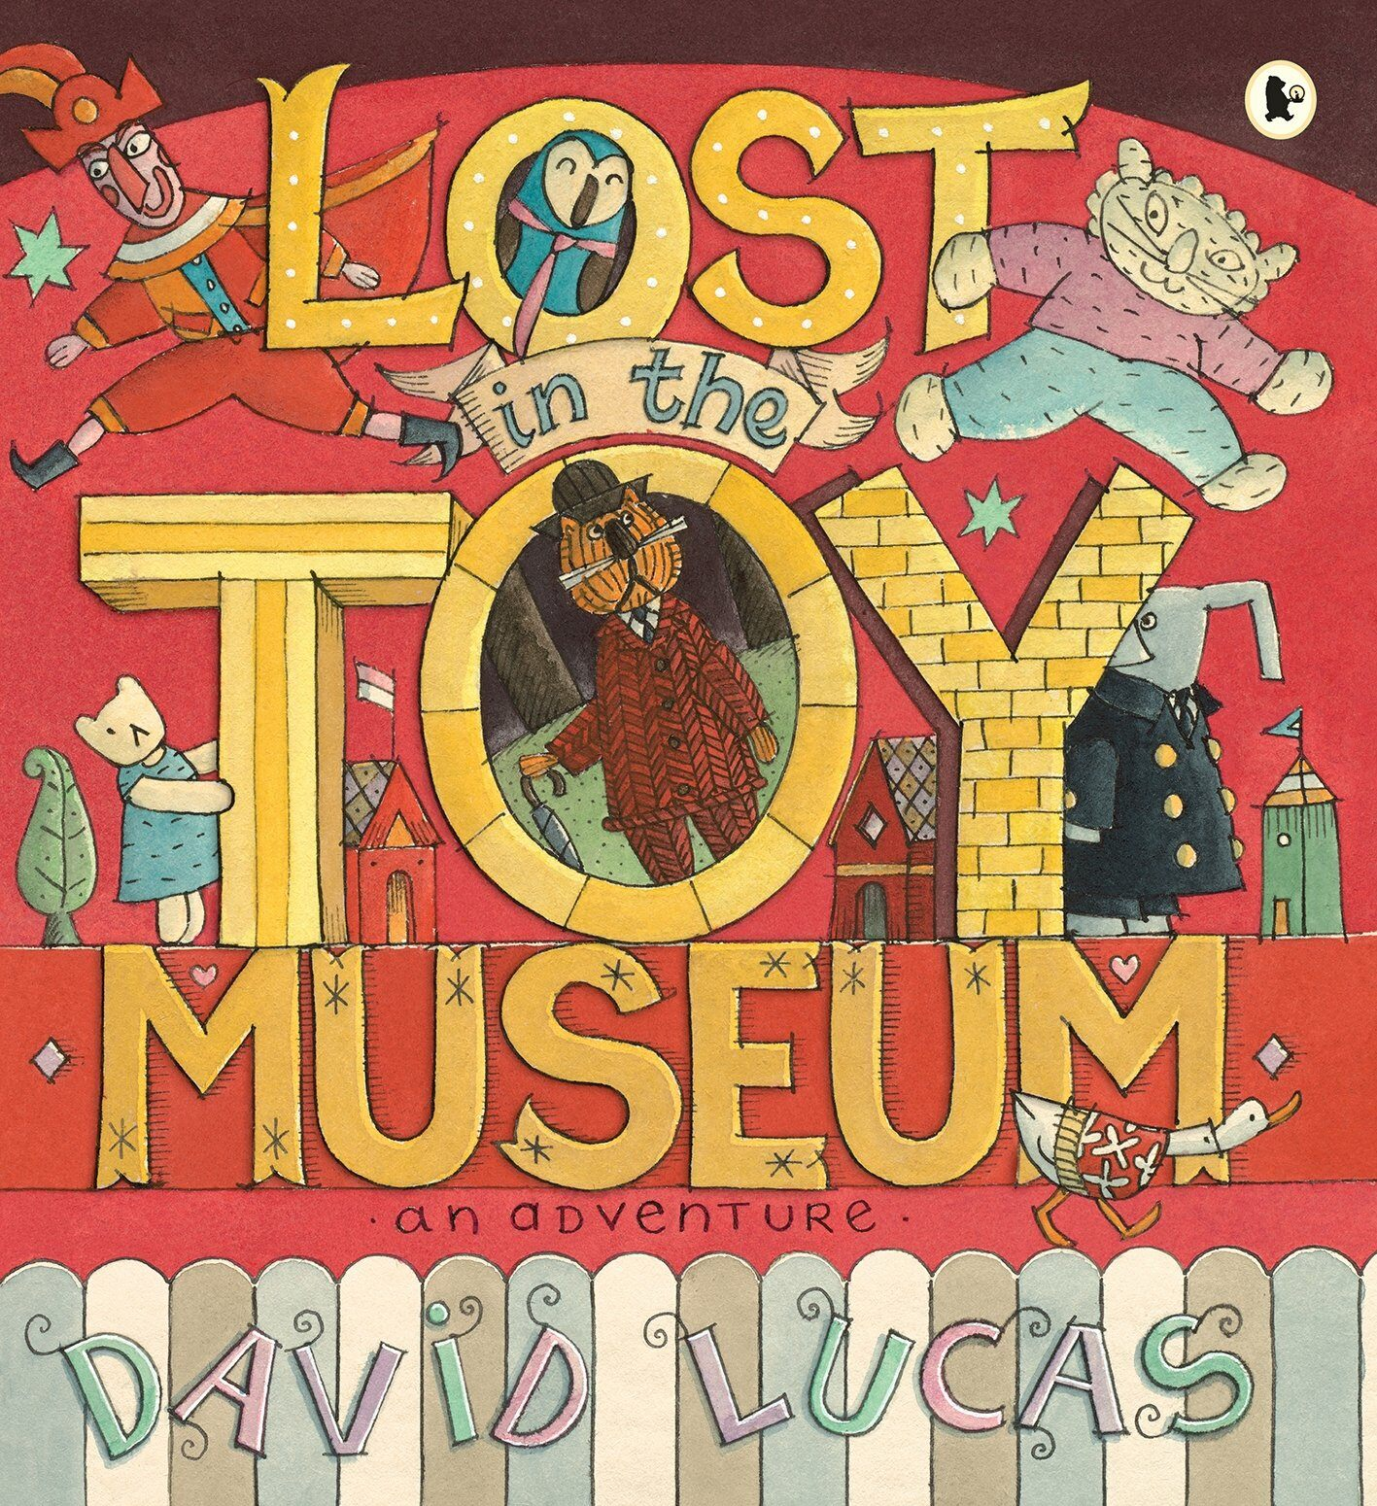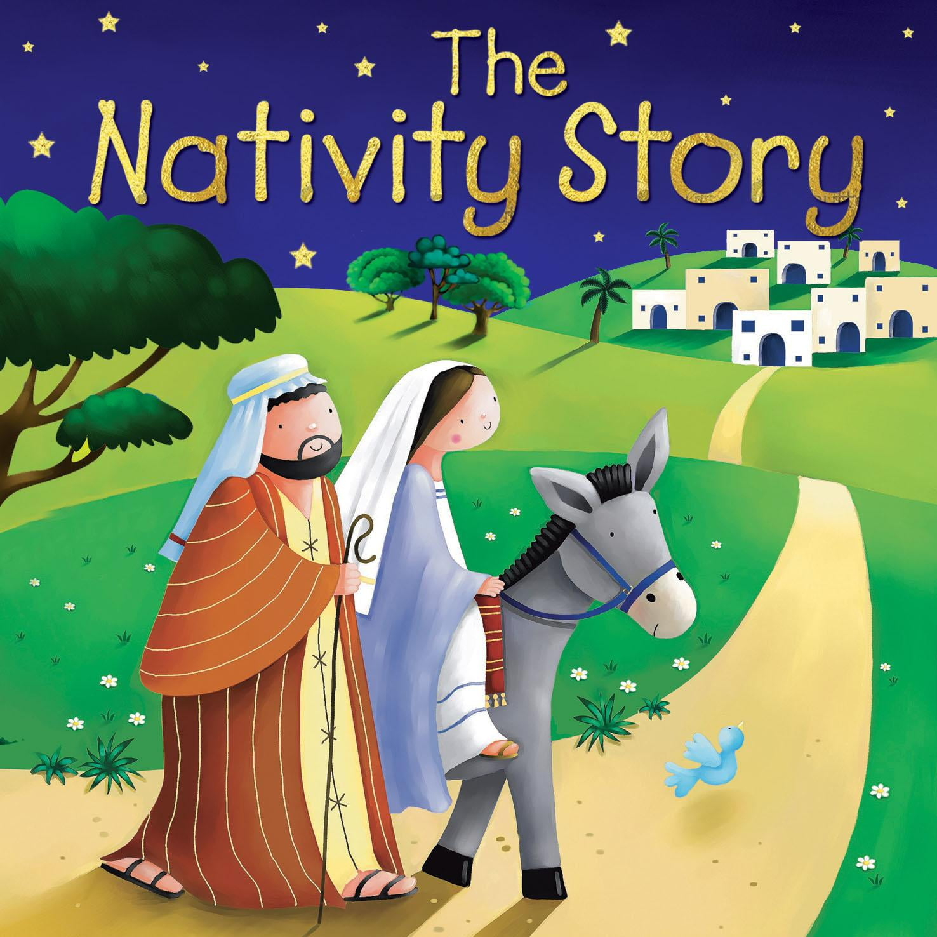
Maths

We will be looking at addition and subtraction within 10.
We will be working on our number bonds to 10.
We will look at place value within 20.
We will then look at both 2D and 3D shapes.
We will be counting in 2’s.

Things you could do at home to support your child’s learning:
Read with your child at least 3 times per week and sign their reading diary.

Practice the tricky words and the new phonemes taught.
Talk to your children about their learning.
Science
We will be learning about seasons.
We will talk about and discuss what happens in each season.
We will be discussing the physical changes that happen during the seasons as well as talking about the weather. 

