 | Term 1 | Term 2 | Term 3 | Term 4 | Term 5 | Term 6
EYFS | Self portraits  Introduction to CP areas- including messy area, dough etc | A range of media, including paint, pastels, collage, dough, felt tips and pencils are available as part of Continuous provision- children to develop skills through themes and own interests | A range of media, including paint, pastels, collage, dough, felt tips and pencils are available as part of Continuous provision- children to develop skills through themes and own interests | A range of media, including paint, pastels, collage, dough, felt tips and pencils are available as part of Continuous provision- children to develop skills through themes and own interests | A range of media, including paint, pastels, collage, dough, felt tips and pencils are available as part of Continuous provision- children to develop skills through themes and own interests | A range of media, including paint, pastels, collage, dough, felt tips and pencils are available as part of Continuous provision- children to develop skills through themes and own interests
Year 1 |  | Drawing/ painting/ printing  Artist study:  David Najar (linked to seasons)  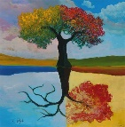 |  |  | Collage  Artist Study: Megan Coyle  Collage pictures linked to ‘Giraffes can’t dance’ book- using a range of media.  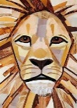  Whole school- rainforest week with an Art focus. Exploring a range of media and techniques to create a final piece with clear environmental message. | 3D form  Create clay fossils  (linked to dinosaurs topic)  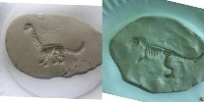
Year 2 | Collage  Artist Study: Andy Goldsworthy  (linked to Science habitats)  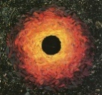 |  | Drawing/ Painting  Artist Study: Vincent Van Gogh (Sunflowers)  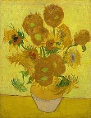 |  | 3D Form-  Clay Dragons Eyes  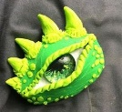  Whole school- rainforest week with an Art focus. Exploring a range of media and techniques to create a final piece with clear environmental message.
Year 3 | Painting/ Printing  Artist study :Banksy  Singing in the rain  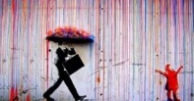 |  |  | Drawing/painting  Artist: Heather Galler  Creating art in her style- flowers and bold colours  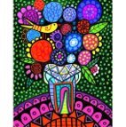 | Whole school- rainforest week with an Art focus. Exploring a range of media and techniques to create a final piece with clear environmental message. | 3D form- Using paper mache to make a river landscape  Painting- exploring different techniques to decorate  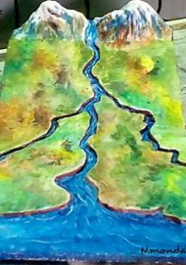
Year 4 |  | Drawing:  Artist: illustrator Chris Mould  Chalk and charcoal sketch of the ironman  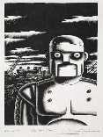 |  | Printing:  Create a resist print of an Aztec pattern.  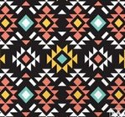 | Whole school- rainforest week with an Art focus. Exploring a range of media and techniques to create a final piece with clear environmental message. | Drawing/ Paintings  Artist study: Hans Holbein  British Monarchs from the past.  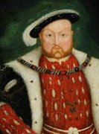
Year 5 | Collage  Layered Viking longboat art  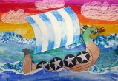 |  |  | Drawing/ Painting - watercolours  Artist study: Henri Rousseu  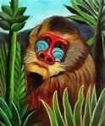 | Whole school- rainforest week with an Art focus. Exploring a range of media and techniques to create a final piece with clear environmental message. | Drawing and printing:  Artist Study: William Morris  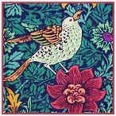
Year 6 | 3D from  Artist study: Bridge Baker, Alexander Calder, Elizabeth Berrien  Wire art linked to WW2  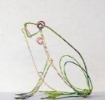 |  |  | Drawing and painting:  Drawings of animals linked to evolution (linked to Science)  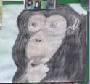 | Whole school- rainforest week with an Art focus. Exploring a range of media and techniques to create a final piece with clear environmental message. | Drawing/ Painting:  Optical illusion  Artist study: Bridget Riley  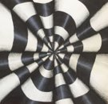
Year 7 | Basic drawing techniques and colour theory  In this introduction topic students will learn the drawing basics, including how to create a successful two stage drawing, understand the meaning of tone and how to apply it along with techniques in mark making. Students will also gain an understanding of colour theory and application. |  |  | Abstract art  In this topic students will learn the fundamentals of abstract art, including relative artists and history. Students will experiment with a range of media such as oil pastel and collage to help create abstract works inspired by selected abstract artists.

