 |  |  | Autumn 1  (6 wks 1 day) | Autumn 2  (7 wks) | Spring 1  (6 wks) | Spring 2  (5 wks) | Summer 1  (7 wks) | Summer 2  (7 wks)
Themes/ concepts    NB: These themes may be adapted to allow for children’s interests |  |  | Ourselves and others  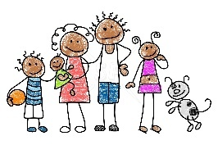 | Animals and Adventures   | Space   | Taking care of our World   |     Lifecycles and change | Super me!  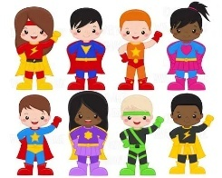
Whole school theme weeks   |  |  |  |  | Careers week/ work in the community    (week 6) |  | Rainforest week    (week 7) |   Sports week  (week 6)
High Quality Text Drivers   |  | F1 | Transition  A Handful of Buttons  The Colour Monster    Pete The Cat and his White Shoes  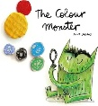  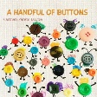 | Rosie’s Walk  Walking through the Jungle  Wow said the Owl  DK Diwali  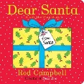  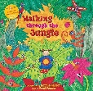  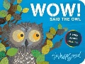  Dear Santa (Christmas)  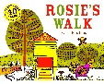 | Whatever Next  There’s an Alien in Your Book  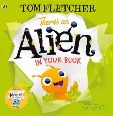  Dragon Noodle Party (Luna New Year)  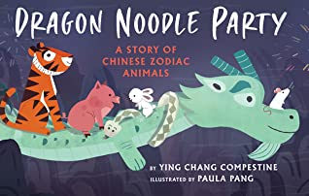  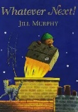 | Tip Tap said the Crab  10 Things I can do to help my world  Festivals Ramadan (Eid)  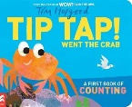  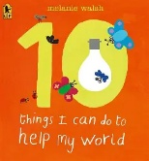 | Hungry Caterpillar  Non-Fiction- Caterpillar to Butterfly  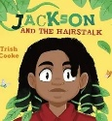  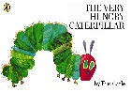  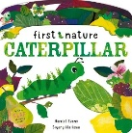  Jackson and the Hairstalk | Super Duper Me  Colour Monster Starts School  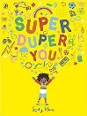  Pete the Cat Rocking in His School Shoes  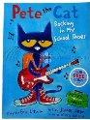  Summer – Non Fiction  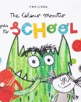
 |  | F2 | Transition  In every house  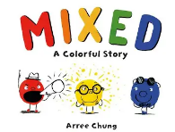  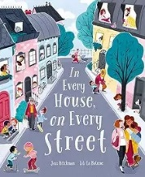  Mixed  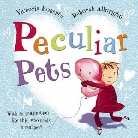  Peculiar Pets  Weekly rhymes and poems linked to theme/high quality text | Bonfire night  Goldilocks  We’re Going on a Bear Hunt  Norman, the slug that saved Christmas  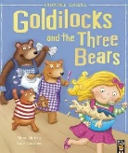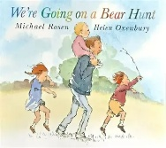    Weekly rhymes and poems linked to theme/high quality text | Look up  The Way Back Home  Astro girl  The Great Race (Luna New Year)      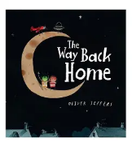    Weekly rhymes and poems linked to theme/high quality text | The Flower thief (Spring)  Golden Domes and Silver Lanterns (Eid)  Clean Up  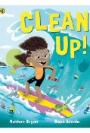  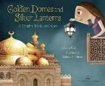  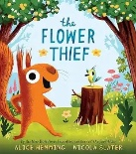  Weekly rhymes and poems linked to theme/high quality text | Chicken Licken  Non-Fiction- Egg to Chicken  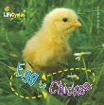  Jack and the Beanstalk  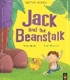  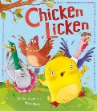  Weekly rhymes and poems linked to theme/high quality text | Farmer Duck  Eliot the midnight superhero  Ruby’s Worry  Transition  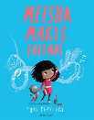  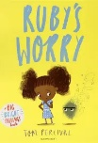  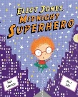  Meesha makes friends  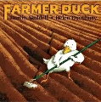  Weekly rhymes and poems linked to theme/high quality text
‘Wow’ moments/ Opportunities and Entitlement   |  | F1  F2 | Pets Day  Baby photographs- transition  Family Bag | Family Bag  Role play of ‘Walking Through the Jungle’  Christmas performance | Cooking  Family Bag  Alien spaceship in woodland area | Family Bag  Role play of ‘Tip Tap Went the Crab’  Easter egg hunt  Caring for our world cafe trip | Family bag  Nottingham Academy EYFS garden  Caterpillar to butterfly- Real life class pets | Family Bag  School walk  N2 Graduation
 |  | F1  F2 | Family photos  Visiting pets | Build a bonfire and hot chocolate  Role play of the bear hunt story in the woods  Going on a Bear Hunt- bare foot walk  Christmas performance | Chinese Dragon performance  Chinese food tasting  Alien spaceship in the woodland area | Mendi experience  Growing plants  Local area litter pick  Walk to the library  Easter egg hunt | Egg to chick- hatching experience | Trip to Manor Farm  Trip to the library
Parental  involvement   |  | F1 | Parent visits | Parent visits  Stay and Play (new starters)  Christmas performance | Parent visits  Parent meetings  World Book Day reading with parents  Careers week showcase | Parent visits  Trip to cafe – parental support  Stay and play (new starters) | Parent visits  Planting with parents  Rainforest week showcase | Parent visits  Nursery to F2 parent meeting  Stay and play (new starters)  N2 Graduation  Sports week
 |  | F2 | Transition  Pets in school visits  Little Wandle Parent workshop  Weekly phonics support videos | Christmas Nativity  Trip- Parental support  Going on a Bear hunt reading workshop  Parents evening  Weekly phonics support videos | Parent maths workshop  ‘Big Build’ space themed creative reading workshop  Weekly phonics support videos  Careers week showcase | Library trip- Parental support  Parent reading/writing workshop  Parents evening  Weekly phonics support videos | Parent reading/writing workshop  Weekly phonics support videos  Rainforest week showcase | Trip- Parental support  Weekly phonics support videos  Sports week
NELI- Language intervention  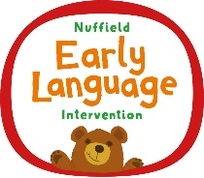 |  | F2 | Assessments for all pupils.  Children identified for intervention group | The Nuffield Early Language Intervention (NELI) is a 20-week, evidence-based programme designed to improve vocabulary, listening, and storytelling skills in 4–5-year-old children at risk of language delay. Children take part in small group and individual sessions which are designed to improve the vocabulary around a range of themes. . |  |  |  | Assessments for all pupils.  Data used to ensure impact of the programme
PSE  Explicitly and implicitly taught throughout everyday through strong routines, provision and high-quality interactions  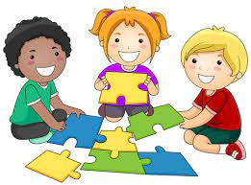 |  |  | Knows that they are in a safe and secure environment  Manage transitions from parent to key person  Shows an interest in other children and/or their play | Shows an awareness of how to complete tasks  Shows likes and preferences  Find ways to calm themselves through being calmed and comforted by their key person | Will show a desire to do things themselves  Is willing to try new things  Know that they have an opinion and ideas  Begin to self-soothe without the need of a key worker | Able to choose what they prefer from a range of activities or resources  Will accept help but only for the part they cannot do for themselves  Play with increasing confidence on their own and with other children | Has a positive relationship with key world but can play and engage without needing direct support  Follows rules and routines  Begin to use limited emotional language about themselves | Shows more confidence in new social situations  Begins to predict routines  Begin to show control for a short amount of time  Begin to understand that their choices can be different or the same as their peers
 |  |  | Begins to talk with their friends about what is fair and why  Begin to support a friend if they are upset or need help  Increase their range of emotional vocabulary.  Increasingly follows rules and routines without needing a reminder | Begin to talk about examples of own and others’ appropriate behaviour  Can accept changes to transitions without becoming upset or confused  Will attempt activities including something new without needing the support or encouragement of an adult | Begins to extend themselves beyond their usual play  Be able to talk about the problem behind the conflict and suggest a resolution with support of an adult  Begin to understand how to make appropriate choices and why | Talk about feelings in a more elaborated way i.e. I’m sad because…  Begin to understand how others might be feeling and why  Becomes more confident when engaging with other adults in the setting | Understand the importance of healthy choices  Be able to talk through conflicts independently and begin to create resolutions independently  Begin to consider and value other points of view particularly when they are different to their own | Feel safe to express a range of feelings and begin to develop an understanding of why they are feeling that way  Embraces change as much as consistency e.g., understands it is a ‘special’ event  Show resilience and perseverance in the face of challenge
Communication and language    Explicitly and implicitly taught throughout everyday through daily ‘talk and write’ sessions and through high quality interactions with adults  The FANTASTICs lenses are used to take an explicit focus on types of vocabulary  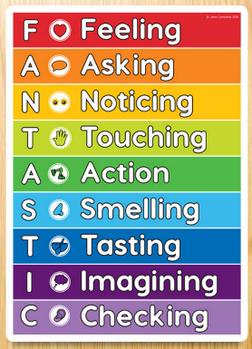 |  |  | Vocabulary explicitly taught through chosen texts and experiences:  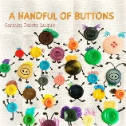  A handful of buttons  The colour monster  Pete the cat and his white shoes  Support to stop and listen to directions  Understands why questions  Start and continue a conversation with an adult or friend | Vocabulary explicitly taught through chosen texts and experiences:  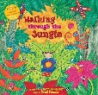  Rosie’s walk  Walking through the Jungle  Wow said the owl  Dear Santa  Listen to simple stories and understand what is happening  Join in with nursery rhymes | Vocabulary explicitly taught through chosen texts and experiences:  Whatever Next  There’s an alien in your book  Dragon Noodle party  Understand a question or instruction that has two parts  Use longer sentences of 4-6 words  Use a wide range of vocabulary | Vocabulary explicitly taught through chosen texts and experiences:  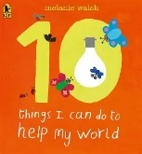  Tip tap went the crab  10 things I can do to help my world  Enjoys listening to longer stories and can remember much of what happened  Use a wide range of vocabulary  Sing a large repertoire of songs | Vocabulary explicitly taught through chosen texts and experiences:  The hungry caterpillar  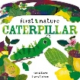  Non fiction – caterpillar to butterfly  Jackson’s hair stalk  Be able to express a point  Use a wide range of vocabulary | Vocabulary explicitly taught through chosen texts and experiences:  Super Duper You!  Colour monster starts school    Pete the cat rocking in his school shoes.  Uses talk to organise play  Use a wide range of vocabulary  Develop communication  Knows many rhymes
 |  |  | Vocabulary explicitly taught through chosen texts and experiences:  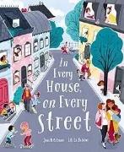  In every house on every street  Mixed  Peculiar pets  Understand how to listen carefully and why listening is important  Engages in story times  Begin to ask questions to clarify  Begin to learn a range of vocabulary  Ask questions to clarify understanding | 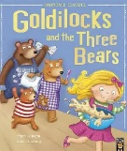  Vocabulary explicitly taught through chosen texts and experiences:  Goldilocks and the three bears  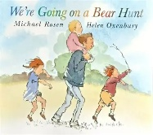  We’re going on a bear hunt  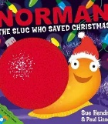  Norman the slug that saved Christmas  Listen to and talk about stories to build familiarity and understanding  Continue to develop questions to clarify understanding.  Use new vocabulary throughout the day | Vocabulary explicitly taught through chosen texts and experiences:  Look up!  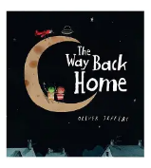  The way back home  Astro girl  The Great Race  Connect one idea or action to another using a range of connectives  Listen carefully to rhymes and songs, paying attention to how they sound  Continue to ask questions to clarify  Listen to and talk about selected non-fiction texts | Vocabulary explicitly taught through chosen texts and experiences:  The Flower Thief  Golden Domes and Silver Lanterns  Clean up  Make comments about what they have heard  Develop questions to clarify understanding  Begin to include use of past, present and future tenses correctly  Describe events.  Use new vocabulary in different contexts | Vocabulary explicitly taught through chosen texts and experiences:  Chicken Licken  Egg to chicken non fiction  Jack and the beanstalk  Make use of conjunctions with modelling  Describe events in some detail  Offer explanations for why things might happen, making use of recently introduced vocabulary from stories, non-fiction, rhymes and poems when appropriate | Vocabulary explicitly taught through chosen texts and experiences:  Framer duck  Elliot the midnight superhero  Ruby’s Worry  Meesha makes friends  Describe events in some detail  Include use of past, present and future tenses  Participate in small group, class and one-to-one discussions offering own ideas, using recently introduced vocabulary  Listen and respond appropriately to adults and peers
Physical- Fine and Gross Motor Skills    Taught explicitly through adult led PE sessions or planned physical activities (GM and FM). Taught implicitly through a high focus on fine and gross motor withing CP design.  Gross motor intervention groups- tracked on Provisions on Insight  Fine motor intervention- tracked on provisions on Insight. |  |  | Balances statistically on two feet  Eat independently using a spoon  Scribbles made of lines  Funky fingers area within provision providing continuous wide range of activities to develop fine motor skills- through use of a variety of tools.  Multilayered activities planned across provision to provide a range of opportunities to apply the use of tools to develop FM as a fundamental priority. | Jump off a step  Throwing ball underarm with feet stationary  Holds scissors with thump and four fingers  Scissor grasp- pencil control  Funky fingers area within provision providing continuous wide range of activities to develop fine motor skills- through use of a variety of tools.  Multilayered activities planned across provision to provide a range of opportunities to apply the use of tools to develop FM as a fundamental priority. | Balances statically on an object  Collaborate with others to manage moving large items  Marks including simple pre-writing shapes  Show preference for a dominant hand  Funky fingers area within provision providing continuous wide range of activities to develop fine motor skills- through use of a variety of tools.  Multilayered activities planned across provision to provide a range of opportunities to apply the use of tools to develop FM as a fundamental priority. | Increasingly able to copy sequences and patterns of taught movements  Chips scrap paper into smaller pieces  Pincer grasp  Funky fingers area within provision providing continuous wide range of activities to develop fine motor skills- through use of a variety of tools.  Multilayered activities planned across provision to provide a range of opportunities to apply the use of tools to develop FM as a fundamental priority. | Stand and jump forward landing safely  Kicking a ball with minimum follow through  Fine pincer grasp  Funky fingers area within provision providing continuous wide range of activities to develop fine motor skills- through use of a variety of tools.  Multilayered activities planned across provision to provide a range of opportunities to apply the use of tools to develop FM as a fundamental priority. | Balances statically on one foot  Makes snips into the edges of paper  Simple representations of people  Palmer grasp  Funky fingers area within provision providing continuous wide range of activities to develop fine motor skills- through use of a variety of tools.  Multilayered activities planned across provision to provide a range of opportunities to apply the use of tools to develop FM as a fundamental priority.
 |  |  | Balances statically on one foot (one leg stand)  Stand and jump forward landing safely  Hanging from climbing equipment  Kicking the ball with minimum follow through  Shows a preference for a dominant hand  Funky fingers area within provision providing continuous wide range of activities to develop fine motor skills- through use of a variety of tools.  Multilayered activities planned across provision to provide a range of opportunities to apply the use of tools to develop FM as a fundamental priority. | Rehearse, repeat, practice and develop a sequence of movements independently  Cuts fairly straight lines across paper  Marks including more complex pre-writing shapes  Funky fingers area within provision providing continuous wide range of activities to develop fine motor skills- through use of a variety of tools.  Multilayered activities planned across provision to provide a range of opportunities to apply the use of tools to develop FM as a fundamental priority. | Drag and pull large/or heavy items safely and independently  Throwing ball underarm while stepping forward  Holds scissors using thumb and one finger  Draws more detailed representations of people  Funky fingers area within provision providing continuous wide range of activities to develop fine motor skills- through use of a variety of tools.  Multilayered activities planned across provision to provide a range of opportunities to apply the use of tools to develop FM as a fundamental priority. | Catching ball with both hands with feet stationary  Balances dynamically e.g., whilst walking along a balance beam  Holds a pencil with a dynamic tripod grasp  Cuts angles  Draws detailed pictures of other objects including shapes  Funky fingers area within provision providing continuous wide range of activities to develop fine motor skills- through use of a variety of tools.  Multilayered activities planned across provision to provide a range of opportunities to apply the use of tools to develop FM as a fundamental priority. | Carry large and/or/heavy items safely and independently  Alternate legs when hopping on the spot and landing safely  Holds a pencil with a dynamic tripod grasp  Cuts curves and circles  Draws more detailed representations of multiple objects  Funky fingers area within provision providing continuous wide range of activities to develop fine motor skills- through use of a variety of tools.  Multilayered activities planned across provision to provide a range of opportunities to apply the use of tools to develop FM as a fundamental priority. | Hold a bat comfortably with hands together in the middle of the handle  Walking forward, stopping and kicking a ball to target  Cuts curves and circles  Holds a pencil with a dynamic tripod grasp  Draws more detailed representations of multiple objects  Funky fingers area within provision providing continuous wide range of activities to develop fine motor skills- through use of a variety of tools.  Multilayered activities planned across provision to provide a range of opportunities to apply the use of tools to develop FM as a fundamental priority.
PE sessions taught weekly in F2   |  |  | Dance  (Primary PE Unit- Word moves dance )  Outside | Mult skills  (Primary PE Unit- Multi skills)  hall | First PE  (Primary PE Unit- First PE)  Outside | Enjoy a ball  (Primary PE Unit- Enjoy a ball)  hall | Fitness  (Primary PE Unit-Fitness and Fundamentals)  Outside | Football  (Primary PE Unit-Football Fundamentals)  hall
Kinetic letters handwriting scheme  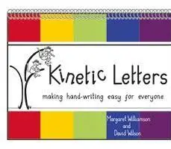  Taught daily in F2 through explicit handwriting sessions |  |  | Establish a dominant hand  Develop pelvic strength  Develop shoulder strength (each up challenges) | Continue to establish a dominant hand  Develop pelvic strength  Develop shoulder strength (each up challenges)  Introduce Animal positions | Develop pelvic strength  Develop shoulder strength (each up challenges)  Introduce Animal positions | Continue with pelvic strength  Continue with shoulder strength (each up challenges)  Animal positions  Develop Forearm and wrist strength | Develop Forearm and wrist strength  Hand and finger strength | Develop Forearm and wrist strength  Hand and finger strength  Dexterity and manipulation  Finger rhymes
 |  |  | 6 moves- monkey/tree. Turtle  Jumper family: hnm  Jumper family: rbp  Abracadabra family: coad  Abracadabra family: gs  Window cleaner family: ltiu | Squirter: e & Fisher family:jyf  Slider family: vwxzk  Jumper family: hnmrbp  Abracadabra family: coadgqs  Window cleaner family: ltiu & w  Squirter: e & Fisher family:jyf (g) | Jumper family  Abracadabra family: coad  Abracadabra family: gqs  Window cleaner family  Fisher family & squirter  Slider family | Pushing numbers  Pulling numbers  Jumper family: target pairs  Abracadabra family: target pairs  Window cleaner family: target pairs  Fisher Family & squirter: target pairs | Slider family: target pairs  Capitals: straight line group  Capitals: curved line group  Capitals: lines then curves group  Capitals: sliding lines group  Abracadabra Fam & HF word | Window cleaner fam & HF word  Squirter & HF word  Fisher fan & HF word  Slider fam & HF word  Pushing numbers  Pulling numbers
Literacy    Daily dash- a daily focus on application of phonics through dictated words and sentences- developing from initial sounds to full sentences by the end of the year.  Daily talk and write- daily book led sessions focussed on the development of vocabulary and comprehension of text through a range of engaging strategies. Every sessions ends with carefully selected dictated writing for the whole class.  Focus writing task- weekly small group writing task with a close focus on application of phonics/ dictation linked to current themes.  Interest led/ writing in CP: carefully panned opportunities for writing in continuous provision, supports by high quality adult interactions and modelling. |  |  | Transcription/ Spelling:  Start to ascribe meaning to marks  Scribbles made of lines  Comprehension:  Enjoys sharing books with an adult  Enjoy songs and rhythms tuning in and paying attention | Transcription/ Spelling:  Ascribe meaning to marks  Make marks on their picture to stand for their name  Imitate and copy patterns  Comprehension:  Repeat words and phrases from familiar stories | Transcription/ Spelling:  Ascribe meaning to marks  Make marks to represent own name.  Show preference for a dominant hand  Comprehension:  Begin to take part in whole class retelling of text map  Repeat words and phrases from familiar stories | Transcription/ Spelling:  Ascribe meaning to marks  Make marks to represent own name  Start to write mock letters  Comprehension:  Begin to understand beginning, middle and end  Begin to understand prepositions  Join in songs and rhymes, copying sounds, rhythms tunes and tempo  Repeat words and phrases from familiar stories | Transcription/Spelling:  Make mock letters  Start to write letter strings  Start to attempt to copy name  Comprehension:  Develop play around favourite stories using props  Begin to spot rhymes in stories  Repeat words and phrases from familiar stories | Transcription/Spelling:  Make mock letters  Start to write letter strings  Start to attempt to copy name  Comprehension:  Develop play around favourite stories using props  Begin to spot rhymes in stories  Repeat words and phrases from familiar stories
 |  |  | Transcription/ Spelling:  Copies name  Start to write initial sounds for words (once taught in phonics lessons)  Comprehension:  Use whole class story map to retell a story  Ask questions about the set books.  Make comments and share ideas about class books.  Learn new vocabulary linked to stories | Transcription/ Spelling:  Writes name- copied or independent.  Continue to hear and write initial sounds in words- directly linked to phonics teaching.  Starts to write CVC words- dictated- directly linked to phonics knowledge.  Comprehension:  Create own story maps.  Retell simple story  Asks questions about the book  Makes comments and shares ideas  Learn new vocabulary linked to stories | Transcription/ Spelling:  Writes name- copied or independent  Continue to write CVC words- dictated- directly linked to phonics knowledge.  Starts to write simple caption- dictated- directly linked to phonics knowledge.  Start to write some tricky words- copied or independent.  Introduce finger spaces.  Comprehension:  Anticipate key events in a story  Engage in extended conversations about stories, learning new vocabulary  Make comments and share ideas | Transcription/ Spelling:  Writes name- copied or independent  Continue to write CVC words- dictated- directly linked to phonics knowledge.  Continue to write simple caption- dictated or orally composed- directly linked to phonics knowledge.  Continue to write some tricky words- copied or independent.  Continue with finger spacing.  Comprehension:  Anticipate key events in a story  Engage in extended conversations about stories, learning new vocabulary  Make comments and share ideas  Understand the names of different parts of a book | Transcription/ Spelling:  Writes name- independently  Continue to write simple caption- dictated or orally composed- directly linked to phonics knowledge.  Start to write a short, dictated sentence- directly linked to phonics knowledge.  Write some tricky words- copied or independent.  Continue with finger spacing.  Introduce full stops and capital letters- use when prompted.  Start to read back own work  Comprehension:  Anticipate key events in a story  Engage in extended conversations about stories, learning new vocabulary  Make comments and share ideas  Understand the names of different parts of a book | Transcription/ Spelling:  Writes name- independently  Continue to write a short dictated or orally composed sentence- directly linked to phonics knowledge.  Write some tricky words- copied of independent.  Continue with finger spacing.  Capital letters and full stops - use when prompted.  Read back own work.  Comprehension:  Anticipate key events in a story  Engage in extended conversations about stories, learning new vocabulary  Make comments and share ideas  Understand the names of different parts of a book
WORD READING  Little Wandle Phonics  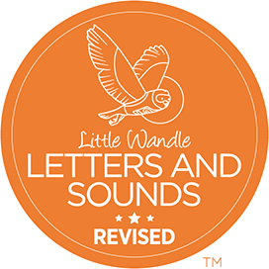  Phonics sessions taught daily within keyworker groups in F1 and whole class in F2.  Keep up groups- tracked in Provisions (Insight) | F1 |  | Teach phonemic awareness and oral blending every day to build children’s focused listening and attention.  Nursery rhymes (shared weekly with parents)  Listening games  Oral blending  Teaching of initial sounds
 | F2 |  | Phase 2  (satpinmdgock ckeurhf)  On going ‘keep up’ intervention groups  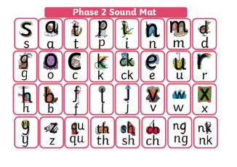 | Phase 2  (ff ll ss j vwxyz zz qu ch sh th ng nk)  On going ‘keep up’ intervention groups | Phase 3  (ai ee igh oa oo o oar or ur ow oi ear air er)  On going ‘keep up’ intervention groups  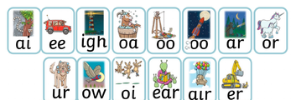 | Phase 3- revisit and consolidation  (ai ee igh oa oo o oar or ur ow oi ear air er)  On going ‘keep up’ intervention groups | Phase 3  Longer words, word endings (ing, s, es) & compound words  On going ‘keep up’ intervention groups | Phase 4  Short vowels, longer words, compound words, root word endings (ing, ed, est)  On going ‘keep up’ intervention groups
Mathematics  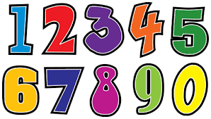  Daily maths sessions taught in Key Worker groups in F1 and as a whole class in F2- explicit teaching of mathematical vocab is a focus with opportunities to use hands on resources to support conceptual understanding.  Children are identified for maths intervention- tracked on Provisions on Insight |  |  | Perceptual subitising- recognise values  Compare collections and talk about which group has more  Recognising attribute (that stick is long) | Say number words in sequence to 5  Can physically partition  Understand fair and unfair when sharing | Subitise objects up to 3  Identify groups with the same number of things  Can physically partition several things into two groups and recombine  Explores 2D and 3D shapes and the attributes through paly | Subitise objects up to 3  Say number words in sequence to 10  Count using 1:1 correspondence  Sequence numbers to 5 | Know that quantity is the same however it is arranged  Compare some types of measure  Create own ABAB patterns | Use vocabulary more and less to compare quantities  Can talk about different numbers within a number  Show awareness of the properties of shapes
 |  |  | Counting  Subitising  Matching and sorting  Comparing amounts  Comparing size and capacity  Simple patterns  Representing and comparing 1, 2 and 3 | Composition of 1, 2 and 3  Circles and triangles  Positional language  Introduce 4  Introduce 5  Number bonds to 5  1 more and 1 less  4 sided shapes | Comparing numbers to 5  Composition of 4 and 5  Compare mass and capacity  Introduce 6, 7 and 8  Making pairs | Combining two groups  Length and height  Introducing 9 and 10  Ordering to 10  Comparing numbers to 10  Number bonds to 10  3D shape  Patterns | Adding more  Taking away  Doubling  Odd and even | Building numbers to 20 and beyond  Addition and subtraction  Sharing and grouping  Manipulate, compose and decompose  Properties of 2D and 3D shapes  Visualise, build and map  Deeping understanding and consolidation
Understanding the World    UoW is taught explicitly and implicitly. Explicitly through carefully planned adult led experiences and use of texts, and implicitly through planned continuous and interest led opportunities facilitated by high quality interactions.  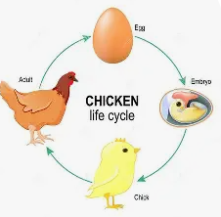  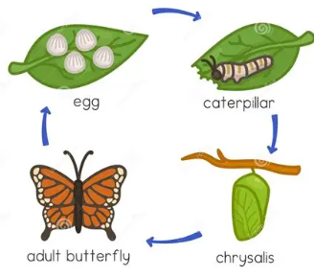 |  |  | Able to say who they are and who they live with  Comments on recent picture of experiences in their own life  Talk about what they can see in their environment | Can briefly talk about some members of their family  Knows that there are special places of worship  Understands that the weather changes. | Show an interest in different occupations (careers week)  Know that there are differences between people believe  Explore and talk about forces (push and pull)  Can identify what you need to wear for each season and why | Talks about a wider range of occupations  Knows that there are special places of worship  Comments on recent pictures of celebrations in their own life  Explore collections of materials identifying with similar or different properties | Can explain the features of other homes  Can explain what daily life is like in our country  Show an awareness of the life cycle of a butterfly  Plants seeds and cares for growing plants with support | Identify features on a simple map  Knows that there are other countries in the world (culture day)  Can talk about local environments  Develop positive attitudes about differences between people
 |  |  | Comments on recent pictures of celebrations in their own life  Talk about local environments | Knows that there are special places of worship  Can articulate some religious celebrations and being able to explain what might happen during these celebrations  Explore the natural world around them, describing what they see, hear and feel whilst outside | Comments on images of familiar experiences  Recognise some environments are different to the one in which they live in  Talks about difference between materials and changes they notice  Explore non-contact forces (gravity and magnetism) | Comments on pictures of a wide range of celebrations  Can name different religious venues  Knows why religious venues are special and who goes there  Explores the natural world around them, making observations and drawing pictures of animals and plants  Understands the need to respect and care for the natural environment and living things  Uses pictures to compare and contrast environments from around the world | Use maps to locate objects in real life  Understand the effect of changing seasons on the natural world around, discussing when and how things grow  Can talk about different life cycles (chicks)  Understands the need to respect and care for the natural environment and living things | Draw information from simple maps  Uses pictures to compare and contrast environments from around the world
Expressive Arts & Design  Ex Art & design is taught explicitly and implicitly. Explicitly through carefully planned adult led experiences and use of texts, and implicitly through planned continuous and interest led opportunities facilitated by high quality interactions.  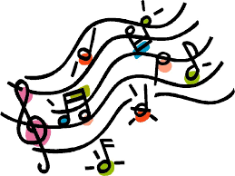   |  |  | Use premade paints- this is me paintings  Drawings- opportunities to make lines and circles with a range of media  Print with sponges  Introduction to glue sticks  Build homes with bricks  Enjoy singing songs and rhymes | Designing and creating props for our Christmas Songs performance  Performing songs and dances  Firework paintings for music  Bonfire experience day in the woodland area  Creative diva lamps for Diwali  Creating props for walking through the jungle role play.  Printing with range of materials  Junk modelling- exploring glue and tape for joining | Designing the alien spaceship for the woodland area  Creating our space station role play are in the shared area  Rocket painting/ printing / collage  Play dough- range of tools for cutting  Singing and dancing- basic actions | Creating Mother’s Day cards  Creating Easter painting  Creating Eid cards  Role play of different occupations in the home corner | Designing our own EYFS garden  Planting seeds  Caterpillar observational drawings  Cooking and trying different fruits and vegetables  Creating homes for our caterpillars  Butterfly painting  Jackson’s hairstalk collage | Creating Father’s Day cards  Designing and creating our Superhero station
 |  |  | Creating all about me displays- self portraits  Draw family- developing more detailed people drawings  Designing and creating homes for our pets- box modelling, exploring ways of joining  Paintings and drawings of visiting pets- different sized brushes for detail  Simple patters with printing  Playdough- using a range of tools  Role pay vets | Designing and creating props for our Christmas performance  Performing songs and dances  Firework paintings to music  Bonfire experience day in the woodland area  Creative diva lamps for Diwali  Creating props for our ‘Going on a Bear Hunt’ role play  Painting bears- increasing details  Playdough- make a bear | Creating rockets for our Colwick woods trip  Designing the alien spaceship for the woodland area  Creating class Chinese Dragons for our dance performance- collage and painting  Creating our space station role play are in the shared area  Painting/ printing/ collage on rockets  3D rockets- box modelling- range of joining and decorating techniques  Role play space station  Role play range of careers (careers week) | Creating Mother’s Day cards  Creating Easter art- split pin chicks  Creating Eid cards  Designing and creating posters to care for our pond- plastic pollution | Designing our own EYFS garden  Planting seeds  Creating homes for our chicks  Observational drawings/ paintings of chicks | Creating Father’s Day cards and decorating biscuits  Creating Eid cards  Designing and creating our superhero call centre in the role play area  Superhero props- capes, masks  Visit to the farm- paintings and drawings with increasing details
Assessment  opportunities   |  | F1 | - School baseline assessments- on Insight (new starters)  - Wow moment observations  - Intervention assessments- Provisions on Insight | - School baseline assessments- on Insight (new starters)  - Wow moment observations-  - End of Aut 2 teacher  - assessments- Insight  - Intervention assessments- Provisions on Insight | - School baseline assessments- on Insight (new starters)  - Wow moment observations Intervention assessments- Provisions on Insight | - School baseline assessments- on Insight (new starters)  - Wow moment observations  - End of Spring 2 teacher assessments- Insight  - Intervention assessments- Provisions on Insight | - School baseline assessments- on Insight (new starters)  - Wow moment observations  - Intervention assessments- Provisions on Insight | - School baseline assessments- on Insight (new starters)  - Wow moment observations  - End of year teacher assessments- Insight  - Intervention assessments- Provisions on Insight
 |  | F2 | - National baseline  - School baseline assessments- on  - Insight (externals)  - On-track for GLD assessment- For trust  - Wow moment observations  - Little Wandle placement assessment  - Intervention assessments- Provisions on Insight | - Wow moment observations  - Little Wandle Placement assessment  - End of Aut 2 teacher  - assessments- Insight  - On-track for GLD assessment – for trust  - Intervention assessments- Provisions on Insight | - Wow moment observations  - Little Wandle Placement assessment  - Intervention assessments- Provisions on Insight | - Wow moment observations  - Little Wandle Placement assessment  - End of Spring 2 teacher assessments- Insight  - On-track for GLD assessment- for trust  - Intervention assessments- Provisions on Insight | - Wow moment observations  - Little Wandle Placement assessment  - Intervention assessments- Provisions on Insight | - Wow moment observations  - Little Wandle Placement assessment  - End of year teacher assessments- Insight  - Achieved GLD assessment for trust  - Intervention assessments- Provisions on Insight

