YEAR 1  2026-27 |  |  | Autumn Term |  |  |  |  |  |  |  | Spring Term |  |  |  |  |  |  |  | Summer Term
Termly breakdown |  |  | 6 weeks 1 day (with children) |  |  | 7 weeks |  |  |  |  | 6 weeks |  |  | 5 weeks |  |  |  |  | 7 weeks |  |  |  | 7 weeks
Topic Driver and theme title |  |  |         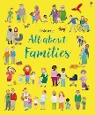  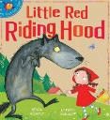  Into the woods   |  |  | 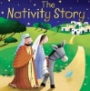    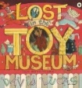  Toy story |  |  |  |  | 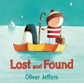  The icy planet   |  |  | 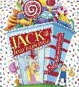  Growth and change |  |  |  |  | 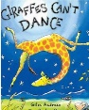    Awesome animals |  |  |  | 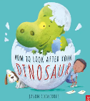  Dinosaurs  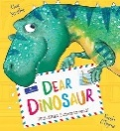  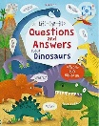
Whole school theme weeks |  |  |  |  |  |  |  |  |  |  | Careers week/ work in the community    (week 6) |  |  |  |  |  |  |  | Rainforest week- art focus (week 7)   |  |  |  | Sports week  (Week 6)  
Core subjects | English | Guided Reading /  Phonics   | Little Wandle validated phonics scheme.  Children are taught to read a range of books within a small group which are closely matched to their phonics ability. The children are exposed to a range of texts, including fiction, non-fiction and poetry which support the development of their early reading skills. The Little Wandle guided reading sessions focus on the skills of decoding, prosody and comprehension. Children re-read the same book throughout the week in order to build up these skills and with repetition of the same text develop fluency in reading.
Core subjects | English | Writing genres  GPS  Spelling   | All about families text- Draw and write about my family. | Little Red Riding Hood- Character/ setting description (FANTASTICS) | Recount of trip to the woods  (FANTASTICS) | Poetry- Firework night- focus on onomatopoeia | Lost in the toy museum- Missing poster and treasure hunt messages |  | Non chronological report- comparing old and toys | Nativity story- narrative- retell | Non fiction- Penguins- fact file | Narrative- Lost and found – retell (FANTASTICS) |  | Instructions- how to plant a beanstalk/ make a sandwich | Jack and the Jelly Beanstalk- narrative (FANTASTICS) |  | Recount of trip to the Windmill |  | Giraffes can’t dance- Narrative- retell (FANTASTICS) | Letter- to Gerald | Giraffes/non fiction- fact files |  | Instructions- how to look after your dinosaur | Dear dinosaur – Questions and statements letter writing |  | Non fiction- dinosaurs-  Lift a flap non-fiction book. |  | All about me- fact file/ letter for my new teacher
Core subjects | English |   Class books |     DAILY BOOK VOTING STATION- Children vote daily for their end of the day story. Children choose from a variety of fiction and nonfiction texts linked to themes or interests. This supports reading for pleasure.
Core subjects | Mathematics   |  | Place value- 4 weeks | Addition and subtraction (within 10) – 2 weeks) |  | Addition and subtraction (within10) 3 wks |  | Place value (within 20)- 3 weeks |  | Shape- 1 week | Consolidation- 1 week | Addition and subtraction (within 20)- 3 weeks | Place value (within 50)- 2wk | Place value (within 50)- 1 wk | Length and height – 2 wks | Mass and  Volume- 1 wks |  | Revisit + & - | Multiplication and division- 4 wks |  | Fractions- 2 wks | Revisit 4 ops -1 wk | Revisit 4 operations- 1wk |  | Place value 2wks |  | Position and direction- 1 wk |  | Time – 2 weeks | Money- 1 week
Core subjects | Science   |  | Everyday materials  Exploring materials around us and finding suitable materials to fix Noah’s Ark |  |  | Seasonal change  An overview of all the seasons with then a focus on Autumn |  |  |  |  | Plants and seasonal change  Types of plants- Evergreen and Deciduous.  A recap on seasons with a focus on Winter. |  |  | Plants  Names of flowers, trees and plants, parts of the plant and their function |  |  |  |  | Animals  Introduction to the 5 types of animals  +  Seasonal change  Focus on Spring/ Summer |  |  |  | Humans  The 5 senses and the parts of the body
Non- core subjects | History  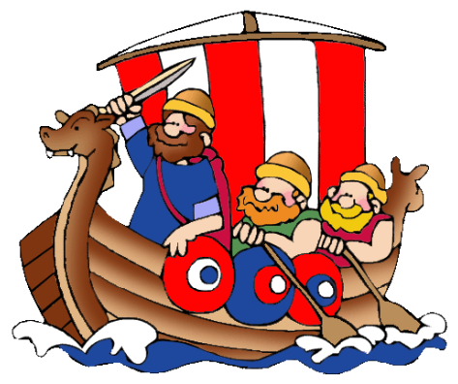 |  |  |  |  | Guy Fawkes  (2weeks)        (Significant event beyond living memory)  Toys    (Changes outside of living memory) |  |  |  |  |  |  |  | George Green- Green’s windmill  (Local study) |  |  |  |  |  |  |  |  | Dinosaurs  The first discovery of dinosaur bones & the extinction of dinosaurs  (Event beyond living memory  Mary Anning- significant discoveries of dinosaur fossils)
Non- core subjects | Geography   |  | Exploring Sneinton  Local area study- an introduction to human and physical features and early map skills. |  |  |  |  |  |  |  | Pole to pole  Identifying and comparing weather patterns in UK and North and South poles |  |  |  |  |  |  |  | Cool Capitals  4 countries and capital cities of UK- identifying and comparing human and physical features.
Non- core subjects |   Art |  |  |  |  | Drawing/ painting/ printing  Artist study:  David Najar (linked to seasons)  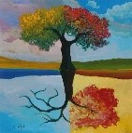 |  |  |  |  |  |  |  |  |  |  |  |  |   drawing/Collage  Artist Study: Megan Coyle - Collage pictures linked to ‘Giraffes can’t dance’ book. |  |  |  | 3D form  Create clay fossils  (linked to dinosaurs topic)  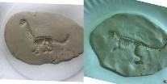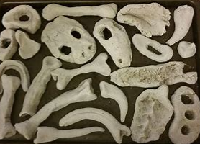
Non- core subjects | D & T   |  | Mechanisms-  levers and sliders-  Design and make a moving pictures- linked to Little Red riding Hood. |  |  |  |  |  |  |  | Construction & mechanisms -  Design and make a moving windmill  (linked to next terms History) |  |  | Food and nutrition:  Design and make a healthy snack for breaktime
Non- core subjects |   Computing (Purple Mash)  Digital literacy  Computer Science  Information technology |  | Online safety- delivered throughout the year using 2BeSafe
Non- core subjects |  |  | Enhance CP using subject areas in Purple Mash |  |  | Unit- Introduction to PM |  |  |  |  | Unit -Creative Computing |  |  | Unit – Creating and following instructions |  |  |  |  | Unit - Technology around us |  |  |  | Unit- Animated stories
Non- core subjects | Music (Charanga)   |  | KS1 weekly singing assembly |  |  | Charanga Unit: Hey You!  Genre: Hip- Hop  KS1 weekly singing assembly |  |  |  |  | KS1 weekly singing assembly |  |  | Charanga Unit: In the Groove  Genre: a variety of styles  KS1 weekly singing assembly |  |  |  |  | KS1 weekly singing assembly |  |  |  | Charanga Unit: Round and Round  Genre: Bossa Nova  KS1 weekly singing assembly  .
Non- core subjects | PE (Primary PE)   |  | Football  (Primary PE Unit- Football Fundamentals) outside |  |  | Team games – ball skills  (Primary PE Unit- Ball skills)  outside |  |  |  |  | Ball games  (Primary PE Unit- Ball games)  Outside |  |  | Fitness  (Primary PE Unit- Fitness)  outside |  |  |  |  | Athletics  (Primary PE Unit- Athletics)  outside |  |  |  | Ball games  (Primary PE Unit- Ball games)  outside
Non- core subjects |  |  | Dance  (Primary PE Unit - Dance)  hall |  |  | Multi skills  (Primary PE Unit- Multi skills)  hall |  |  |  |  | Gymnastics  (Primary PE Unit-Gymnastics) hall |  |  | Dance  (Primary PE Unit-Fairytale dance) hall |  |  |  |  | Tennis  (Primary PE Unit- Tennis) outside |  |  |  | Fundamental movement skill  (Primary PE Unit- Dinosaur dance) hall
Non- core subjects | RE   |  | Myself and Caring for Others  How do we show we care for others? Why does this matter?  (Christians and Jewish people. Non-religious worldviews such as Humanism)   |  |  | Beliefs and teachings  What can we learn from them? How do religious stories make a difference to people’s lives?  (Christianity)  Enrichment – visit from Kate Fear (Trinity Church)    (Focus on Nativity story) |  |  |  |  | Celebrations and Festivals  Who celebrates and why?  (Christians and Jewish people)  (Focus on Easter)  Enrichment – visit from Kate Fear (Trinity Church) |  |  |  |  |  |  |  | Symbols in religious worship and practice  In what ways are churches/synagogues important to believers?  (Christians and Jewish people)    Enrichment: Visit to local Church
Non- core subjects | PSHE  & British Values   |  | BM (Being Me in My World)  'Who am I and how do I fit?'  Belonging   |  |  | CD (Celebrating Difference)  Respect for similarity and difference. Anti-bullying and being unique  What is bullying? |  |  |  |  | DG (Dreams and Goals)  Aspirations, how to achieve goals and understanding the emotions that go with this  ‘I can do it!’ |  |  | HM (Healthy Me)  Being and keeping safe and healthy  Being healthy and safe. |  |  |  |  | RL (Relationships)  Building positive, healthy relationships  Relationships with myself and others. |  |  |  | CM (Changing Me)  Coping positively with change  From baby to now.
Non- core subjects | Curriculum Enrichment opportunities   |  | Visit to Colwick woods- Little Red Riding Hood  Local area walk - Geography |  |  | Old toys- Artefacts  Kate Fear – Trinity Church- Nativity  Colwick woods- signs of Autumn |  |  |  |  | Kate Fear – Trinity Church  Careers week- links with the community |  |  | Visit to Greens windmill  Trip to the woods- sign of Spring  Stephen Lawrence day  Eid celebrations |  |  |  |  |   Mental health awareness day  Visit to Trinity Church  Animals visit- to support science unit  Rainforest week- |  |  |  | Colwick woods- senses walk (Science)  Whole school culture day  Whole school sports week-
 | Parental involvement   |  | Little Wandle reading workshop  Parents evening |  |  | Christmas performance  Parents reading workshops |  |  |  |  | Parent reading workshop  World book day  Careers week showcase |  |  | Parents evening |  |  |  |  | Rainforest showcase |  |  |  | Culture day  Sports week

