YEAR 2  2026-27 |  |  | Autumn Term |  |  |  |  |  |  | Spring Term |  |  |  |  |  |  |  | Summer Term
Termly breakdown |  |  | 6 weeks 1 day |  | 7 weeks |  |  |  |  | 6 weeks |  |  |  | 5 weeks |  |  |  | 7 weeks |  |  |  |  | 7 weeks
Theme and text driver |  |  | 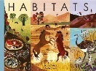  Amazing animals    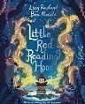 |  |     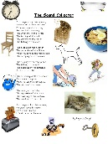    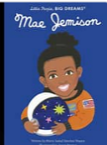  Outer Space |  |  |  |  |   Wonderful World  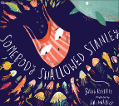 |  |  |  | Fire, Fire  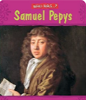  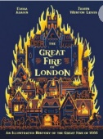 |  |  |  | Dragons    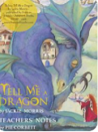  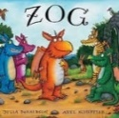 |  |  |  |  | 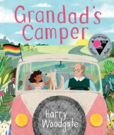  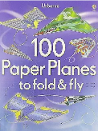  Transport
Whole school theme weeks |  |  |  |  |  |  |  |  |  | Careers week/ work in the community  (week 6) |  |  |  |  |  |  |  | Rainforest week- art focus (week 7)   |  |  |  |  | Sports week  (Week 6)  
Core subjects | English | Writing genres  GPS  Spelling   | Narrative- Little red Reading Hood | Non Chronological report on whales | Poetry- The sound collector | Biography- Mae Jemison |  | Narrative- Christmas Star |  | Instructions- how to plant a seed | Explanation- How a seed grows | Narrative- Someone swallowed Stanley |  | Report- Great Fire of London |  | Diary - Great Fire of London |  | Narrative- Zog | Description Tell me a dragon |  | Non-fiction  Komodo Dragon |  | Narrative- Grandad’s camper |  | Recount- trip to Crich |  | Instructions- How to make a paper plane
Core subjects | English | Guided Reading /  Phonics  
Core subjects | English |  |   Gorilla- Antony Brown  The storm whale-Benji Davis  Grandma Bird- Benji Davis  Habitats |  | The darkest dark- Chris Hadfield  Lights on cotton rock- David Litchfield  Non- fiction-astronauts- One giant leap |  |  |  |  | Tidy- Emily Gravett  There’s an orangutan in my bedroom- James Sellick  The Koala who could- Rachel Bright  Where on Earth- Australia- non fiction |  |  |  | The Bakers boy- Tom and Tony Bradman  Great Fire of London- Poem by Paul Perro |  |  |  | The dragon machine- Helen Ward  The boy who grew dragons  Zog and the flying doctors |  |  |  |  | Izzi Gizmo- Pip Jones  Bessie Coleman- flying free- Karen Paryn  The Magical yet- Angela DiTerlizzi
Core subjects | English | Class texts   | The boy who grew a dragon- Andy Shephard |  |  |  |  |  |  | Charlie changes into a chicken-  Sam Copeland |  |  |  |  |  |  |  | The Worries- Jion Sheibani
Core subjects | Mathematics    NB- Teachers will adapt to reflect needs of the children |  | Number and place value- 4 weeks | Addition and subtraction- 2 weeks | Addition and subtraction – 3 wks | Money including addition and subtraction – 2wks | Shape |  | Shape & revisit + & - | Revisit addition and subtraction -1wk | Multiplication and division – 4wks |  | Revisit addition and subtraction -1wk | Revisit 4 operations – 1wk |  | Length and height- 2 weeks | Mass, capacity and temp-2 wks | Revisit 4 operations 1wk | Fractions- 3 wks | Statistics incl 4 op- 2 wks |  | Fractions- 1wk | Revisit 4 operations-1 wk | Position and direction – 2 wks |  | Time -2 wks |  | Revisit 4 op- 1wk | Consolidation 1 wk
Core subjects | Science   |  | Living things and their habitats  An introduction to types of habitats and animals that live there.  Animals  Lifecycles and offspring of animals, how they grown and change. |  |  |  |  |  |  | Plants  An in depth look at the parts of the plant, what plants need to grow and stages of growth. |  |  |  | Materials  An in depth look at common materials and their properties |  |  |  | Animals  Recap of animals group and classification  Humans  How to keep our bodies fit and healthy.
 | History  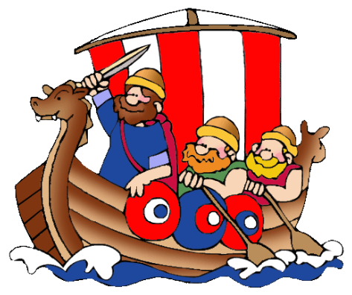 |  |  |  | Neil Armstrong and the first moon landing  (Significant person and event) |  |  |  |  |  |  |  |  | Great Fire of London  (Significant Event) |  |  |  |  |  |  |  |  | Aviation history- The Wright brothers/ Bessie Coleman  (Significant individual and event)  
 | Geography    Non- core subjects |  | Human vs Physical  Exploring and comparing human and physical features in the local area |  |  |  |  |  |  | Comparing Capitals  Comparing Capitals- London VS Sydney |  |  |  |  |  |  |  | Mega Maps  A deeper look at maps and creating maps of the school environment
 | Art   |  | Collage  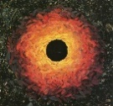  Artist Study: Andy Goldsworthy  (linked to science habitats) |  |  |  |  |  |  | Drawing/ Painting  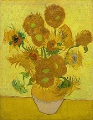  Artist Study: Vincent Van Gogh (Sunflowers) |  |  |  |  |  |  |  | 3D Form-  Clay Dragons Eyes  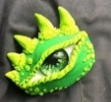
 | D & T   |  |  |  | Textiles-  Design and make a Christmas decoration |  |  |  |  |  |  |  |  | Construction:  Design and make a Tudor house |  |  |  |  |  |  |  |  | Mechanisms  Wheels and axles-  Design and make a moving vehicle
 |   Computing (Purple Mash)  Digital literacy  Computer Science  Information technology |  | Onsline safety- delivered throughout the year using 2Be Safe
 |  |  | Unit- Creating pictures |  | Unit -spreadsheets |  |  |  |  | Unit- Route explorers |  |  |  | Unit- Presenting ideas |  |  |  | Unit- Questioning |  |  |  |  | Unit- Coding
 | Music   |  | KS1 Singing assembly |  | Charanga Unit: Hands, Feet, Heart  Genre: Afro-pop  KS1 Singing assembly |  |  |  |  | KS1 Singing assembly |  |  |  | Charanga Unit: I wanna play in a band  Genre: Rock  KS1 Singing assembly |  |  |  | KS1 Singing assembly |  |  |  |  | Charanga Unit: Friendship song  Genre: Vocal music  KS1 Singing assembly
 | PE   |  | Ball skills  (Primary PE Unit- Ball skills) hall |  | Team Games- ball games  (Primary PE Unit- ball games) outside |  |  |  |  | Fitness  (Primary PE Unit- Fitness)  Outside |  |  |  | Dodgeball  (Primary PE Unit-dodgeball) outside |  |  |  | Kwik Cricket  (Primary PE Unit-Kwik Cricket)  outside |  |  |  |  | Athletics  (Primary PE Unit-Athletics)  outside
 |  |  | Football- Team games  (Primary PE Unit- Football) outside |  | Multi-skills  (Primary PE Unit- Multi-skills) hall |  |  |  |  | Gym  (Primary PE Unit- Gymnastics)  hall |  |  |  | Dance  (Primary PE Unit- Great Fire of London Dance) hall |  |  |  | Yoga  (Primary PE Unit-Yoga) hall |  |  |  |  | Net and wall- tennis  (Primary PE Unit-Tennis)  outside
 | RE  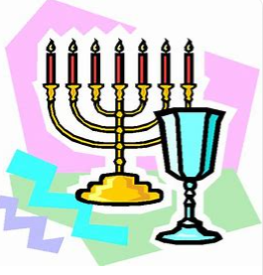 |  | Leaders  What makes some  people inspiring to others? Moses and Saint Peter  (Christians and Jewish people. Non-religious) |  | Believing  What do Jewish people believe about God, creation, humanity, and the natural world? What are some ways Jewish people show how they belong?  (Jewish people) |  |  |  |  | Belonging  What does it mean to belong? What is it like to belong to the Christian religion in Nottingham City and Nottinghamshire today?  (Christians) |  |  |  |  |  |  |  | Story  How and why are some stories important in religions? What can we learn from these stories and from the Torah and the Bible?  (Jewish and Christian)  Enrichment: Synagogue visit
 | PSHE  & British Values   |  | BM (Being Me In My World)  ‘Who am I and how do I fit?  Rights and Responsibilities |  | CD (Celebrating Difference)  Respect for similarity and difference. Anti-bullying and being unique  Celebrating diversity.   |  |  |  |  | DG (Dreams and Goals)  Aspirations, how to achieve goals and understanding the emotions that go with this |  |  |  |  | HM (Healthy Me)  Being and keeping safe and healthy |  |  | RL (Relationships)  Building positive, healthy relationships |  |  |  |  | CM (Changing Me)  Coping positively with change
 | Curriculum Enrichment opportunities   |  | Animals visit  Library visit  Kate Fear – Trinity Church |  |  |  |  |  |  | Colwick Woods  Library visit |  |  |  | Fire Station visit  Kate Fear- Trinity Church    Stephen Lawrence day  Eid day |  |  |  | Visit to Synagogue/  Visit from Rabbi  Mental Health awareness day |  |  |  |  |   Charity Day  Culture day  Crich tramway village
 | Parental involvement  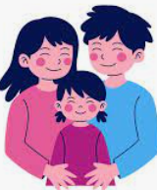 |  | Little Wandle parent workshops  Parents evening |  | Christmas performance |  |  |  |  | Careers/ links with community week |  |  |  | Parents evening  Curriculum showcase event - GFOL |  |  |  | Rainforest showcase |  |  |  |  | TTRS day  Culture day  Sports week

