YEAR 3  2026-27 |  |  | Autumn Term |  |  |  |  | Spring Term |  |  |  |  |  |  | Summer Term
Termly breakdown |  |  | 6 weeks |  | 7 weeks |  |  | 6 weeks |  |  |  |  | 5 weeks |  | 7 weeks |  |  |  | 7 weeks
Topic themes and driver texts |  |  | 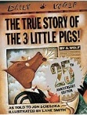    Twisted tales |  |   Rocks, sticks and stones  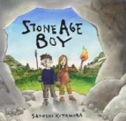     |  |  | 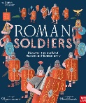  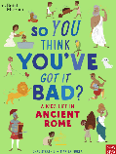  Rome wasn’t built in a day |  |  |  |  | Disaster zone!  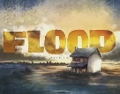  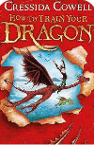  How to train your dragon? |  | Egyptians  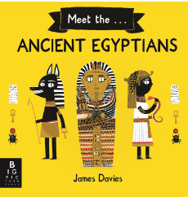 |  |  |  | Roaring Rivers  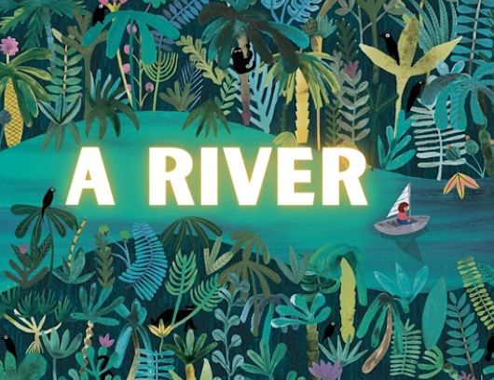
Whole school theme weeks |  |  |  |  |  |  |  | Careers week/ work in the community  (week 6) |  |  |  |  |  |  | Rainforest week- art focus (week 7)  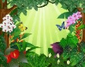 |  |  |  | Sports week  (Week 6)  
 | English | Writing genres  GPS  Spelling   | Narrative - The true story of the three little pigs | Letter from prison | Narrative- Stone Age Boy | Letter- from Stone age boy character | Instructions- Instructional guide for Stone-age hunter | Diary- So you think you’ve got it bad- a kids life in Ancient Rome | Fact file- Ancient Rome |  |  |  | Narrative- Flood | How to tarin your dragon - ? | Instructions- volcanoes | Write a class non fiction book – The Egyptians |  |  | Poetry- the River- Valerie Bloom |  | Narrative – A river | Recount- Trip to Cowlick Park
 | English | Guided Reading /  Phonics   | Little Wandle is our validated phonics scheme- Rapid catch-up groups in place for identified children.
 | English |  | 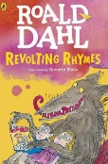  Roald Dahl Revolting rhymes |  | 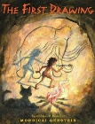  The First Drawing- Mordicai Gertein |  |  | 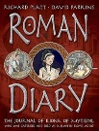  Roman Diary- The Journey of Iliona  The Secret of Vesivius  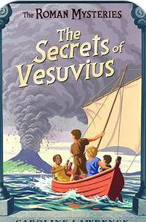 |  |  |  |  | How to train your dragon 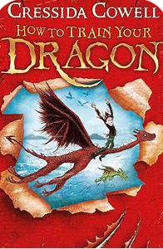 |  | 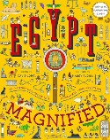  Egypt Magnified  -David Long |  |  |  | Nothing to see here hotel  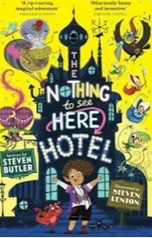  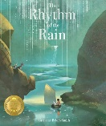  The Rhythm of the rain- Graheme Baker-Smith
 | English | Class texts   | The Wild Robot- Peter Brown |  |  |  |  | How to Train Your Dragon |  |  |  |  |  |  | Nothing to see here hotel
 | Mathematics  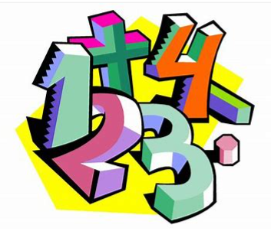 |  | Number and place value- 4 weeks | Addition and subtraction- weeks | Revisit Addition and subtraction – 1 week | Multiplication and division- 6 weeks |  | Revisit Addition and subtraction- 1 wk | Revisit Multiplication and division- 1 wk | Addition and subtraction through Length and perimeter – 2 wks | Statistics including 4 ops – 1wk | Revisit 4 operations – 1wk | Revisit 4 operations – 1wk | Fractions- 4 weeks | Fractions 2 wk | Revisit 4 operations – 1 wk | Mass and capacity- 2 wks | Addition and subtraction- through money1 wk | Revisit 4 operations- 1 wk | Revisit fractions-1wk | Time – 2 wks | Shape- 2 wk | Revisit 4 op / consolidation– 1 wk
 | Science   |  | Light  Light sources and how shadows are formed. |  | Rocks  The 3 main types of rock and their properties. How fossils are formed. |  |  | Forces and Magnets  Friction- comparing surfaces. Exploring magnetic and non-magnetic materials. Exploring how magnets behave.  Plants  The lifecycle of a flowering plant. What is photosynthesis? The function of parts of the plant |  |  |  |  |  |  | Plants  A continuation of plants, including experiments  Animals including humans  Nutrients our bodies need. How our skeletons and muscles work. The difference between vertebrates and invertebrates.
Non- core subjects | History  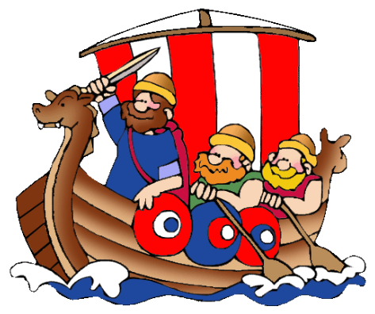 |  |  |  |   The Stone Age to Iron Age |  |  | Romans and the impact on Britain |  |  |  |  |  |  |   Ancient Egypt
Non- core subjects | Geography   |  | Land, mass and sea  Exploring countries, continents and oceans |  |  |  |  |  |  |  |  |  | Extreme Earth  Exploring volcanoes around the world |  |  |  |  |  | Raging Rivers  A Local river study with fieldwork
Non- core subjects | Art   |  | Painting/ Printing  Artist study :Banksy Singing in the rain   |  |  |  |  |  |  |  |  |  | Drawing/painting  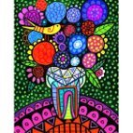  Artist: Heather Galler Creating art in her style- flowers and bold colours |  |  |  |  |  | 3D form- Using paper mache to make a river landscape  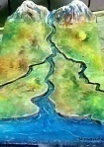  Painting- exploring different techniques to decorate
Non- core subjects | D & T   |  |  |  | Mechanisms-  Levers and linkages  Design and make a moving Stone Age character |  |  | Construction:  Design and make a Roman shield |  |  |  |  |  |  | Food and Nutrition-  Design and make Egyptians bread
Non- core subjects |   Computing (Purple Mash)  Digital literacy  Computer Science  Information technology |  | Online safety- delivered throughout the year using 2BeSafe
Non- core subjects |  |  | Unit -Touch typing |  | Unit- Coding |  |  | Unit- Spreadsheets |  |  |  |  | Unit- Email |  | Unit- Route planner |  |  |  | Unit - Presentations
Non- core subjects | Music   |  |  |  | Charanga Unit: Let your spirit fly  Genre: RnB |  |  |  |  |  |  |  | Charanga Unit: Glockenspiel Performance- unit 1  Genre: Percussion |  |  |  |  |  | Charanga Unit: Three little birds  Genre: Reggae  Charanga Unit: The Dragon Song  Genre: Traditional Folk
Non- core subjects | PE   |  | Football  (Primary PE Unit-Football)  outside |  | Dodgeball  (Primary PE Unit-Primary PE) outside |  |  | Handball  (Primary PE Unit-Handball) outside |  |  |  |  | Tennis  (Primary PE- tennis) outside |  | Kwik cricket  (Primary PE Unit-Kwik cricket) outside |  |  |  | Basketball  (Primary PE Unit-basketball) outside
Non- core subjects |  |  | Fitness  (Primary PE Unit-Fitness)  hall |  | Yoga  (Primary PE Unit-Yoga) hall |  |  | Dance  (Primary PE Unit-Roman Dance) hall |  |  |  |  | Gym  (Primary PE Unit-Gymnastics) hall |  | Dance  (Primary PE Unit-Egyptian dance) hall |  |  |  | Athletics  (Primary PE Unit-Athletics) outside
Non- core subjects | RE  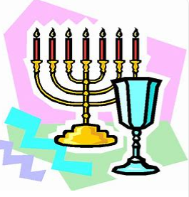 |  | Beliefs and questions    What difference does it make to be a Christian? How do Christian people’s beliefs about God, Jesus, and the world and others have impact on their lives?  (Christianity) |  |  |  |  | Inspirational people form the past  What can we learn from inspiring people in sacred texts and in the history of religions? Religious leaders: Moses, Jesus and Muhammad.  (Christians, Muslims and Jewish people. Non-religious worldviews such as Humanism can also be considered and so can Sikh Gurus.) |  |  |  |  |  |  | Religion, family and community: Prayer  How do religious families and communities practice their faith? The example of prayer.  (Christians and Muslims) |  |  |  | Worship and sacred places  Where, how and why do people worship? Investigating places of worship in Nottingham City and Nottinghamshire.  (Muslims, Hindus, Christians)
Non- core subjects | MFL   |  | Numbers  Colours  (KS1 - EL) |  | Incidental  recapping |  |  | Revisit:  Numbers 1-10  Colours (KS1 -EL) |  |  |  |  | Incidental  recapping |  | Revisit:  Greeting  (KS1- EL) |  |  |  | Incidental  recapping
New learning:
I know how …(KS1-EL)

New learning:
Greetings (KS1- EL)
Non- core subjects | PSHE  & British Values   |  | BM (Being Me in My World)  ‘Who am I and how do I fit?’    Understanding myself and others. |  | CD (Celebrating Difference)  Respect for similarity and difference. Anti-bullying and being unique  Family and friends -conflicts and resolutions. |  |  | DG (Dreams and Goals)  Aspirations, how to achieve goals and understanding the emotions that go with this  Keep on learning. |  |  |  |  | HM (Healthy Me)  Being and keeping safe and healthy  Healthy body and mind |  | RL (Relationships)  Building positive, healthy relationships  Families and friends |  |  |  | CM (Changing Me)  Coping positively with change  Growing and learning,
Non- core subjects | Curriculum Enrichment opportunities   |  |   Kate Fear- Trinity Church |  | Trip to Cresswell Crags  Colwick Woods visit (English) |  |  | Roman topic- performance to parents  Kate fear – Trinity Church  World book day  Careers week- links with community |  |  |  |  |   Stephen Lawrence Day  Kate Fear- Trinity Church  Eid day |  | Egyptian day  Use of secondary food lab  Mental health awareness day |  |  |  | River study trip  Charity Day  Culture Day  Animal handling workshop – Science
 | Parental involvement   |  | Parents evening |  |  |  |  | Roman topic performance/ showcase event  Careers week- showcase |  |  |  |  | Parents evening |  | Curriculum celebration event – rainforest week |  |  |  | Culture day  Sports week

