YEAR 4  2026-27 |  |  | Autumn Term |  |  |  | Spring Term |  |  |  |  |  |  |  | Summer Term
Termly breakdown |  |  | 6 weeks 1 day |  | 7 weeks |  | 6 weeks |  |  |  |  |  | 5 weeks |  | 7 weeks |  |  |  |  | 7 weeks
Topic Driver and theme title |  |  | Brilliant books |  | Marvellous Metal |  | Mayan and Aztecs |  |  |  |  |  | Animals and us |  | Creative concoctions |  |  |  |  | The power of me
 | English | Theme and text driver |   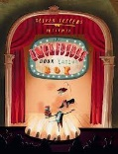 |  | 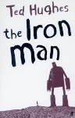       |  | 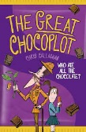 |  |  |  |  |  |   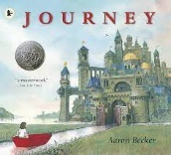 |  | 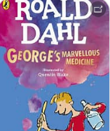 |  |  |  |  | 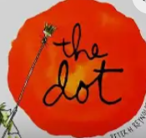
 | English | Whole school theme weeks |  |  |  |  |   Careers week/ work in the community  (week 6) |  |  |  |  |  |  |  |   Rainforest week- art focus (week 7) |  |  |  |  | Sports week  (Week 6)  
 | English | Writing genres  GPS  Spelling   | Narrative – the incredible book eating boy | Letter-  From perspective of doctor | Narrative- The Iron man | Diary- related to Ironman | Letter-The great chocoplot |  | Chronological report- from bean to bar |  |  |  | Narrative-The journey | Review of Wollaton Hall | Poetry | Recipe and report- George’s marvellous medicine | Recipe- instructions on how to make a healthy food (smoothie) |  | Persuasion advert  Linked to smoothie | Fact file- The digestive system |  |  | Narrative/poetry  The Dot
 | English | Guided Reading /  Phonics   | 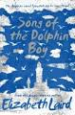  Song of the dolphin boy- Elizabeth Laird |  | Monster Slayer- Brian Pattern (version of Beowulf)  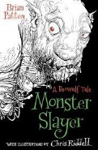 |  | 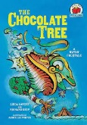  The chocolate tree- traditional    tale |  |  |  |  |  | 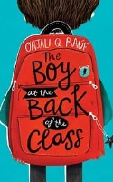  The Boy at the back of the class |  |  |  |  |  |  | The legend of Podkin one ear- Kieran Larwood  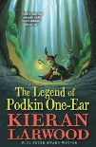
 | English | Class texts   | Planet Omar- Accidental Trouble Magnet  - Zanib Main |  | Song of the dolphin boy-  Elizabeth Laird |  | The boy at the back of the class-Onjali.K. Rauf |  |  |  |  |  |  |  |  |  |  |  |  | Podkin- 1 ear
 | Mathematics  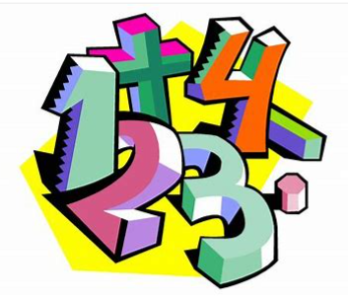 |  | Place value- 4 weeks | Addition and subtraction – 2 weeks | Revisit addition and subtraction – 1 week | Multiplication and division – 6 weeks | Revisit addition and subtraction- 1wk | Revisit multiplication and division – 1 week |  | + & - with length and perimeter -2 weeks | Area including multiplication – 1 wk | Revisit 4 operations – 1 wk | Fractions- 4 weeks | Decimals- 1 week | Revisit 4 operations – 1 week | Decimals 4 wks | 4 operations- involving money – 1 week | Time- 1 week |  |  | Revisit 4 operations – 1 week | Statistics with 4 ops- 1 |  | Shape/ position/ direction – 3 wks | Revisit fractions- 1 wk | consolidation 1 wk
 | Science   |  | State of matter  Exploring the 3 states, their properties and how they can change. |  | Electricity  Electrical appliances around us, insulators and conductors. How to make a simple circuit. |  | Sound  How sound and made and how it travels |  |  |  |  |  | Living things and their habitats  How habitats can change or be destroyed- the impact on animals.  Classifying animals according to their characteristics. |  | Living things and their habitats  A continuation from last term  Animals, including humans  The digestive system, a close look at our mouth and teeth. Carnivores, herbivores and the food chain.
Non- core subjects | History  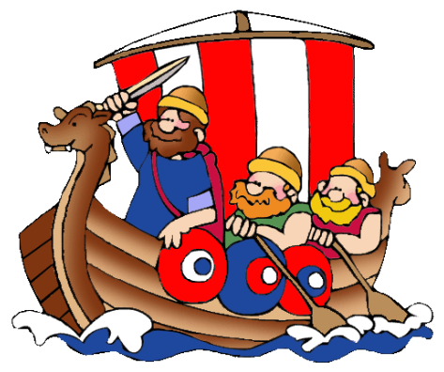 |  |  |  | Britain’s settlement by Anglo-Saxons |  | Civilization: Mayan and Aztecs |  |  |  |  |  |  |  |  |  |  |  |  |   The changing power of monarchs using case studies
Non- core subjects | Geography   |  | Whacky Weather  Exploring water cycle and thunderstorms |  |  |  |  |  |  |  |  |  | UK vs Spain  Cities of the UK, Countries, continents  Comparing and contrasting Nottingham and region of Spain |  | UK vs South America  Comparing and contrasting types of settlements
Non- core subjects | Art   |  |  |  | Drawing:  Artist: illustrator Chris Mould  Chalk and charcoal sketch of the ironman  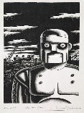 |  |  |  |  |  |  |  | Printing:  Create a resist print of an Aztec pattern.  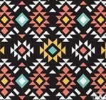 |  |  |  |  |  |  | Drawing/ Paintings  Artist study: Hans Holbein  British Monarchs from the past.  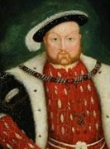
Non- core subjects | D & T   |  |  |  | Construction/ electrical systems:  Design and make a replica of the Iron man |  | Food and Nutrition:  Design and make Mayan corn tortillas |  |  |  |  |  |  |  | Construction:  Design and make an interactive model to show how the digestive system works.
Non- core subjects | Computing  Purple Mash    Information technology  Computer science  Digital literacy |  | Online safety-delivered throughout the year using 2BeSafe
Non- core subjects |  |  | Unit- Coding |  | Unit- Animation |  | Unit- Logo |  |  |  |  |  | Unit- Effective searching |  | Unit – Sound stories |  |  |  |  | Unit- Introduction to AI
Non- core subjects | Music   |  |  |  | Charanga Unit: Mamma Mia  Genre: Pop |  |  |  |  |  |  |  | Charanga Unit: Glockenspiel Performance- unit 2  Genre: Percussion |  |  |  |  |  |  | Charanga Unit: Stop!  Genre: Grime  Charanga Unit: Lean on me  Genre: Soul/Gospel
Non- core subjects | PE   |  | Dodgeball  (Primary PE Unit-Dodgeball)  Outside |  | Invasion games – handball outside  (Primary PE Unit-Handball) |  | Kwik cricket  (Primary PE unit- kwik cricket) outside |  |  |  |  |  | Netball  (Primary PE- netball) outside |  | Striking and fielding- rounders  (Primary PE Unit- rounders)  Outside |  |  |  |  | Football  (Primary PE Unit Football)  outdoor
Non- core subjects |  |  | Yoga  (Primary PE Unit-Yoga) hall |  | Dance  (Primary PE Unit-Dance) hall |  | Fitness  (Primary PE Unit-Fitness) hall |  |  |  |  |  | Gymnastics  (Primary PE Unit-Gymnastics) hall |  | Indoor Athletics  (Primary PE unit- Indoor athletics  Hall |  |  |  |  | Tennis  (Primary PE Unit-Tennis)  Outside
 |  |  |  |  |  |  |  |  |  |  |  |  | Swimming
Non- core subjects | RE  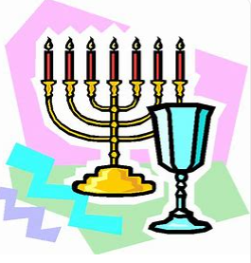 |  | Religion, family,  community,  worship,  celebration,  ways of living  How do Hindu  families practise faith? What are the deeper meanings of some Hindu festivals?  (Hinduism) |  | Spiritual expression  Christianity, music and worship: what can we learn?  (Christianity and also the idea of being ‘spiritual but non-religious) |  | Symbols and religious expression  How do people express their religious and spiritual ideas on pilgrimages?  (Islam, Hinduism, Christianity, non-religious worldviews) |  |  |  |  |  |  |  | The journey of life and death  Why do some people think life is like a journey? Where do we go? What do different people think about life after death?  (Christianity, Hinduism, Islam, Non-religious worldviews such as Humanism can also be considered)
Non- core subjects | MFL  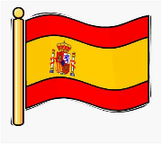 |  | Revisit:  Me presento: about me |  | Incidental recap |  | Revisit:  Las Estaciones – The seasons(EL) |  |  |  |  |  | Incidental recap |  | Revisit:  Animals |  |  |  |  | Incidental recap
Non- core subjects |  |  | New learning:  Animals (EL) |  |  |  | New learning:  Fruit and veg (EL) |  |  |  |  |  |  |  | New learning: Weather and date (IN)
Non- core subjects | PSHE  & British Values  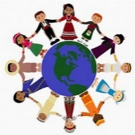 |  | BM (Being Me in My World)  'Who am I and how do I fit?'  Democracy   |  | CD (Celebrating Difference)  Respect for similarity and difference. Anti-bullying and being unique  Accepting self and others. |  | DG (Dreams and Goals)  Aspirations, how to achieve goals and understanding the emotions that go with this  Hopes and dreams |  |  |  |  |  | HM (Healthy Me)  Being and keeping safe and healthy  Inner strength |  | RL (Relationships)  Building positive, healthy relationships  Changes – grief and memories. |  |  |  |  | CM (Changing Me)  Coping positively with change  Changing Me
Non- core subjects | Curriculum Enrichment opportunities   |  | Visit to Hindu temple |  | Visit from UON lecturer for robot workshop morning |  | Maya experience day  Food tech lab  Year 4 whole school virtual concert with the music service  Y4- Great Orchestra Experiment live concert  Whole school careers week and links with community |  |  |  |  |  | Performance-Linked to Mayans & Aztecs  Visit –Wollaton Hall (Science focused)  Eid day |  | Rainforest week |  |  |  |  | Big band concert    Charity day  Culture day  Whole school sports week
 | Parental involvement   |  | Parents evening |  | Ironman showcase event |  | Careers week showcase |  |  |  |  |  | Mayan AND Aztecs performance  Parents evening |  | Rainforest week- showcase |  |  |  |  | Culture day  Summer Fayre  Sports week

