YEAR 6  2026- 27 |  |  | Autumn Term |  |  |  |  |  |  |  |  | Spring Term |  |  |  |  |  |  | Summer Term
Termly breakdown |  |  | 6 weeks 1 day |  |  |  |  | 7 weeks |  |  |  | 6 weeks |  |  |  | 5 weeks |  |  | 7 weeks |  |  |  |  | 7 weeks
Theme and text driver |  |  | The Blitz      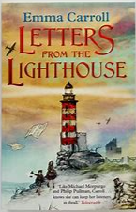 |  |  |  |  |   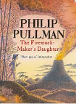    Sparks will fly   |  |  |  |   Aspirations  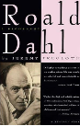 |  |  |  | Protecting our planet    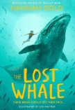 |  |  | 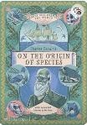  Adapting and Evolving |  |  |  |  | 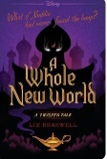  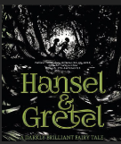  Traditional with a twist
Whole school theme weeks |  |  |  |  |  |  |  |  |  |  |  |   Careers week/ work in the community  (week 6) |  |  |  |  |  |  |   Rainforest week- art focus (week 7) |  |  |  |  | Sports week    (week 6)
 | English | Writing genres  GPS  Spelling   | Diary- linked to WW2 |  | Narrative- Letter from the lighthouse |  |  | Narrative- The firework makers daughter | Letters – From different perspectives |  |  | Narrative Poem- Hope-o-potamus |  | Biography- Overco ming adversity |  | Narrative Lost whale– scene setting and character development |  | Shorter pieces of writing with GPS focus | SATS Prep- apply to writing |  |  | Non Chronological report -Origin of the Species |  | Narrative – Hansel and Gretel -scenes from different perspective |  |  | Diary entry - A whole new world a twisted tale
 | English |   Guided Reading / Class text | Letters from the Lighthouse – Emma Carroll |  |  |  |  |  |  |  |  | The lost whale- Hannah Gold  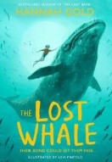 |  |  |  |  |  |  | SATS prep  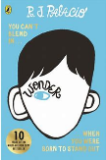  Wonder – R. J. Palacio
 | Mathematics  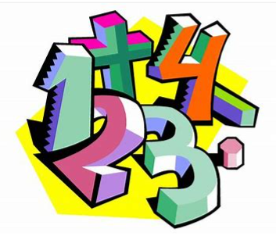 |  | Number and place value- 1 wk | Number and place value- including negative no. 1 wk |  | Addition and subtraction- 2 wks | Multiplication and division- 2wks | Revisit 4 op – 1 wk | Fractions- 3 wks | Decimals including converting units 2 wks | Position & direction -1wk | Fraction, decimals and percentages- 3wks | Ratio and proportion – 2 wks |  | 4 op, fract, dec, % - 1 wk | Revisit 4 op, fractions , decimals and percentages- 1wk | Perimeter, area and volume- including 4 ops – 2 wks | Algebra, including properties of shape – 2 wks | Statistics- with 4 op & angles- 1 wk | Revision- 3Wks | SATS week |  | Revisit 4 op, fract, decimals and percentages – 2 wks | 4 op, fract, dec &% - 1 wk | Ratio and proportion -1 wk | Statistics incl angles- 1 wk | Revisit algebra including property of shape– 1 wk | Themed projects, consolidation and probelm solving
 | Science   |  | Animals including humans  The circulatory system |  |  |  |  | Electricity  Series and parallel circuit, types of conductors and insulators, function of components in a circuit. |  |  |  | Living things and their habitats  Reproduction in plants and animals |  |  |  | Evolution and inheritance  Exploring how adaption to environment can lead to evolution |  |  |  |  |  |  |  | Light  Light sources and how light travels. Exploration of shadows, rainbows and reflection.
Non- core subjects | History  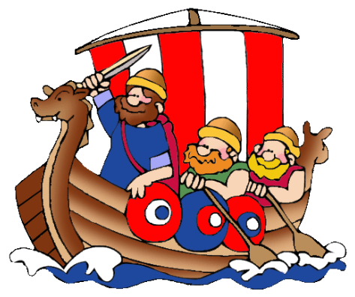 |  | WW2      (Significant turning point in history) |  |  |  |  |  |  |  |  | Ancient Greece  
Non- core subjects | Geography   |  |  |  |  |  |  | UK vs Greece  Comparing UK and Greece- comparing human and physical a features, population, diversity and tourism |  |  |  |  |  |  |  | Cataclysmic Climate Change  Exploring how human and physical processes result in climate change and impact the planet. |  |  | Our Wonderful World  Locating and comparing regions using sophisticated map skills.
Non- core subjects | Art   |  | 3D from  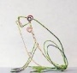  Artist study: Bridget Baker, Alexander Calder, Elizabeth Berrien  Wire art linked to WW2 |  |  |  |  |  |  |  |  |  |  |  |  | Drawing and painting:  Drawings of animals linked to evolution (linked to Science)  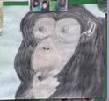 |  |  |  |  |  |  |  | Drawing/ Painting:  Optical illusion  Artist study: Bridget Riley  
Non- core subjects | D & T   |  |  |  |  |  |  | Construction/ electrical systems  Design and make a theme park ride- powered by electrical circuit |  |  |  | Food and Nutrition:  Design and make a simple Greek dish |  |  |  |  |  |  |  |  |  |  |  | Textiles:  Design and make a sunglasses case for your summer holidays
Non- core subjects |   Computing (Purple Mash)  Digital literacy  Computer Science  Information technology |  | Online safety delivered throughout the year using 2BeSafe
Non- core subjects |  |  | Unit- Coding |  |  |  |  | Unit- spreadsheets |  |  |  | Unit- Graphing |  |  |  | Unit- 3D modelling |  |  | Unit - Networks |  |  |  |  | Unit- Blogging
Non- core subjects | Music   |  |  |  |  |  |  | Charanga Unit: Happy  Genre: Pop/ neo-soul |  |  |  |  |  |  |  | Charanga Unit: Classroom Jazz- Unit 2  Genre: Pop ballad |  |  |  |  |  |  |  | Charanga Unit: The music of Carole King  Genre: Pop
Non- core subjects | PE   |  | Invasion games- basketball  (Primary PE Unit-basketball)  outside |  |  |  |  | Invasion games- football  (Primary PE Unit-football) outside |  |  |  | Netball  (Primary PE unit – netball)  Outside |  |  |  | Fitness  (Primary PE Unit-fitness)  outside |  |  | Gymnastics  (Primary PE Unit-Gymnastics)  hall |  |  |  |  | Indoor Athletics  (Primary PE Unit-Indoor Athletic  hall
Non- core subjects |  |  | Developing less traditional activities- dodgeballs  (Primary PE Unit-dodgeball) outside |  |  |  |  | Handball  (Primary PE unit – handball)  hall |  |  |  | Kwik cricket  (Primary PE Unit-Kwik Cricket) outside |  |  |  | Tag rugby  (Primary P unit- tag rugby)  Outside |  |  | Athletics  (Primary PE Unit-Athletics)  Outside |  |  |  |  | Net and wall- Tennis  (Primary PE Unit-Tennis)  outside
 |  |  |  |  |  |  |  |  |  |  |  | Swimming- top up
Non- core subjects | RE  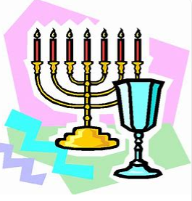 |  | Belief in action in the world  How do religions and beliefs respond to global issues of human rights, fairness, social justice and the importance of the environment?  (Christianity, Hinduism, Humanism)  (Christianity, Hinduism and Humanism) |  |  |  |  | Belief in action in the world  What was the Kindertransport? Who resisted and rescued? How can we be Upstanders today?  (Judaism) |  |  |  | Teachings, wisdom and authority  What can we learn by reflecting on words of wisdom from religions and worldviews?  (Christianity & Islam) |  |  |  |  |  |  | Religion, worldviews, family and community  What contributions do religions make to local life in Nottingham City and Nottinghamshire? How can we make Nottingham City and Nottinghamshire a country of tolerance and respect?  (Christianity, Islam)
Non- core subjects | MFL   |  | Revisit:  The date (KS2 IN) |  |  |  |  | Incidental  recapping |  |  |  | Revisit:  Seasons (KS2 IN) |  |  |  | Incidental recapping |  |  | Revisit:  Do you have a pet? (KS2 IN) |  |  |  |  | Incidental recapping
Non- core subjects |  |  | New learning:  Do you have a pet? (KS2 IN) |  |  |  |  |  |  |  |  | New learning:  In the classroom (KS2 IN) |  |  |  |  |  |  | New learning:  At the weekend (KS2 Pro)
Non- core subjects | PSHE  & British Values   |  | BM (Being Me in My World)  'Who am I and how do I fit?'  My impact on the community and the world. |  |  |  |  | CD (Celebrating Difference)  Respect for similarity and difference. Anti-bullying and being unique  Differences: Conflict or celebration? |  |  |  | DG (Dreams and Goals)  Aspirations, how to achieve goals and understanding the emotions that go with this  Making the world a better place. |  |  |  | HM (Healthy Me)  Being and keeping safe and healthy  Staying safe in the world. |  |  | RL (Relationships)  Building positive, healthy relationships  Managing feelings through different circumstances. |  |  |  |  | CM (Changing Me)  Coping positively with change  Conception.  From Year 6 to teenager.
Non- core subjects | Curriculum Enrichment opportunities   |  | Yr6 residential |  |  |  |  | Christmas Concert with Music service for year 5 and year 6 musicians |  |  |  | MHST NottAlone Festival  INTU University- Visit for PP- work to support careers and aspirations  Whole school careers week |  |  |  | Spring concert with the music service  Eid day |  |  | Whole school rainforest week |  |  |  |  | Whole school sports week  Climbing depot  University Campus Visit- career aspirations (architecture and design)  Nottingham Tennis Open  City ground tour  Summer concert with music service  Grade 1 exams for Strings  Charity day    Culture day
 | Parental involvement   |  | Parents evening |  |  |  |  |  |  |  |  | Parents in for science week to explore science capital.  Careers week showcase |  |  |  | Parents evening |  |  | SATS preparation evening  Curriculum celebration event  Rainforest week showcase |  |  |  |  | End of year performance  Culture day  Sports week

