The following pages show progression in calculation (addition, subtraction, multiplication and division) and how this works in line with the National Curriculum. The consistent use of the CPA (concrete, pictorial, abstract) approach helps children develop mastery across all the operations in an efficient and reliable way. This policy shows how these methods develop children’s confidence in their understanding of both written and mental methods.
Addition
Key language: addition, add, more, and make, sum, total, altogether, double, near double, half, halve one more, two more, ten more, one hundred more, one thousand more… how many more to make …? how many more is … than …? how much more is …?
Year 1
Objective | Concrete | Pictorial | Abstract
Add two 1-digit numbers to 10 | When adding numbers to 10, children can explore both aggregation (combining a range of values to make a single value) and augmentation (increasing the value).     | Use pictures to add two numbers together as a group.  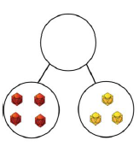 | Use the part-part-whole diagram to move into the abstract.  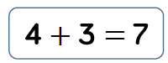  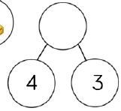  4 + 3 = 7  (4 is a part, 3 is a part, 7 is a whole)  4 + 3 = 7  3 + 4 = 7  7 = 3 + 4  7 = 4 + 3  3 +__ = 7  __+ 3 = 7
Add 1 and 2 digit numbers to 20 | When adding one-digit numbers that cross 10, it is important to highlight the importance of ten ones equalling one ten.   | Use pictures or a number line. Regroup or partition the smaller number to make 10.  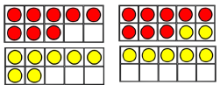  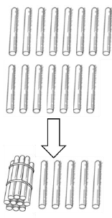 | Use the number line to move into the abstract.  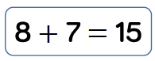  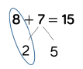  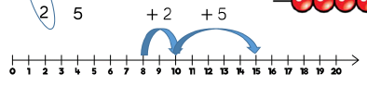
Year 2
Objective | Concrete | Pictorial | Abstract
Adding three 1-digit numbers | When adding three 1-digit numbers, children should be encouraged to look for number bonds to 10 or doubles to add numbers more efficiently.  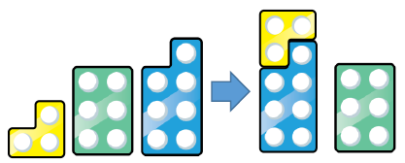 | Add together three groups of objects. Draw a picture to recombine the groups to make 10.  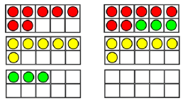 | Combine the two numbers that make  10 and then add on the remainder.  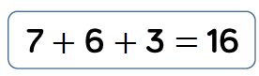  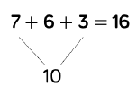
Add 1-digit and 2-digit numbers to 100 | When adding single digits to a two digit number, children should be encouraged to count on from the larger numbers.  They should also apply their knowledge of number bonds to add more efficiently e.g. 8 + 5 = 13 so 38 + 5 = 43  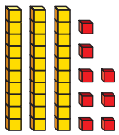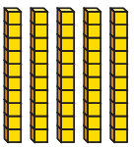  =  + | 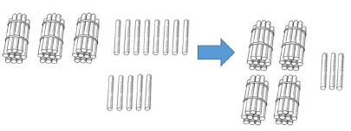 | 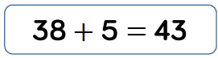  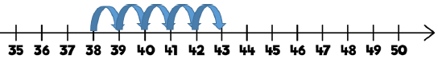  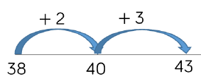
Add two 2-digit numbers to 100 | At this stage, encourage children to use the formal column method when calculating straws, base 10 or place value counters. As numbers become larger, straws become less efficient.  Continue to develop understanding of partitioning and place value.  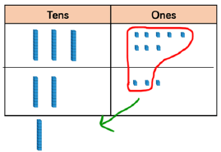  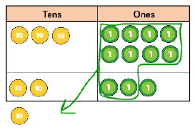 | 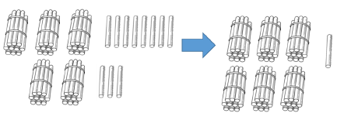 | 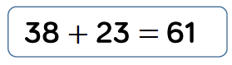  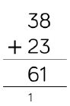  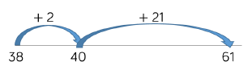
Year 3/4
Objective | Concrete | Pictorial | Abstract
Add numbers with up to 4- digits - Column method with regrouping. | Make both numbers on a place value  Grid. Base ten and place value counters are most effective when adding numbers with up to 4-digits. When there are 10 ones in the 1’s column- we exchange for 1 ten, when there are 10 tens in the 10’s column (in the example below) we exchange for 1 hundred and so on.  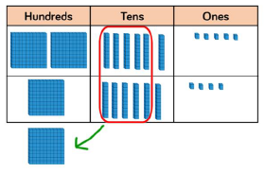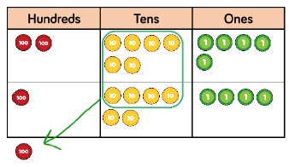  As children move on to decimals, money  and decimal place value counters can be  used to support learning.  NB By Year 4 children will progress on to  adding four digit numbers. | Children can draw a pictorial  representation of the columns and place  value counters to further support their  learning and understanding.  NB Addition of money needs to have £  and p added separately.  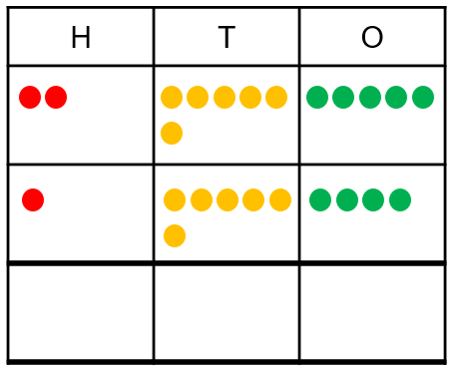 | 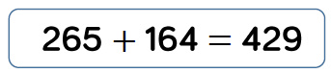  200 + 60 + 5  100 + 60 + 4  400 + 20 + 9 = 429  As the children progress, they will move  from the expanded to the compacted  method.  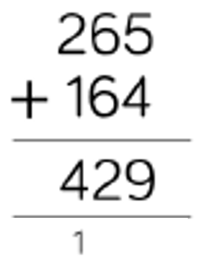  As the children move on, introduce  decimals with the same number of  decimal places and different. Money can  be used here.
Year 5/6
Objective | Concrete | Pictorial | Abstract
Add numbers with more than 4- digits - Column method with regrouping – Children consolidate their understanding using numbers with more than 4 digits | 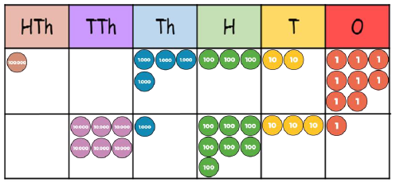 | 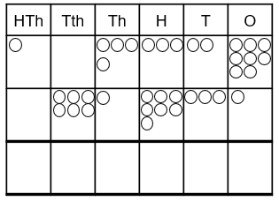 | At this stage, children should be encouraged to work in the abstract, using the column method to add larger numbers efficiently.  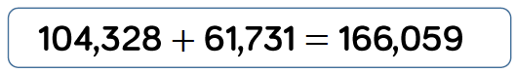  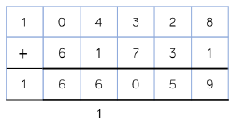
Add numbers up to 3 decimal places | Introduce decimals with the same number of decimal places and then move children onto adding with a variety of decimal places. This includes putting this into context when adding money and other measures.  Make both numbers on a place value  Grid. Place value counters are most effective when adding decimals. When there are 10 tenths in the Tth’s column, we exchange for 1 one and so on. 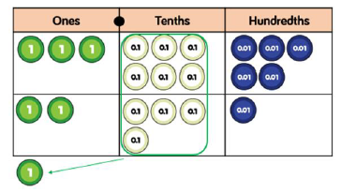 | 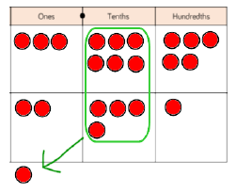 | 

