The following pages show progression in calculation (addition, subtraction, multiplication and division) and how this works in line with the National Curriculum. The consistent use of the CPA (concrete, pictorial, abstract) approach helps children develop mastery across all the operations in an efficient and reliable way. This policy shows how these methods develop children’s confidence in their understanding of both written and mental methods.
Division
Key language: halving, sharing, share, share equally, split, repeated subtraction, division, dividing, divide, divided by, divided into, divisor, dividend, quotient, grouping, grouped, ungrouped, left, left over, remainder
Year 1/2
Objective | Concrete | Pictorial | Abstract
Solve 1-step problems using division (sharing) | Children solve problems by sharing amounts into equal groups.  In Year 1, children use concrete and pictorial representations to solve problems. They are not expected to record division formally.  In Year 2, children are introduced to the division symbol.  20 ÷ 5 = 4  Children use any concrete objects such as counters (example below) or cubes and share them into 5 equal groups.  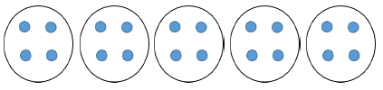 | Represent the sharing pictorially.  There are 20 apples altogether. They are shared equally between 5 bags. How many apples are in each bag?  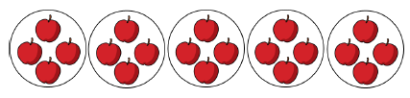  Arrays will also be used to support children’s understanding.  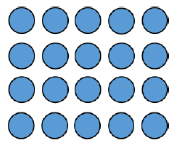 | 20 ÷ 5 = 4
Solve 1-step problems using division (grouping) | Children solve problems by grouping and counting the number of groups.  Grouping encourages children to count in multiples and links to repeated subtraction on a number line.  They can use concrete representations in fixed groups such as number shapes (numicon) which helps to show the link between multiplication and division.   | Represent the grouping pictorially.  There are 20 apples altogether. They are put (grouped) in bags of 5. How many bags are there?  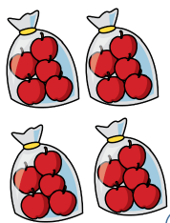  Use a number line to show jumps in  groups. The number of jumps equals the  number of groups.  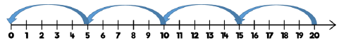  Arrays help to show the link between multiplication and division.  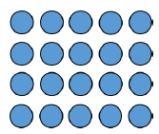  20 ÷ 5 = 4  20 ÷ 4 = 5  5 x 4 = 20  4 x 5 = 20 | 20 ÷ 5 = 4  Children should also be encouraged to use their 5 times table facts.
Divide 2-digits by 1 digit (sharing with no exchange) | When dividing larger numbers, children can use manipulatives that allow them to partition into tens and ones.  Place value counters and Base 10 can be used to share numbers into equal groups.  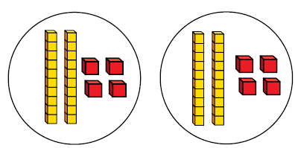  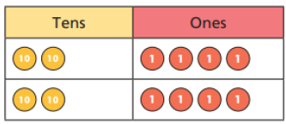 | Represent sharing pictorially  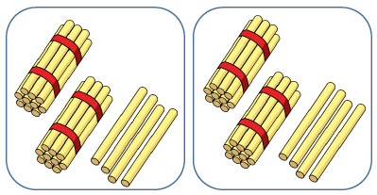 | 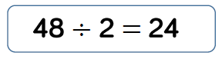  Part-whole models can provide children with a clear written method that matches the concrete representations.  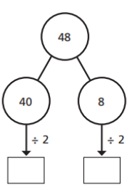
Year 3/4
Objective | Concrete | Pictorial | Abstract
Divide 2 digits by 1-digit (sharing with exchange) | When dividing numbers involving an exchange children can use base ten and place value counters to exchange one ten for ten ones.  Children should start with the equipment outside the place value grid before sharing the tens and ones equally between the rows.  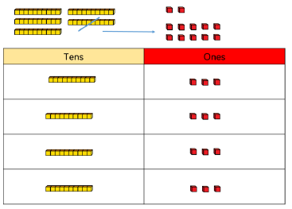 | Children can represent the work they  have done with place value counters in a  way that they understand.  They can draw the counters, using  colours to show different amounts or  just use circles in the different columns  to show their thinking.  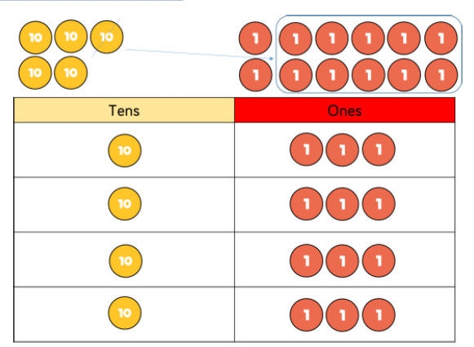 | 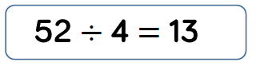  Flexible partitioning in a part-whole model supports this method.  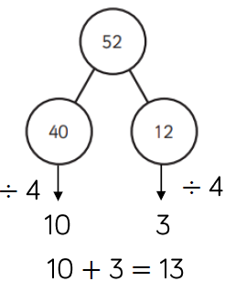
Divide 2 digits by 1-digit (sharing with remainders) | When dividing with remainders, children can use base 10 and place value counters to exchange one ten for ten ones.  Starting with the equipment outside the place value grid will highlight remainders, as they will be left outside the grid once the equal groups have been made.  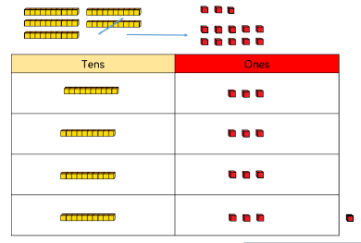 | Children can represent the work they  have done with place value counters in a  way that they understand.  They can draw the counters, using  colours to show different amounts or  just use circles in the different columns  to show their thinking.  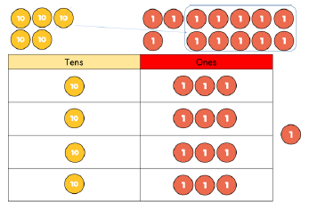  The bar model also supports children’s understanding with this concept.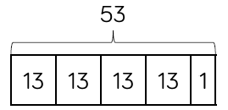 | 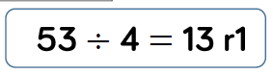  Flexible partitioning in a part-whole model supports this method.  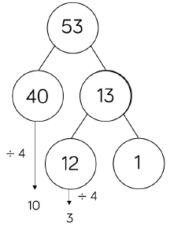
Year 4/5
Objective | Concrete | Pictorial | Abstract
Divide 2 -digits by 1-digit (grouping) – Year 4  Divide 2/3/4 -digits by 1-digit (grouping) – Year 4 | When using the short division method, children use grouping. Starting with the largest place value. Then group by the divisor.  Language is important here. Children should consider ‘How many groups of 4 tens can we make?’ and ‘How many groups of 4 ones can we make?’  Remainders can also be seen as they are left ungrouped.  Base 10 or place value counters (below) can be used on a place value grid to support this understanding.  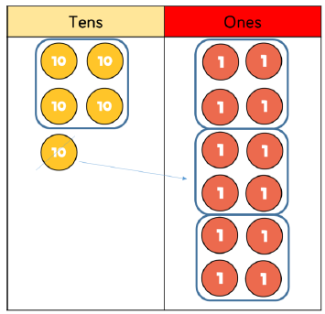 | They can draw their own counters and group them through a more pictorial method.  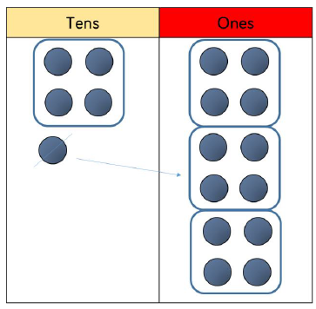 | 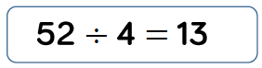  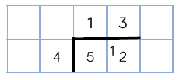
Year 6
Objective | Concrete | Pictorial | Abstract
Divide multi digits by 2-digits (short division) | When children begin to divide up to 4 digits by 2 digits, written methods become the most accurate as concrete and pictorial representations become less effective.  Children can write out multiples to support their calculations with larger remainders.  Children will also solve problems with remainders when the quotient can be rounded as appropriate. |  | 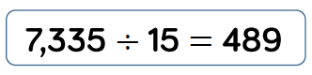  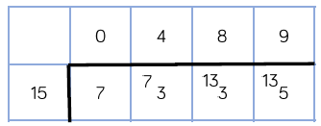
Divide multi digits by 2 digits (long division) | Again, written methods become the most accurate as concrete and pictorial representations become less effective.  Children can write out multiples to support their calculations with larger remainders. |  | When a remainder is left at the end of a calculation, children can either leave it as a remainder or convert it to a fraction.  This will depend on the context of the question.  Children can also answer questions where the quotient needs to be rounded according to the context.  

