The following pages show progression in calculation (addition, subtraction, multiplication and division) and how this works in line with the National Curriculum. The consistent use of the CPA (concrete, pictorial, abstract) approach helps children develop mastery across all the operations in an efficient and reliable way. This policy shows how these methods develop children’s confidence in their understanding of both written and mental methods.
Multiplication
Key language:, doubling, repeated addition, array, row, column, multiplication, multiply, multiplied by, multiple, times, groups of, lots of, equal groups of, multiple factor, product, squared, cubed, commutative, inverse.
Year 1/2
Objective | Concrete | Pictorial | Abstract
Solve 1-step problems using multiplication | Children represent multiplication as repeated addition in many different ways.      In Year 1, children use concrete and pictorial representations to solve problems. They are not expected to record multiplication formally.  In Year 2, children are introduced to the multiplication symbol. | Use pictures or a number line to continue support in counting in multiples.  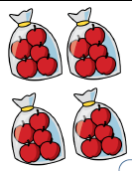  One bag holds 5 apples.  How many apples do 4 bags hold?  5 + 5 + 5 + 5 = 20  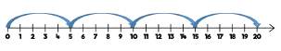 | Use an array to write multiplication  sentences and reinforce repeated  addition.    4 lots of 5 is the same as 5 + 5 + 5 + 5 = 20  5 groups of 4 is the same as 4 + 4 + 4 + 4 + 4 = 20  Children to  4 x 5 = 20  5 x 4 = 20
Year 3/4
Objective | Concrete | Pictorial | Abstract
Multiply 2-digit numbers by 1-digit numbers | Teachers may decide to first look at the expanded column method before moving on to the short multiplication method.  Base ten or place value counters should be used to support understanding of the method rather than supporting the multiplication, as children should use times table knowledge.  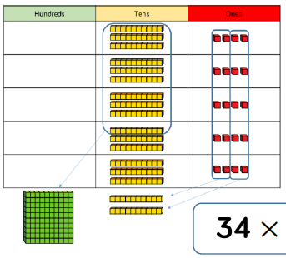 | Children can represent the work they  have done with place value counters in a  way that they understand.  They can draw the counters, using  colours to show different amounts or  just use circles in the different columns  to show their thinking as shown below.  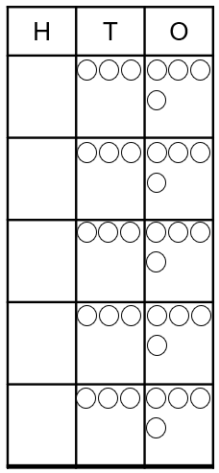 |   Expanded column method:  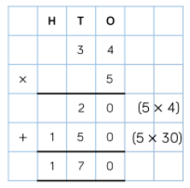  Short multiplication method:  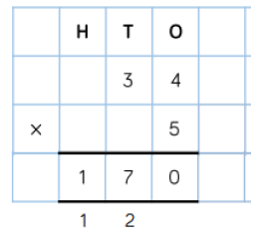
Multiply 3-digit numbers by 1-digit numbers | When moving to 3-digit by 1-digit multiplication, encourage children to move towards the short, formal method.  Base 10 and place value counters continue to support the understanding of the written method.  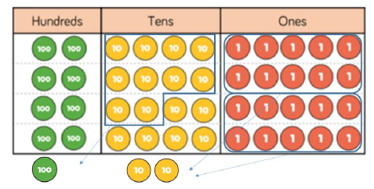  Limit the number of exchanges needed in the question and move children away from resources when multiplying larger numbers. | Children can represent the work they  have done with place value counters in a  way that they understand.  They can draw the counters, using  colours to show different amounts or  just use circles in the different columns  to show their thinking as shown below.  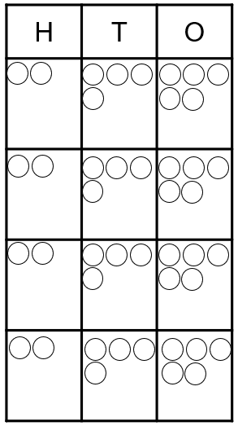 |   Short multiplication method 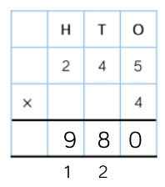
Year 5
Objective | Concrete | Pictorial | Abstract
Multiply 4-digit numbers by 1-digit numbers | When multiplying 4-digit numbers, place value counters are the best manipulative to use to support children in their understanding of the formal written method.  If children are multiplying larger numbers and struggling with their times tables, encourage the use of multiplication grids so children can focus on the use of the written method.  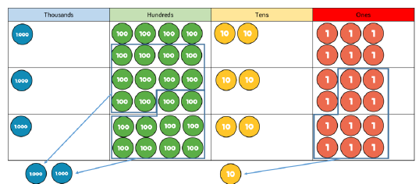 | Children can represent the work they  have done with place value counters in a  way that they understand.  They can draw the counters, using  colours to show different amounts or  just use circles in the different columns  to show their thinking as shown below.  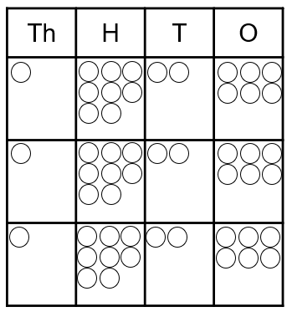 |   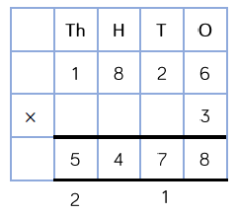
Multiply 2/3-digit numbers by 2-digit numbers | When multiplying multi-digit number by 2-digits, use the area model to help children understand the size of the numbers they are using. This links to finding the area of a rectangle by finding the space covered by the Base 10.  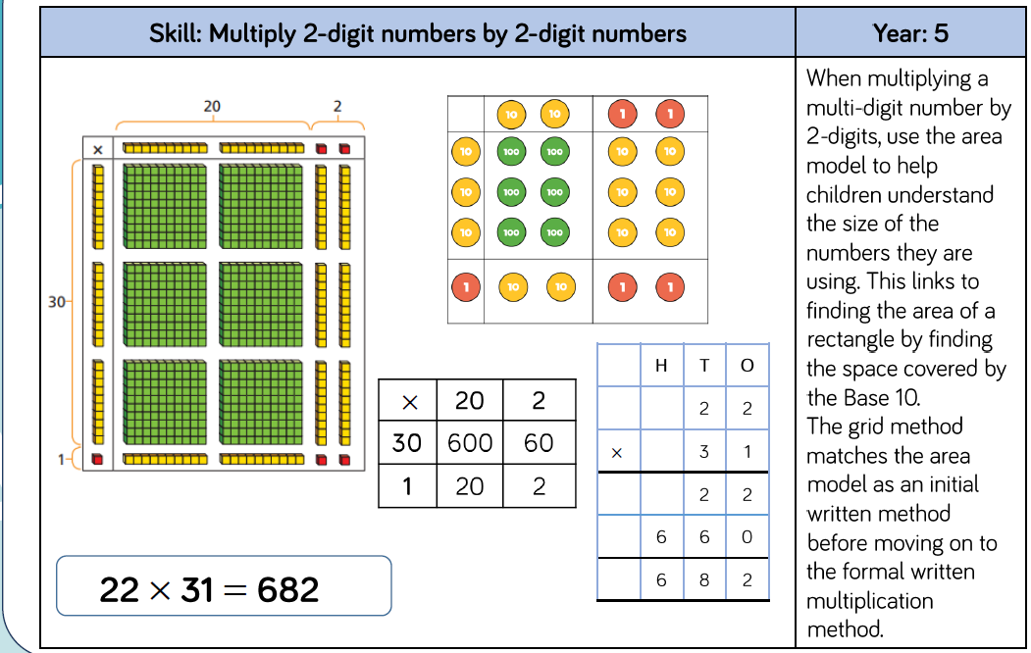  The grid method matches the area model as an initial written method before moving children on the formal written method. | Children can represent the work they  have done with place value counters in a  way that they understand.  They can draw the counters to show their thinking as shown below.  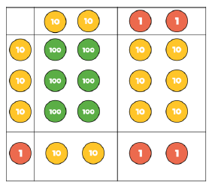  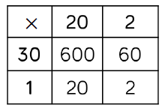 | Encourage children to move towards the formal written method, seeing the links with the grid method.
Year 6
Objective | Concrete | Pictorial | Abstract
Multiply 4-digit numbers by 2-digit numbers | When multiplying 4-digits by 2-digits, children should be confident in the written method. It will be difficult to support children using concrete resources due to the size of the calculation.  If they are still struggling with times tables, provide multiplication grids to support when they are focussing on the use of the method.  Consider where exchanged digits are placed and make sure this is consistent. | Due to the size of the calculation, it will be difficult for children to represent the calculation pictorially. |   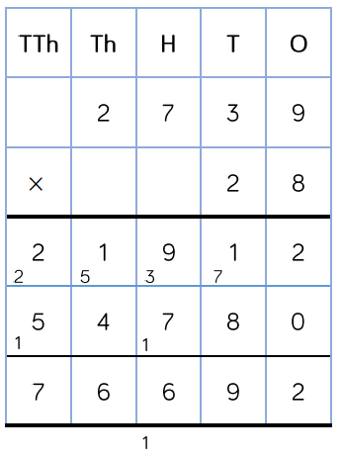
Times Table Expectations |  | Year 2: 2, 5, 10  Year 3: 2, 3, 4, 5, 8, 10  Year 4: All facts up to 12 x 12

