The following pages show progression in calculation (addition, subtraction, multiplication and division) and how this works in line with the National Curriculum. The consistent use of the CPA (concrete, pictorial, abstract) approach helps children develop mastery across all the operations in an efficient and reliable way. This policy shows how these methods develop children’s confidence in their understanding of both written and mental methods.
Subtraction
Key language:, subtraction, subtract, find the difference, take away, minus, deduct, decrease, fewer, less, left over.
Year 1
Objective | Concrete | Pictorial | Abstract
Subtract two 1-digit numbers to 10 | Physically taking away and removing objects from a whole (ten frames, Numicon, cubes and other items such as beanbags could be used).    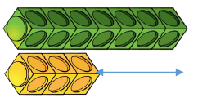  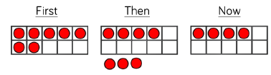  Counting back (using number lines or number tracks).  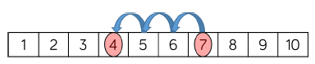 | Children to draw the concrete resources they are using and cross out the correct amount. The bar model and number lines can also be used.  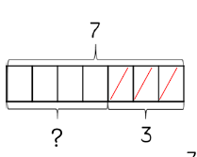 | 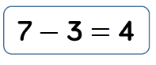  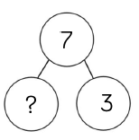  7 – 3 = ___  7 – 4 = ___  ___ = 7 – 3  ___ = 7 – 4  7 - ___ = 4  7 - ___ = 3
Subtract 1 and 2 - digit numbers to 20 | When subtracting one-digit numbers that cross 10, it is important to highlight the importance of ten ones equalling one ten.  Children should be encouraged to find the number bond to 10 when partitioning the subtracted number. Ten frames, number shapes and numbers lines or tracks are useful for this.  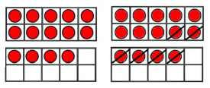  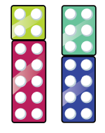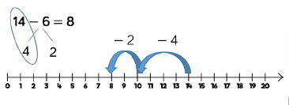 | Children to draw concrete resources (e.g. ten frames) or use pictures (below) and discuss what they did to make 10. E.g. start at 14. Take away 4 to reach 10. Then take away the remaining 2 so you have taken away 6 altogether. You have reached your answer.  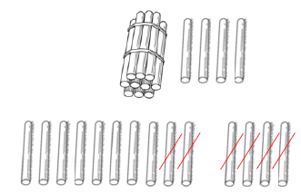 | 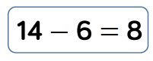  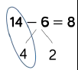
Year 2
Objective | Concrete | Pictorial | Abstract
Subtract 1 and 2 -digit numbers to 100 (with regrouping) | At this stage, children should be encouraged to use the formal column method when calculating alongside base ten or place value counters  Children can also use a blank number line to count on to find the difference. If using this method, encourage children to jump to multiples of 10 to become more efficient  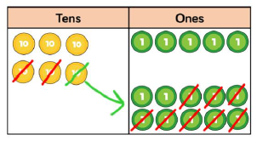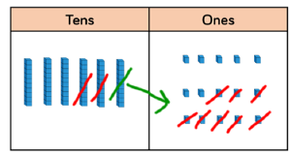 | Children can represent and draw concrete resources such as place value counters or base ten or they can use pictures (below); remembering to show what has been exchanged.  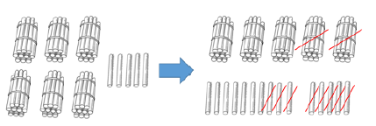 | Children must understand that when they have exchanged the 10 they still have 65 because 65 = 50 + 15.  Children must understand what has happened when they have crossed out digits.  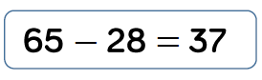  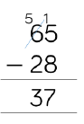
Year 3 & 4s
Objective | Concrete | Pictorial | Abstract
Subtract with up to 3-digits (Year 3)  Subtract with up to 4-digits (Year 4) | Base 10 and place value counters are the most effective manipulative when subtracting numbers with up to 3-digits.  Ensure children write out their calculation alongside any concrete resources so they can see the links to the written column method.  Start with one exchange before moving onto subtractions with more than one exchange.  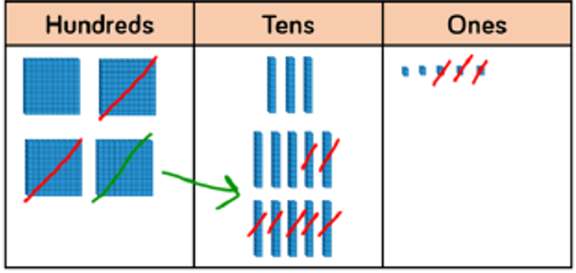  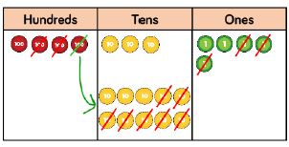 | Children can represent and draw concrete resources such as place value counters or base ten; remembering to show what has been exchanged.  The bar model is a pictorial representation of the concept. The bars are used to represent the known and unknown quantities.  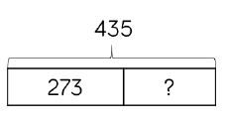  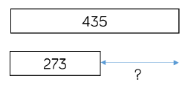 | 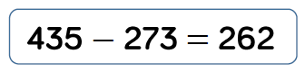  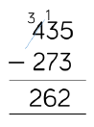
Year 5/6
Objective | Concrete | Pictorial | Abstract
Subtract with up to 4-digits | Base 10 and place value counters are the most effective manipulative when subtracting numbers with more than 4-digits.  At this stage, children should be encouraged to work in the abstract, using column method to subtract larger numbers efficiently.  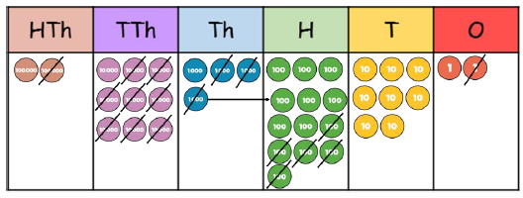 | The bar model is a pictorial representation of the concept. The bars are used to represent the known and unknown quantities.  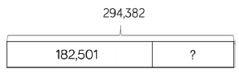  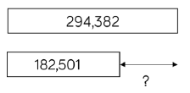 | 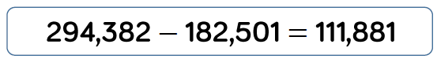  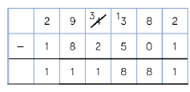
Subtract with up to 3 decimal places | Place value counters on a place value grid are most effective manipulative when subtracting with 1,2 and then 3 decimal places.  Ensure children have experience of subtracting decimals with a variety of decimal places. This includes putting this into context when subtracting money and other measures.  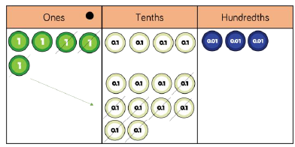 | Children can represent and draw concrete resources such as place value counters; remembering to show what has been exchanged.  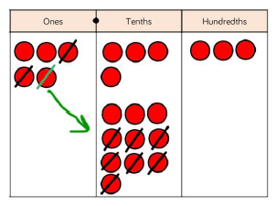  The bar model is a pictorial representation of the concept. The bars are used to represent the known and unknown quantities.  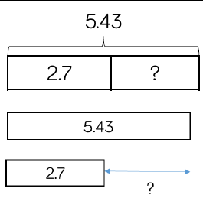 | 

