Supporting children with Special Educational Needs and Disabilities (SEND) in Maths at Nottingham Academy Primary
At Nottingham Academy Primary, we are committed to supporting all learners, including those with Special Educational Needs and Disabilities (SEND). Our approach emphasises quality first teaching and is underpinned by the mastery maths approach, which are supported by the big 5 ideas (representation and structure, fluency, mathematical thinking, variation and coherence). At our school, we meticulously structure our planning to ensure it is layered and progresses in small, logical steps which breaks down learning into manageable chunks preventing cognitive overload. Central to our methodology is the concrete, pictorial, abstract approach (see an example in our calculation policy below), which fosters children's conceptual understanding of mathematics, ensuring every student can thrive and succeed.
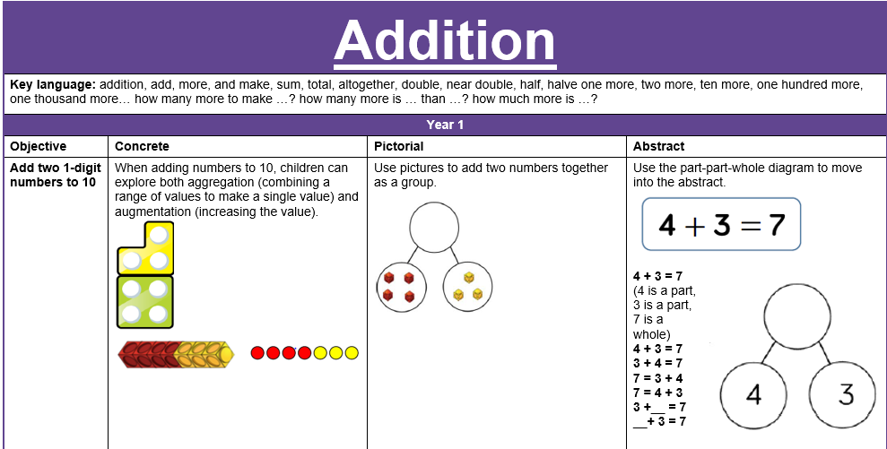
The SEND Code of Practice (2014)
The SEND Code of Practice groups needs into four broad areas to support schools to plan the provision that they offer:
- Cognition and learning;
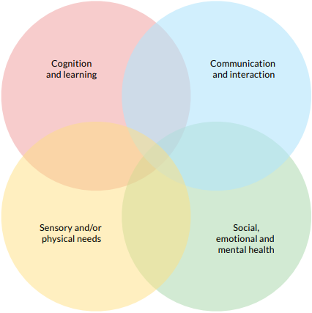
- Communication and interaction;
- Social, emotional, and mental health; and
- Sensory and physical needs.
Considering these primary needs is a useful first step, but a more detailed understanding of an individual child is required. At Nottingham Academy Primary, teachers understand the individual characteristics of pupils’ needs, and how these relate to their classroom environment and the content that they are teaching. Supporting pupils with SEND should be part of a proactive approach to supporting all pupils. We use the graduated approach which means teachers understand the specific barriers pupils face to learning, and therefore are clear about what they need in order to thrive at our school. Using guidance from the Education Endowment Foundation, we consider five strategies aimed at supporting pupils with SEND.

Five strategies aimed at supporting pupils with SEND:
Create a positive and supportive environment for all pupils without exception | Build an ongoing, holistic understanding of your pupils and their needs | Ensure all pupils have access to high quality teaching | Complement high quality teaching with carefully selected small-group and one-to-one interventions | Work effectively with teaching assistants
- We are an inclusive school that removes barriers to learning and participation, provides an education that is appropriate to pupils’ needs, and promotes high standards and the fulfilment of potential for all pupils. We aim to:  - Promote positive relationships, active engagement, and wellbeing for all pupils;  - Ensure all pupils can access the best possible teaching; and  - Adopt a positive and proactive approach to behaviour. | - We understand individual pupil’s learning needs using the graduated approach of the ‘assess, plan, do, review’ approach.  - Our assessments are regular and purposeful rather than a one-off event, and seek input from parents and carers as well as the pupil themselves and specialist professionals.  - Teachers feel empowered and trusted to use the information they collect to make a decision about the next steps for teaching that child. | - We believe great teaching for pupils with SEND is great teaching for all.  - We use a range of teaching strategies to support all learners including pupils with SEND. Teachers develop a repertoire of these strategies they can use flexibly in response to the needs of all pupils such as:  - Flexible grouping;  - Cognitive and metacognitive strategies;  - Explicit instruction;  - Using technology to support pupils with SEND; and  - Scaffolding. | - We use small-group and one-to-one interventions to support learners with SEND. We are mindful that ineffective use of interventions can create a barrier to the inclusion of pupils with SEND.  - We recognise high quality teaching should reduce the need for extra support, but it is likely that some pupils will require high quality, structured, targeted interventions to make progress.  - We understand that the intensity of intervention should increase with need.  - Our interventions are carefully targeted through identification and assessment of need. | - We ensure there is effective deployment of teaching assistants (TAs). School leaders pay careful attention to the roles of TAs and ensure they have a positive impact on pupils with SEND.  - TAs supplement, not replace, teaching from the classroom teacher.

Teaching and learning SEND
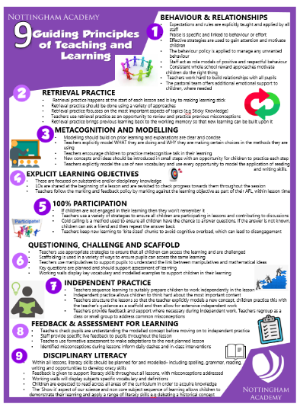
Incorporating the 9 guided principles of teaching and learning as stated in our learning policy is essential for fostering effective instruction and maximising student engagement and achievement across all subjects, including mathematics.
By incorporating these guided principles into mathematics, teachers can create an engaging, student-centred learning environment where all students have the opportunity to thrive and achieve success in mathematics.
Here's how these principles may be applied specifically in the context of teaching mathematics at Nottingham Academy in order to support children with SEND:
- Think about each pupil as an individual
- Plan sequences of units and lesson carefully to gradually introduce concepts
- Structure lesson by breaking lessons into short chunks
- Use accurate, concise and precise language
- Retrieval practice
- Encourage pupils to give explanations in full sentences
- Focus on learning and not task completion
- Scaffolding
- Build confidence and remove scaffolds gradually
- Metacognition and modelling
- Make careful use of manipulatives, concrete resources and display multiple representations to support conceptual understanding
- Formal recording isn’t always needed
- Promote opportunities for collaborative talk
- Use of technology
- Continuously assess and monitor

