Topics | EYFS | Year 1 | Year 2 | Year 3 | Year 4 | Year 5 | Year 6
Seasonal changes  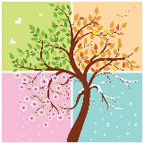 | Children observe and comment on the changes they notice throughout the seasons whilst playing outdoors.  Adult initiated activities include going on a Spring walk, walking through autumn leaves, observational drawings, making ice pictures. | Children learn that there are 12 months in a year, 4 seasons. Spring, Summer, Autumn  and Winter. They learn there are 24 hours in a day that is split into day and night.  They learn that in Spring the days begin to get longer.
Everyday materials  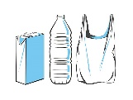 | Children explore materials as part of continuous provision e.g playdough area, modelling area, as they explore how things feel and choose materials suitable for models.  They are explicitly taught about plastic pollution and the effects on the environment. | Children learn about common materials around us- including wood, plastic, glass, metal, water and rock. They learn about properties of materials e.g wood is hard, plastic and metals are smooth, and water is wet. Experiments allow children to explore the properties and suitability of materials further- best material to build a boat. | Children continue to learn about types of materials and their properties sin more detail. Experiments include exploring the best materials to build a house. What materials are waterproof, transparent, absorbent and opaque are investigated and sorted. | Through investigation, children learn which materials are magnetic.  *In Forces topic | Children continue to develop vocabulary around describing materials as they explore states of matter. E.g solid, liquid, gas, flowing, hard. Through experiments they learn how these properties can change through freezing, evaporation etc.  *In State of matter topic  Children learn about insulators and conductors.  *in electricity topic. | Properties and changing materials.  Children learn that objects are either transparent, translucent or opaque. Children recap materials that are magnetic. Through experiments, children learn which materials that make good insulators or conductors. Children conduct experiments around the change of matter.
Plants  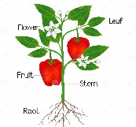 | Children experience planting and taking care or plants in their outdoor area. Children learn that plants need water and sun to grow.  Children enjoy texts linked to growing. | Children are taught about a variety of common and wild plants, including deciduous and evergreen trees. Children learn that all plants grow from a seed and have roots, a stem, leaves and that some have a flower.  Children observe and record the growth of a beanstalk. | Children learn that when a plant sprouts, it grows new shoots, those shoots grow upwards from the seed or plant to find sunlight. Through experiments, children learn that plants need water and sunlight to grow. Through exploration, children learn what seeds and bulbs need to grow, where they are found and how they grow. | Children learn about the structure and function of a plant. Plant stems have special cells called xylem. Children explore the life cycle of flowering plants, include pollination, seed formation and seed dispersal. Children learn about the process of photosynthesis. |  |  | Children learn about the parts of the flower in more detail and their function e.g stigma, stamen, petal, anther, filament, sepal, style, ovary​.  Children explore pollination- the transfer of pollen from male part to the female part to produce seeds​.  Children explore germination- when seeds settle in suitable ground, breaks down and starts to grow.
Animals including humans  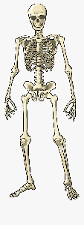 | Children observe how caterpillars grow and change- making daily observations, recording etc.  They learn that the chrysalis protects the caterpillar whilst it turns into a butterfly, and it takes 3-5 weeks for a caterpillar to turn into a butterfly.  Children learn how to keep themselves healthy through daily healthy snack and milk time.  They learn they have five senses are sight, touch, taste, smell, hearing (supporting the use of the FANTASTICS).  Through their pets topic, children have first-hand experience of a range of animals- their features and how to care for them . | Children learn what herbivores, omnivores and carnivores are. Children are taught that a mammal has warm blood and a vertebrate and are distinguished by having hair or fur, they feed their young with their own milk and give birth to live young. An amphibian is an animal that is cold blooded, they live on land and in water. A bird is an egg laying animal that has feathers and wings and usually can fly.  Children learn that humans are mammals and have 2 hands to touch, two ears to hear, one nose to smell, two eyes to see and a tongue to taste. Children learn the parts of the body. Alongside this, humans need a healthy diet to grow. | Children explore what food is healthy and unhealthy. The importance of exercise is also acknowledged and what happens to our heart when we exercise. Hygiene and its importance is also discussed. To grow into a healthy adult, we must eat the right types of food in the right amount and exercise. To stay alive, all humans have three basic needs for survival: water, food and air. The importance of teeth (brushing teeth) is also touched upon. | Nutrition is explored and the idea that humans need the correct nutrition to be able to grow and develop. The importance of a skeleton is acknowledged and what part our muscles play within our bodies is identified. The different types of animals are retrieved with invertebrates and vertebrates being added to the children's knowledge. | Children learn about digestive system and its main parts- the mouth, esophagus, stomach, small intestine, large intestine, rectum and anus. Children are taught that the digestive system breaks down food into tiny particles which are absorbed into the blood. Children identify the different types of teeth including molars, incisors and canines and the importance of teeth. Children are also introduced to how energy is passed from herbivores to carnivores. | Puberty is discussed and explored. Children learn that animals’ bodies develop and change over time. The understanding that an embryo starts in the womb of the female, a foetus is the unborn offspring of an animal and that animals have different gestation periods. The human cycle is embryo, foetus, baby, toddler, child, teenager, adult, elderly adult. | Children learn that the heart, blood vessels, arteries, veins and blood are parts of the circulatory system. Arteries carry oxygenated blood away from the heart to the rest of the body.  Veins carry deoxygenated blood back to the heart.  The function of the heart is to pump blood around your body.  The heart is a muscle at the centre of the circulatory system.  Diet, exercise and drugs can impact the way the body functions.  Nutrients and water are absorbed in the stomach, small and large intestines.  Nutrients and water enter the bloodstream via the capillaries where they are passed through the arteries.
Living things and their habitats  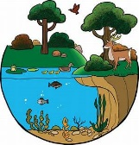 | Through their pet topic, children learn how to take care of living things. Children explore their woodland area and pond- bug hunting etc | Through their ‘Icy Planet’ topic, children learn about the habitat of Antarctica, the animals that live there and how they are able to survive.  *Geography led topic | Children are taught that a habitat is a place that an animal lives. It provides the animal with food, water and shelter. There are many different sorts of habitats around the world from forests, grasslands, mountains and deserts. Some animals are specifically identified and discussed such as; a polar bear lives in an arctic habitat because it has thick fur to keep warm. The idea that some things are alive, some things are dead and some things have never been alive is investigated. |  | Children explore which habitats suit the needs of plants and animals best. Children are introduced to the idea that habitats can be changed, damaged, and destroyed, including how and what is responsible for their demise (humans). The definition of classification is taught and how this supports with grouping animals. All living things share 7 of the same characteristics- reproduction, respiration, excretion, senses, nutrition, movement, and growth is explored. | Animals with no backbone are called invertebrates. Animals with a backbone are called vertebrates. Animals can be sorted into different groups: fish, mammal, amphibian, bird, reptile. Every living animal goes through a process called a life cycle. Sexual reproduction involves a mother and a father while asexual reproduction involves one parent producing an identical clone. Parts of the flower are explored. Children learn that pollination and germination. | Vertebrates are classified into 5 main groups (Mammals, Reptiles, Amphibians, Birds and Fish)  Organisms can be divided into groups or 'classified' by looking at the similarities and differences between them.  Animals are divided into two main groups- vertebrates and invertebrates.  A key is a set of questions about the characteristics of living things - you can use a key to identify a living thing or decide which group it belongs to by answering the questions.  Microorganisms are tiny living organisms - they are so small they can only be seen with a microscope.  Yeast is a helpful microorganism which makes bread rise. Bacteria is a microorganism which breaks down plants into nutrients.  Plants could be classified by those that have seeds and those without seeds.
Rocks  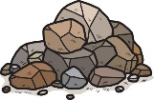 | Vocabulary around properties of materials is explored through play and exploration of continuous provision. | Children learn about everyday materials and their properties- including rock and brick. | Through Everyday Materials topic,  children understand the uses of materials, such as: brick and stone are the best material to build a house; metal and plastic are waterproof materials; glass is transparent; fabric is absorbent; wood is opaque, and the properties of materials can be considered for sorting. | Children learn that there are three main types of rocks: igneous, metamorphic, and sedimentary. ​  Hard types of rocks are usually resistant to erosion. Some soft rocks hold a lot of water. Soil is a mixture of tiny particles of rock, dead plants and animals, air and water. Fossil is the preserved remains or traces of a dead organism.​  Children learn how fossils are formed.
Forces  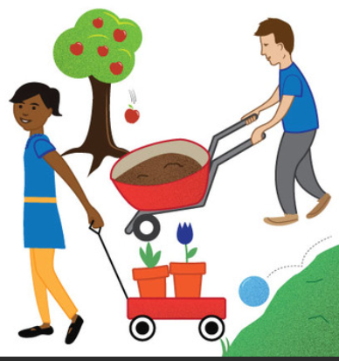 | Through their Space topic, children learn about the force of gravity- very simply that it is a force that pulls us down to Earth. |  |  | Children explore friction and the fact it is the force that is created when an object travels along a surface. Magnets attract/repel, North/South is investigated and what materials are magnetic is identified. The concept that rough surfaces create lots of friction and smooth surfaces create little friction. |  | Children learn that friction is a force between two surfaces that are sliding .  Friction always works in the direction opposite to the direction in which the object is moving .  Children explore which materials create more friction. ​  Gravity is the force that pulls things to the ground on Earth (and other planets). Children learn that gravity holds Earth and the other planets in their orbits around the Sun​. When two forces are balanced, it means the forces are the same size but are acting in opposite directions.  Children find out that when two balanced forces are acting on an object, that object will not change its motion.  Children learn about forces around a lever.
Light  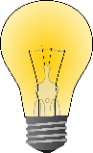 | Children explore light and dark through the use of torches in continuous provision. |  |  | Children are taught that: light is reflected from surfaces, light from the sun can be dangerous, shadows are formed when the light from a light source is blocked by an opaque object. Children investigate how the size of shadows can change. |  |  | Children learn that a light ray or beam is a source of light. They learn that light seems to  travel in a straight line.  Children know that when we see something, what we actually see is reflected light-  light bounces off the object- that is how we see it.  Children recap how a shadow is formed and how the size can be changed by the light source.  Children learn how rainbows are formed- light shining through water.  Children learn about refraction.
Sound  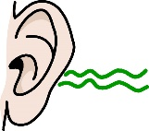 | Children learn that ears for hearing. Children enjoy listening games. | During their animals including humans topic, children learn that about features and functions of the body- including ears. They learn hearing is one of the 5 senses. |  |  | Children learn that sound is made when objects vibrate. They learn how sound vibrations travel to our ears.  Children explore how sound waves can travel through solids, liquids and gases.  Children experiment with pitch- high pitched sound is made from smaller, shorter, thinner, tighter and denser objects. They experiment with ​  Low pitched sounds- made from longer, thicker, looser and less dense objects​.  They explore sound volume and how this can be changed. ​  Children learn about how sound travels over distance.
Electricity  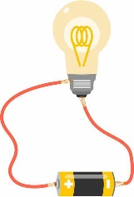 | Children know the purpose of switches and sockets and are taught health and safety around that. |  |  |  | Children are taught that electricity flows through all the components in a circuit. Children investigate how an open switch breaks the circuit stopping electricity from moving around the circuit; a closed switch maintains electricity flow. Insulators are introduced and children learn that these do not allow electricity to pass through them. Alongside this, children learn about conductors and the idea that these are materials that let electricity pass through them easily. Renewable and non-renewable electricity is also explored. | Children know what materials make good insulators or conductors.  *taught in changing state and materials topic | Children explore the impact of voltage on a circuit- e.g the higher the voltage the brighter the light.  Children learn that a battery is a source of power, a switch will break the flow of electricity and a fuse it is an emergency switch that cuts power when there is too much power.  Children learn about a series and parallel circuits and their differences. Children understand how components function including the brightness of a bulb, the loudness of buzzers and the on/off position of switches.  Children learn about common conductors and insulators.
States of Matter  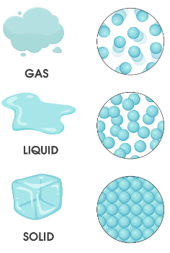 | Children explore ice in the outdoor area during Winter. They explore how it feels and begin to explore vocabulary related to this e.h hard, slippery. Some children explore how what happens as the ice melts. | During the Antarctica topic, children explore blocks of ice and make observations around melting. |  |  | Children learn the properties of a solid, liquid and gas.  Through experiments, they learn that solids and liquids can be changed from one state to another by heating or cooling. Children investigate freezing, melting and evaporation. | Through properties and changing material topic, children learn that when we dissolve a solid into a liquid, we create a solution​.  When you cannot dissolve any more solid it means the solution is saturated. ​  Children explore soluble and insoluble solutions.  Children learn that Objects in a solution can be separated through filtration or evaporation.
Space  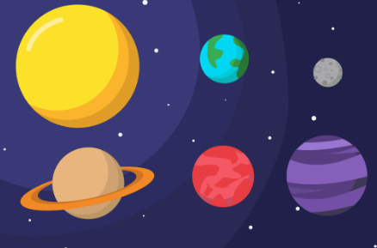 | Through their Space topic, children learn that the moon stays in place because of gravity. The children are taught about meteor showers through the text ‘look up’. They explore plants names through songs and nonfiction books within provision. |  | Through their Neil Armstrong History topic, children learn some facts around space- including that the moon is made of rock and there is less gravity on the moon. |  |  | Children learn that there are 8 planets in our solar system and can name and order them.  Planets in our solar system orbit the Sun.  Children learn about how the moon orbits Earth.  Children explore the phases of the moon.  Children know that Earth takes 24 hours to rotate and that  Earth takes 365 ¼ days to orbit the Sun.
Evolution and inheritance  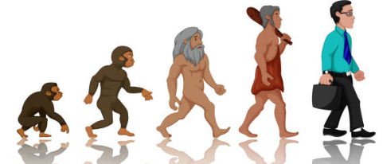 |  | During animals and humans topic, children learn what herbivores, omnivores and carnivores are.  Through their ‘Icy Planet’ topic, children learn about the habitat of Antarctica, the animals that live there and how they are able to survive.  *Geography led topic | During living things and their habitats topic, children learn that a habitat is a place that an animal lives. It provides the animal with food, water and shelter. Some animals are specifically identified and discussed such as; a polar bear lives in an arctic habitat because it has thick fur to keep warm. | During the animals vs humans topic, the different types of animals are retrieved with invertebrates and vertebrates being added to the children's knowledge.  Children learn how fossils are formed  *taught during rocks topic | During the animals and h nts and animals best. Children are introduced to the idea that habitats can be changed, damaged, and destroyed, including how and what is responsible for their demise (humans). All living things share 7 of the same characteristics- reproduction, respiration, excretion, senses, nutrition, movement, and growth is explored.  Animals including humans topic, children learn how energy is passed from herbivores to carnivores.  During their living things and their habitat topic, children explore which habitats suit the needs of plants. | In geography, children learn about different biomes of the world.  During their living things and their habitats topic, children are taught the differences between invertebrates and vertebrates. Children are taught about life cycles and animals reproduction- including sexual and asexual reproduction. | Children know that fossils are imprints of long dead plants and animals found in rocks.​  Children learn about variation within offspring.  Children explore that animals and plants are adapted to suit their environment and that adaptation may lead to evolution. ​  Children explore how adaptation supports the features of herbivores, carnivores and omnivores. Children are taught how animals adapt to their harsh habitats.

